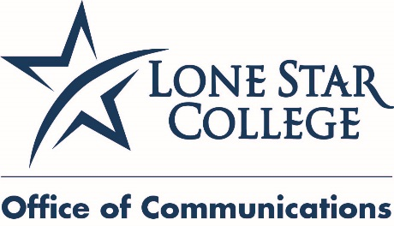

April 20, 2015
FOR IMMEDIATE RELEASE

Media Contacts:
Jed T. Young
832.813.6521, desk
281.974.6878, cell
Jed.T.Young@LoneStar.edu

Bill Van Rysdam
832.813.6206, desk
Bill.VanRysdam@LoneStar.edu

Lone Star College trains Ablecare Oilfield Services employees in Malta

HOUSTON (April 20, 2015) – Twenty-four students recently earned their Oil and Gas Drilling Floorhand/Roustabout Workforce certification from the Ableman Drilling Careers Academy (ADCA) in Malta to work in the oil and gas industry. Lone Star College developed the seven-week course and trained the students at the ADCA facilities in San Gwann.

“Lone Star College is truly a global leader when it comes to training workers for the oil and gas industry,” said Stephen Head, LSC chancellor. “We were pleased when asked to partner with Ablecare Oilfield Services Group and assist them in developing skilled employees.”

The Floorhand Workforce certificate course is part of the International Association of Drilling Contractors (IADC) Workforce Attraction and Development Initiative (WADI) and provides trainees with 70 percent hands-on practical learning and 30 percent theoretical learning. It consists of seven modules comprising 288 contact hours, including two industry-specific certificates: IADC Rig Pass and IADC Introduction to WellCap.

“The creation of the Ableman Drilling Careers Academy shows the commitment of the Ablecare Oilfield Services Group toward upgrading the standards of preparation for prospective employees in the oil and gas industry,” said Paul Abela, Ablecare OSG chairman.

The Ablecare Oilfield Services Group developed the Ableman Drilling Careers Academy with the assistance of LSC to train an educated and skilled workforce enabling the citizens of Malta to work for U.S. based companies operating in North Africa and the Middle East and beyond.

“Lone Star College has successfully trained more than 200 students in the 288-hour oil and gas upstream drilling program. Of those who completed the program, 92 percent were able to find employment,” said Head. “The Ablecare Oilfield Services Group was looking for a partner who could train a workforce that is qualified for entry level positions in both offshore and onshore.”

The Ableman Drilling Careers Academy Floorhand Workforce Certificate is the first such comprehensive program in the Mediterranean region. It was developed in line with the recently launched Knowledge, Skills and Abilities (KSA) requirements of the International Association of Drilling Contractors (iadc) and is fully recognized by the IADC.

“We cannot be successful in our community or as a country without helping our multi-national Houston-based business partners be successful,” said Head. “They need a well-trained and highly-skilled workforce available to them here in Houston, and also in Malta, in Africa, in Brazil and everywhere else they are working. The real value is that the technical and personal competencies were designed by employers and have the IADC accreditation. That accreditation along with the college accreditation assures the students completing are work ready.”

Ablecare Oilfield Services Group, is a Maltese owned group which specializes in the specific requirements of drilling contractors. Through its founding companies Ableman International Ltd. and Mainticare Ltd. the group offers services ranging from Manpower planning, project recruitment, contracting of prescreened and qualified personnel for the offshore/onshore industry to logistics, supply chain solutions, project management, rig agency services, and rig stop services and facilities.

Lone Star College has been opening doors to a better community for more than 40 years. Founded in 1973, LSC remains steadfast in its commitment to student success and credential completion. Today, with almost 83,000 students in credit classes, and a total enrollment of more than 95,000, Lone Star College is the largest institution of higher education in the Houston area and one of the fastest-growing community colleges in the nation. Stephen C. Head, Ph.D., is the chancellor of LSC, which consists of six colleges including LSC-CyFair, LSC-Kingwood, LSC-Montgomery, LSC-North Harris, LSC-Tomball and LSC-University Park, seven centers, LSC-University Center at Montgomery, LSC-University Center at University Park, Lone Star Corporate College, and LSC-Online. To learn more visit LoneStar.edu.
####

