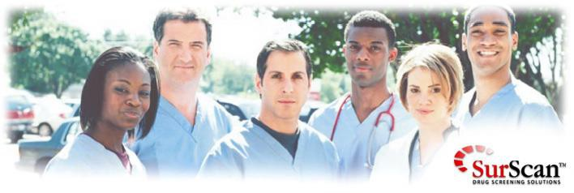

Welcome to the Drug Screening Registration site for LSC - North Harris College
The following webpage will guide you through the quick and easy process of fulfilling your drug test requirement. As part of the admission process, all students are required to complete this specific drug test. This is done in order to obtain access to clinical rotation. SurScan has been chosen to provide this service for all incoming students.

http://www.surscan.com/nhc2030.html

The process is simple:

  - You will enter the requested personal and payment information (we accept most credit cards).
  - After you have submitted your registration (step 1), you will receive an e-mail that is your "Auto- Receipt". Be sure to keep this for your records.
  - Once you have registered on-line you have completed everything you need to do for your drug test.

