Logging in for your Video Session

When your time nears for your live video session, log in to the WC Online page.

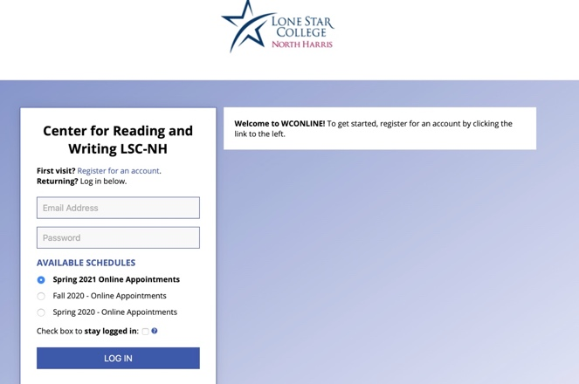

Logging in should connect you to the schedule page. Your session will be in yellow:

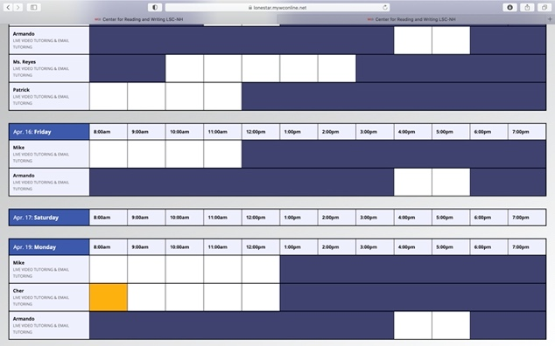

Click on your session (the yellow square), and you should see your Appointment Form:

That center box will have a link that says “Start or Join Your Tutoring.” Click that link.

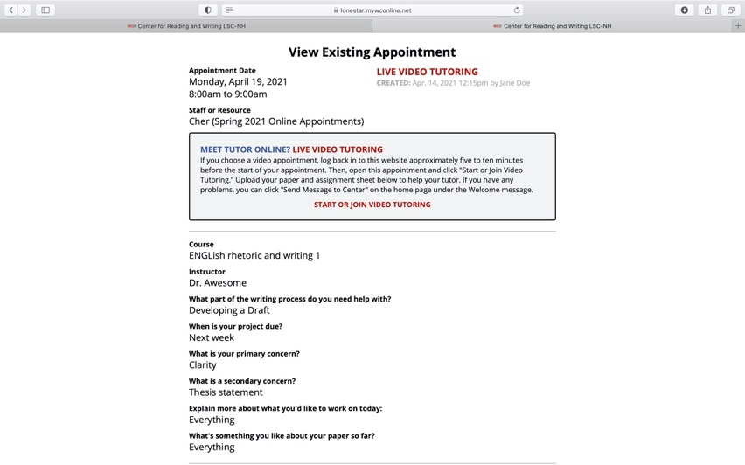

You should now be in your tutoring session. Your tutor will be waiting or will be with you shortly.

