The Cycle of Socioeconomic Oppression of Marginalized Communities
Through Poor Access to Reproductive Health Services

By Margaret Buhrer
“The author displays her larger language awareness, starting with herself, her family, and then the local community. Margaret has multiple life experiences to bring out her expertise and critical awareness on the topic of reproduction rights, and she immediately brings her confidence and motivation to this conversation. The submitted project also represents her participation, vis social networks, in the larger national conversation, as seen in the multi—modality of tweets and other screenshots. Her writing represents how multiple conversations come together from the community into the college and then return the college experience back to the community. The assignment focused on 21st century public sphere discourses, and uses MLA documentation style, even though her training in health sciences requires the APA system of documentation..
---English Professor Bruce Martin
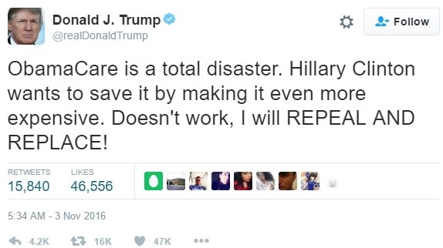
With the incoming Donald Trump Presidential administration comes a very real possibility that millions of women will lose affordable access to contraceptives, maybe even access to contraceptives all together. Reproductive rights have been a hot topic on both sides of the political aisle throughout this election cycle, and with the election of Donald Trump, his promise of repealing the Affordable Care Act (ACA), which benefits many Americans that cannot afford health insurance otherwise. Access to contraceptives helps women to plan for their future family and prevent unintended pregnancy, increasing their likelihood of finishing college and entering the workforce. In Dan William’s article “Abstinence-Only Education: Are Abstinence-Only Sex Education Courses Effective,” he researches pregnancy and advocates for reproductive rights, finding that black and Hispanic women have the highest rates of teen pregnancy, contributing to racial inequalities in education and income. While some argue that teaching abstinence is the only way to prevent teen pregnancy, advocates for comprehensive sex education have found that teaching teens about how contraceptives work as well as encouraging abstaining from sex until older or married has proven to lower teen pregnancy rates (Williams). On the other hand, abstinence-only programs or the complete lack of sex education for teens in Texas could be contributing to the high instances of unintended minority teen pregnancies. Without this access, millions of women will not have the option to prevent unwanted pregnancies, potentially preventing them from ever seeking higher education. A lack of proper sex education, and the lack of access to affordable or free birth control, is a part of a cycle of events that directly prevents marginalized groups from improving their socioeconomic status. Authors of pro-life blogs target minority women, potentially persuading them to eliminate the option of pregnancy termination.
Figure 1 Donald Trump's Tweet from 3 Nov 2016 (@realdonaldtrump)
With the passage of the Affordable Care Act in 2011, women gained access to contraceptives completely covered by their insurance companies (see figure 2). Even though American women now have what could be seen as easy and free access to contraceptives, Carrie Fiebel reports that Texas has the highest instance of repeat teen pregnancies, and that Hispanics, who make up thirty-eight percent of the state’s population, have the highest rate of repeat teen pregnancy compared to other ethnic groups. Fiebel also found that of the ninety-one percent of teen moms that were using birth control, only twenty-two percent were using the most effective form, such as an IUD (Fiebel). This could be attributed to the high cost of more long lasting and effective contraceptive implants. With no insurance, depending on their socioeconomic status, a woman has limited if any access to any type of contraceptive. Furthermore, a woman choosing to terminate a pregnancy would find a search on the internet confusing. Pro-life blog Abort73 describes abortion with terms redefining the procedure as an agenda, even as a racist institution in their entry titled “Abortion and Race: For Decades, Abortion has Disproportionately Targeted Minority Babies.” The piece compares statistics of the 2008 US Census with 2009 Center for Disease Control demographic information of African Americans that have received an abortion, and argues that abortion disproportionately kills more black children than white 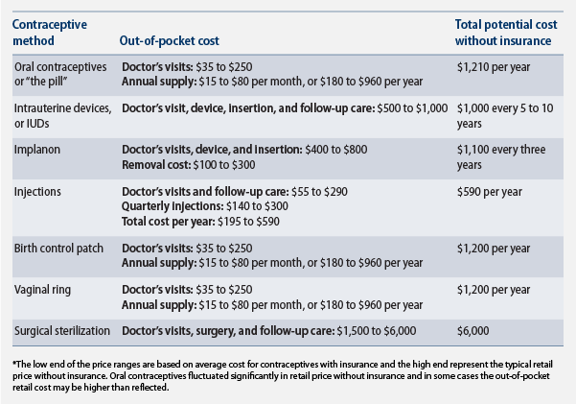
Figure 2 “The High Cost of Birth Control”
children, that “abortion has thinned the black community in ways the Ku Klux Klan could have only dreamed of.” It further implies that Planned Parenthood clinics are only in minority communities to secretly practice eugenics and seek to control the black population (Loxafamosity Ministries). These extremes of misinformation dissuade those seeking facts from taking proper action in accordance with their situation, and prevent them from seeking assistance and medical care at low or no cost from an organization like Planned Parenthood.
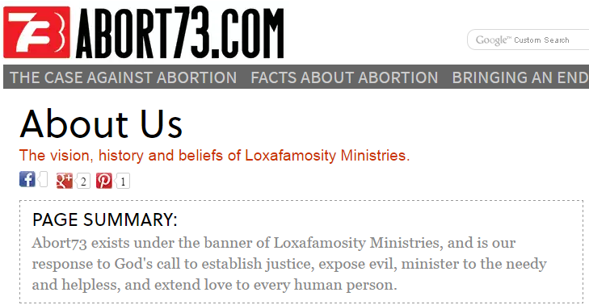
Abort73 is a subdivision of Loxafamosity ministries and claims to seek to comprehensively educate students about the injustice of abortion, as well as provide these students, of which an age group is not specified, with the tools to educate others. Their website refers to an out-of-context quote in a letter written by Planned Parenthood founder Margaret Sanger in 1939: “We do not want the word to go out that we want to exterminate the Negro population.” Abort73 contends that Sanger did not want the black community to wrongly assume Planned Parenthood’s true intentions, and that elimination of the black community was the organization’s goal. Ultimately, Abort73 believes that Sanger’s true intention was to keep the black community submissive and in line (Loxafamosity Ministries). Through this rhetoric, Abort73 is targeting an audience of African-American women seeking information on abortion, potentially dissuading them from utilizing the services offered by Planned Parenthood—actions that would be based on intentional misinformation and fear-mongering. Of Planned Parenthood’s services, thirty-four percent is prevention of unwanted pregnancy, while only three percent of their services are for abortion (Planned Parenthood). If Abortion73’s data is applied to the fact that minority populations cannot afford and do not have coverage for contraceptives, unwanted pregnancies can result. Planned Parenthood has placed their clinics in marginalized communities to reach those who need their services at the lower prices they provide.
Figure 3 "About Us" (Loxafamosity Ministries)
The use of racially-specific scare tactics by this particular pro-life blog singles out African-Americans to persuade them not to terminate their pregnancies. This blog does not address the financial implications of choosing to bring an unintended pregnancy to term, which will directly impact the socioeconomic status of the family for generations, or the possibility that this is the actual intention of some pro-life groups and elected officials. Abort73 places a great deal of emphasis upon the life of an unborn child, but fails to account for the future of the mother that will sustain the life of this child once it is born. The economic impact of an unintended pregnancy, especially teen pregnancy, can be felt for generations within a family.
Rachel Walden writes in Our Bodies Our Selves about a report published by the Guttmacher Institute that examines how birth control affects the lives of women. This study reviews more than sixty-six other studies over the past thirty years and finds that use of contraceptives to prevent unwanted pregnancies has increased the likelihood of young women to obtain some college education, to pursue advanced professional degrees, to join the workforce, and ultimately to decrease in the gender gap in salaries. Her research found gaps in the literature, particularly in research on the effects on racial and ethnic marginalized communities (Walden).
Contraceptives indeed have a positive socio-economic benefit. Jeremy Eagle, in “Birth Control Funding: Should Health Insurance Companies Provide Complete Coverage for Birth Control?” explains that with the passing of the Affordable Care Act in August of 2011, insurance plans are currently required to cover all government-approved contraceptives and preventative care without a co-pay. According to the Obama administration, this will reduce the number of unwanted pregnancies as well as the number of abortions. The article also states that women have a greater chance of completing their education with access to birth control, and that some couples that are struggling financially are able to delay having children until they are in a better place (Eagle). Richard V. Reeves and Joanna Venator write in “The Implications of Inequalities in Contraception and Abortion” that more affluent women tend to use birth control more often and more effectively, improving their education and employment prospects. They argue for policies to be put in place to help close the income gap through increasing access to long-acting reversible contraceptives to women of lower incomes (Reeves and Venator). While these authors lack enough information to determine the effects of easy access to contraceptives on minority communities, it is made clear that the ability to delay starting a family increases the chances of a woman completing a college education, increasing their potential to improve their socio-economic status, thus stopping the cycle of the financial burden of seeing through an unintended pregnancy.
With the incoming Trump administration, there comes the looming possibility that the president-elect will keep his promise of abolishing the Affordable Care Act. This will affect millions of women’s ability to maintain their birth control due to financial restrictions. While not all women have the education or the tools to seek access to free contraceptives in their community, the possibility of zero access to contraceptives will cause an explosion in unintended pregnancies. This will directly affect minority communities, continuing the cycle of inability to raise household income levels through acquiring a college education and potentially seeking a professional degree. The direct targeting of minority communities by pro-life blogs is not only an effort to decrease community usage of Planned Parenthood clinics, but I argue that preventing women, especially marginalized women, from receiving proper reproductive care and education will prevent them from having the same opportunities as white males. The financial implications of both teen and unwanted pregnancy affect several generations of a family, furthering the possibility that in addition to the mother not receiving a college education, her children are statistically unlikely to attend college as well. Much of the rhetoric around contraceptives and abortion advocates for the unborn child, but does not address the impact these pregnancies have on low income communities. I would like to see more long-term research into the effects of contraceptive access through the Affordable Care Act on minority communities.
Proper contraceptive usage and education is proven to reduce abortion rates, and if preventing access to abortion is a goal of the incoming Trump administration, keeping parts or all of the ACA is better than abolishing it. Comprehensive sex education for teens in Texas, including Houston, could reduce the instance of teen and repeat teen pregnancy, which disproportionately affects Hispanics and African Americans. By seeing proper education and easy access to contraceptives as prevention of unintended pregnancy and not permission to have sex at an inappropriate age, pro-life members of government have the opportunity to help minority communities increase their socioeconomic status and better plan for their future families, unless this is a future they are directly trying to prevent from coming to fruition.

Works Cited
Eagle, Jeremy. “Birth Control Funding.” Issues & Controversies. Infobase Learning, 14 Nov. 2011. http://icof.infobaselearning.com.lscsproxy.lonestar.edu/articles/religion,-ethics,-and-morality/birth-control-funding.aspx?ID=2493&hd=2493. Accessed 8 November 2016.
Feibel, Carrie. “Teenage Pregnancy in Decline, But Texas Still #1 for ‘Repeat’ Teen Births.” Houstonpublicmedia.org. https://www.houstonpublicmedia.org/articles/news/2013/05/30/43916/teenage-pregnancy-in-decline-but-texas-still-1-for-repeat-teen-births/. Accessed 8 November 2016.
“High Cost of Birth Control, The.” Center for American Progress. AmericanProgress.org. 15 Feb. 2012. https://www.americanprogress.org/issues/women/news/2012/02/15/11054/the-high-costs-of-birth-control/
Loxafamosity Ministries Inc. “Abortion and Race: For Decades, Abortion has Disproportionately Targeted Minority Babies.” Abort73.com, http://abort73.com/abortion/abortion_and_race. Accessed 7 November 2016. Accessed 8 November 2016.
Planned Parenthood Inc. “Planned Parenthood by the Numbers.” 2013. Planned Parenthood Federation of America, Inc. https://www.plannedparenthood.org/files/9313/9611/7194/Planned_Parenthood_By_The_Numbers.pdf. Accessed 8 November 2016.
@realdonaldtrump. “ObamaCare is a total disaster. Hillary Clinton wants to save it by making it even more expensive. Doesn’t work, I will REPEAL AND REPLACE!” Twitter, 3 Nov. 2016. https://twitter.com/realDonaldTrump/status/794155725152980992
Reeves, Richard V. and Joanna Venator. “The Implications of Inequalities in Contraception and Abortion.” Brookings.edu, https://www.brookings.edu/blog/social-mobility-memos/2015/02/26/the-implications-of-inequalities-in-contraception-and-abortion/. Accessed 7 November 2016.
Walden, Rachel. “Access to Contraception Increases Social Benefits for Women and Society.” Ourbodiesourselves.org, www.ourbodiesourselves.org/2013/03/access-to-contraception-increases-social-and-economic-benefits-for-women-and-society/. Accessed 8 November 2016. Accessed 6 November 2016.
Williams, Dan. “Abstinence-Only Education.” Issues & Controversies. Infobase Learning, 14 Apr. 2014. http://lscsproxy.lonestar.edu/login?url=http://icof.infobaselearning.com/recordurl.aspx?wid=99152&ID=14177. Accessed 8 November 2016.

