Uploading Your Assignment and Draft Documents

- Log into your schedule, and click on your appointment session.

When your time nears for your live video session, log in to the WC Online page.

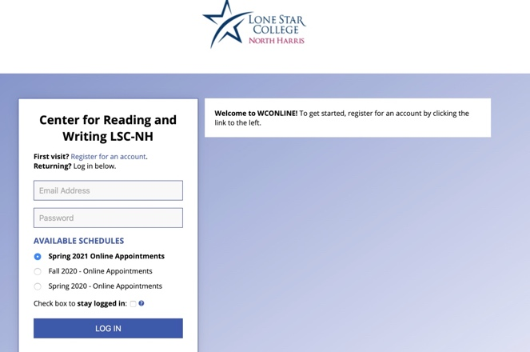

Logging in should connect you to the schedule page. Your session will be in yellow:

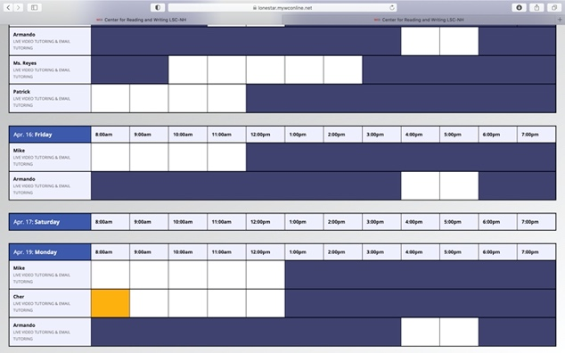

- From your appointment window, click the “Choose File” button and open your file from where you saved your document.
Note: You will need to upload two files; your assignment instructions and a copy of the essay you’re working o

- After your files have been uploaded, place a title for the documents and click “Create Appointment”.
