 **FREE EL/CIVICS, ESL & GED CLASSES FOR ADULTS**

* **EL/CIVICS**: English Literacy Civics-The English Literacy civics program incorporates English literacy and Civics education services for immigrants and other limited-English –speaking populations. Testing is required to determine class placement and to monitor progress.
* **ESL** classes are for immigrant adults who do not speak or read English as their native language. In these classes, students will develop the speaking, listening, reading, and writing skills they need for everyday life in the United States. Beginner, intermediate and advanced classes are available at no cost on a first come, first served basis.
* Students must take the BEST Plus test and be registered before entering the program.
* The **General Equivalency Diploma (GED**) program offers adults an opportunity to complete their high school education, improve basic education skills, and enhance their employment situation through courses which prepare students for the GED test. There may also be an opportunity to jointly progress through the GED and College Workforce training. TABE assessment administered to determine skill level.
* All Students must present **a valid photo ID** at the time of Registration / Assessment.
  + ***16*** year olds must have a ***court order*** and **valid photo ID**
  + Minimum age: ***17*** years with ***parental permission form***, an ***official withdrawal*** from school and a **valid photo ID**. Parental permission forms may be obtained in the Adult Education Office at the LSC-Greenspoint Center.

**THESE CLASSES ARE SCHEDULED TO BEGIN**

February 17 to June 12, 2015/4 days a week

**Mon., Tues., Wed., & Thurs. 6:00PM-9:00PM**

**The classes will take place at**

**The** **Oscar Johnson Community Center**

100 Park Place, Conroe, TX 77301

In order to be eligible, the required placement test will take place on

**February 17th at 6:30PM**

**at** The Oscar Johnson Center

**Must be on time./ No children allowed at testing or at classes.**

For More information: Call ______________________

**For more information please call:**

**281-260-3576**

**AEL (Adult Education & Literacy)**

**Lone Star College – Greenspoint Center**

**250 N. Sam Houston Pkwy E, #112**

**Houston, TX 77060**

**The office is open**

**Monday-Thursday from 8:00AM-5:00PM, on Fridays we close at 4:00PM**

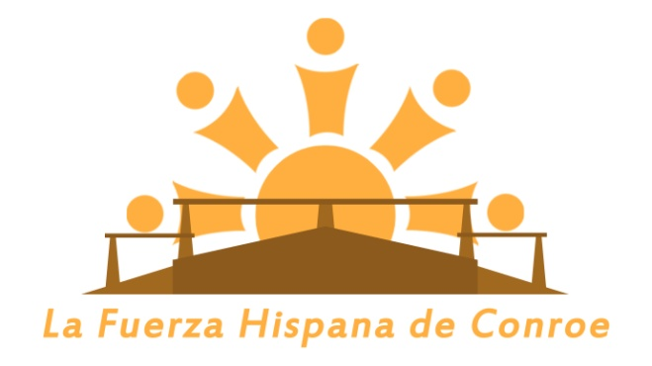

**OFRECEMOS  
CLASES GRATUITAS DE INGLÉS**

* Usted debe tomar un examen antes de tomar la clase.
* Usted debe presentar una identificación oficial, válida y vigente (Licencia de manejo, Identificación Estatal, o Matricula Consular)
* No debe traer niños ni a las clases ni el día del examen.
* La edad mínima es de 16 años. Los de 16 y 17 años deben llamar para más información.

**ESTAS CLASES ESTÁN PROGRAMADAS PARA**

el 17de febrero al 12de junio. Cuatro días a la semana

**lunes, martes, miércoles y jueves: 6:00PM-9:00PM**

**Las clases se llevarán a cabo en**

**Oscar Johnson Jr. Community Center**

100 Park Place, Conroe, TX 77301

El examen previo a las clases para que usted sea aceptado en el programa se llevará a cabo el día **17 de febrero a las 6:00PM en**  The Friendship Center

**POR FAVOR LLEGUE PUNTUAL**

For More information: Call ______________________

**Para más información, favor de comunicarse al:**

**281-260-3576**

**AEL (Adult Education & Literacy)**

**Lone Star College – Greenspoint Center**

**250 N. Sam Houston Pkwy E, #112**

**Houston, TX 77060**

**La oficina está abierta**

**del lunes al jueves de 8:00AM-5:00PM, y los viernes 8:00AM-4:00PM**