Catering Coordinator:
Michelle Berrios
presto-caterings@att.net
Phone: 281-765-7871
Fax: 281-618-1169

Catering Office Hours:
Monday – Friday
10:00 am - 4:00 pm

Cafeteria Manager:
Carlos Barrales
carlos-minuti@att.net
Phone: 281-618-1125
Fax: 281-618-7116

Cafeteria Hours:
Monday – Thursdsay
9:30 am – 3:00 pm
Friday
10:00 am – 1:00 pm

Minuti Coffee Café:
Phone: 281-618-1126

Café Hours:
Monday – Thursday
7:00 am – 7:00 pm
Friday
7:00 am – 2:30 pm

TERMS AND CONTITIONS FOR CATERINGS

- Large events should be planned and booked at least seven (7) days in advanced.
- Smaller events must be planned and booked at least 24 hours prior to the start time of the event.
- To submit a request, please fill out a request form, which can be found online under the cafeteria/food service department, and email it to presto-caterings@att.net. A confirmation will be sent via email once request is received.
- Requests that are faxed, left on voicemail or emailed are not a guaranteed booking. You must receive verbal or written confirmation on all events. Confirmation will be sent within 24 hours from the time request is submitted via email. A signed request form must be faxed or email to catering coodinator once confirmation is given to finalize the booking of the event.
- If the request is urgent and you can not get a hold of the catering coordinator, or you do not get a response after 24 hours, please call: Ardavan Motamedi: 832-766-8331 or James Berrios: 713-249-5026 or Café Manager: on coversheet.
- Final headcount for all food and beverage requests must be made 72 hours prior to the event.
- Any modifications to meal requested, time or style of service could result in price change.
- Any modifications to order will be accepted up to 36 hours prior to event.
- Same day requests will be available for pick up only.
- All cancellations must be emailed to presto-caterings@att.net 48 hours in advance of the catered event.
- China, glass and silverware are available at an additional fee.
- The private dining room may be reserved through NHC Scheduling.
If you desire foods that are not listed on the menu, please inquire with the catering coordinator as to the availability by
sending an email to presto-caterings@att.net.
Any special request will be considered.

LABOR/SET UP FEES
Labor/Set up fees will be applied for large events, early morning events, evening and Saturday events requiring staff to come in before or after regular operating hours.

Presto Foods reserves the first right of refusal for all food and beverages served at North Harris College. Outside food and beverages are not allowed due to Harris County Health Department regulations and liability. If we are unable to provide your requested menu, we will grant you permission to use an insured caterer.

PRICES ARE SUBJECT TO CHANGE DUE TO MARKET CONDITION AND FOOD PRICE INDEX. ALL POLICIES, PROCEDURES, MENUS AND
PRICES ARE SUBJECT TO CHANGE WITHOUT NOTICE.
THIS LISTING WILL BE REVISED PERIODICALLY.

CONTINENTAL BREAKFAST
~ $5.50 per person ~


- Variety of Bagels with Cream Cheese OR Variety of Fruit Filled Danishes
OR Variety of Donuts OR Variety of Muffins
- Freshly Brewed Italian Coffee (Regular/Decaf)
- Chilled Orange Juice

- Add Fresh Fruit for $3.50 more per person

BREAKFAST TRAY
~ $2.00 per person ~

A selection of breakfast breads and pastry favorites:
Fruit filled Danishes, Muffins and Bagels w/cream cheese.

- Add Fresh Fruit for $3.50 more per person

ALL AMERICAN BREAKFAST
~ $6.50 per person ~

- Fluffy Scrambled Eggs
- Two choices of: Crispy Bacon OR Tasty Sausage Patties OR Grilled Ham
- Hash browns
- Choice of: Biscuit and Gravy OR Toast (wheat or white)
- Butter, Jelly & Honey
- Chilled Orange Juice


OTHER BREAKFAST OPTIONS
~prices are quoted per person~

- Assortment of Fruit filled Danishes, Muffins…………………………… $2.00
- Assortment of Bagels w/Cream Cheese…………………………………. $2.00
- Assortment of Donuts…………………………………….……............... $2.00
- Ham Croissant (Ham, American Cheese & Croissant)………………………... $3.00
- Sausage Biscuit (Sausage, American Cheese & Biscuit)…………...…………. $2.25
- Breakfast Tacos………………………......…………..………………….. $2.00
(Choice of: Eggs, Sausage & Cheese OR Eggs, Ham & Cheese OR Eggs & bacon)
- Fresh Fruit………………..……………………………………………… $3.50
- Freshly Brewed Italian Coffee…...……………………………………… $2.00
- Bottled Juices (assorted flavors)………………………………………… $2.00
- Chilled Orange Juice…………….…………………………….………… $1.50
- Chilled Apple, Grape or Cranberry Juice.……………………….………. $2.00
- Hot Water w/Tea Selections……………………………………………... $1.50

PIPING HOT SOUPS
(All soups includes 2 cracker packets) ~prices are quoted per person~

- Chicken Noodle Soup (8 oz.)……………………………………………. $3.00
- Tomato Soup (8 oz.)………………………………………….………….. $3.00
- Minestrone Soup (8 oz.)…………………………………………………. $3.25
- Tortilla Soup (8 oz.)……………………………………………………....$3.25
- Hoagie Bread (1/4 size)………………………………………………….. $0.30

TASTY SALADS
(Individually packaged) ~prices are quoted per person~

- Grilled Chicken Salad...…………………………………….………..… $5.50
Romaine lettuce, Iceberg lettuce, grape tomatoes, carrots, red cabbage, sliced grilled chicken.
- Chicken Caesar Salad………………………………………………..… $5.50
Romaine lettuce, parmesan cheese, sliced grilled chicken with Caesar dressing.

- Chicken Pasta Caesar Salad………………………………………....... $5.50 Romaine lettuce, pasta salad, parmesan cheese, grape tomatoes, sliced grilled chicken.
- Italian Salad……………………………….……………….…………… $6.00
Salad blend with baby spring mix, black olives, pepperoni, grape tomatoes, sliced salami, sliced ham, sliced provolone cheese and house Italian dressing.
- Caprese Salad…………....……………………………………………... $6.00
Salad blend with baby spring mix, mozzarella balls, grape tomatoes, sliced grilled chicken breast, basil presto drizzle and Balsamic Vinaigrette dressing.
- Lone Star Chicken BLT Salad………….……..………………………. $6.00
Salad blend with baby spring mix, bacon pieces, grape tomatoes, sliced crispy chicken, cheese spice blend and Parmesan Peppercorn Ranch dressing.
- House Special Salad……………………..………………………………$6.00
Salad blend with baby spring mix, dried cranberries, glazed walnuts, mozzarella balls, sliced grilled chicken and red wine vinaigrette dressing.
- Mediterranean Salad…………………………………………………....$6.00
Salad blend with baby spring mix, diced red peppers, artichoke hearts, sliced grilled chicken breast, cheese spice blend and lemon basil vinaigrette dressing.
- Chicken Fruit Salad……………………………………………………. $5.50
Spring mix, mandarin orange, pineapple chucks, cranberries, grilled chicken.
- Taco Salad………………………………………………………………. $5.00
Iceberg lettuce, chopped tomatoes, tortilla chips, chili, sour cream, hot sauce and shredded American cheese.
- Side Garden Salad……………………………………………………… $2.00
Romaine lettuce, Iceberg lettuce, grape tomatoes, carrots, red cabbage.
- Side Caesar Salad………………………………………………………. $2.00
Romaine lettuce, parmesan cheese with Caesar dressing

COMBO MEALS
~prices are quoted per person~

- Choice of Soup & Half Sandwich Meal………………………………..$5.50
- Choice of Side Salad and Half Sandwich Meal.................…………….$4.50

TRADITIONAL BOX LUNCH
~ $7.00 per person ~

Traditional Hoagie Sub Sandwich
(Choice of Ham, Turkey, Tuna Salad, Chicken Salad or Veggie)
Bag of Chips



Cookie

DELUXE BOX LUNCH
~ $8.00 per person ~

Traditional Hoagie Sub Sandwich
(Choice of Ham, Turkey, Tuna Salad, Chicken Salad or Veggie)
Bag of Chips
Cookie
Drink
(Choice of: Fresh Brewed Iced Tea, Lemonade, Bottle Water or Canned Soda)

GOURMET SUB SANDWICHES
(Served on toasted Chibatta bread with lettuce and tomato)
~prices are quoted per person~

      - Original (ham, salami, pepperoni, giardiniere).............................................................$6.00
      - Club (ham, turkey, bacon)......................................................................................... $6.00
      - Meatball (5 meatballs, marinara sauce, cheese)........................................................... $6.00
      - Chick Parm (breaded chicken, marinara sauce, cheese).................................................$6.00
      - Ham...................................................................................................................... $6.00
      - Turkey.................................................................................................................. $6.00
      - Veggie.................................................................................................................. $5.00
Lettuce, tomato, pickles, black olives, bell pepper, mushrooms, cucumbers, asiago cheese & house Italian dressing.
TASTY SANDWICHES
      - Four Cheese & Tomato........................................................................................$6.00
Provolone, Swiss, asiago & parmesan cheese, tomato and roasted red pepper.
      - Fajita Pita………………………………………………………………………. $5.00
Beef or chicken fajitas, lettuce, tomatoes, onions on a pita bread
      - Gyro Sandwich …..………………………………………………………..…… $5.00
Lamb & beef, lettuce, tomatoes, onions, Tzatziki sauce on pita bread
      - Sandwich Italiano………………………………………………………………. $3.00
Sliced wheat or white bread, real butter, asiago cheese with a choice of: ham, turkey or chicken.
      - Grilled or Rotisserie Chicken Sandwich….……………..……………………... $3.00
Grilled or Rotisserie chicken, lettuce, tomatoes & honey mustard on a bun
      - Breaded Chicken Sandwich…..…………………………………………………$3.00
Bread chicken,lettuce, tomatoes, mayo on a bun.
      - Spicy Chicken Sandwich…..…………………………………………………....$2.00
Bread spicy chicken, pickles on a bun.

SANDWICHES TRAYS
~prices are quoted per person~
      - Hoagie Sub Sandwich Tray (enough supplied for a min. of 2/pp)……………..….…. $5.00
      - Sliced Bread Sandwich Tray (White or wheat, 1/4 cut, enough for a min. of 4/pp).......... $5.00

LUNCH & DINNER
ENTREES

FRESHLY BAKED PIZZAS
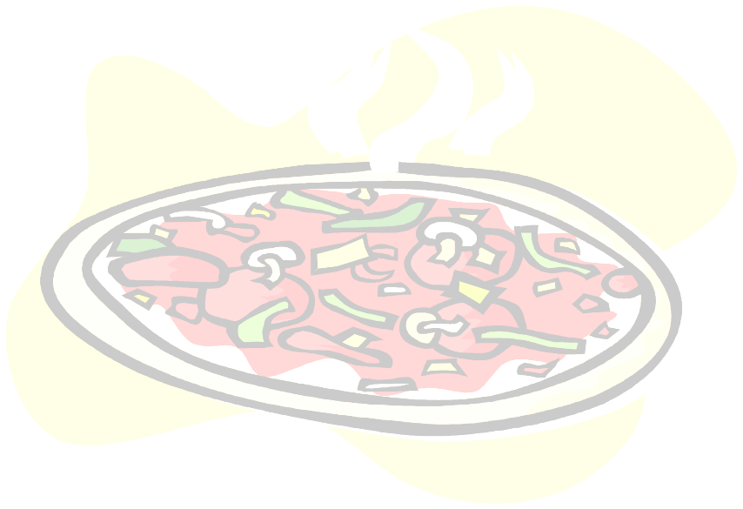
~ Prices are quoted per person ~

- Cheese Double Slice……………………………………………….. $2.70
- Pepperoni Double Slice…………………………………………….. $2.70
- Whole 12” Cheese or 1-Topping Pizza (each)……………………... $5.00
- Whole 14” Cheese Pizza (each)……………………………………. $6.00
- Whole 14” Pepperoni Pizza (each)………………………………… $7.00
- Whole 14” Build-your-own Pizza (each)………………………… $6.00 +
Meat Toppings - $1.25 each Veggie Topping - $0.50 each

Available Toppings:
Pepperoni Sausage Ham Grilled Chicken
Mushrooms Green Peppers Olives Tomatoes
Onions


- Baked Potato Bar……………………..........…….……………........ $7.00
Toppings included: sour cream, chives, butter, bacon bits, shredded cheese, broccoli & chili
- Fresh Side Garden or Caesar Salad:
add $2.00 per person

- Chicken Breast or Chopped Beef
add $3.00 per person

- Chicken Parmesan.............................................................................. $7.00
Bed of Spaghetti Marinara topped with breaded chicken and parmasan cheese
(Entrée includes bread)
- Chicken Carbonara………....…………….…………………………$7.00
Linguine, Alfredo sauce, broccoli florets, crumbled bacon, sliced grilled chicken, cheese spice blend (Entrée includes bread)

- Baked Penne Basil............................................................................. $8.00
Penne pasta, mozzarella cheese, pesto basil sauce, grilled chicken breast.
(Entrée includes bread)

- Chicken Florentine............................................................................. $8.00
Creamy Fettuccini Alfredo with grilled chicken, spinach and diced tomatoes
(Entrée includes bread)

- Beef or Chicken Fajitas……………………..……………….…….$15.00
Includes: Rice, beans, tortillas, pico de gallo, sour cream & guacamole

** Buffets, early mornings, evenings, Saturdays and large functions will be charge for additional labor costs, if required. **

ITALIAN FAVORITES
(All Entrees include bread)
~ Prices are quoted per person ~
- Spaghetti Marinara
Half Portion - Individual…….…………………………………………………...……. $2.25
Full Portion - Individual…….…………………………………………………………. $4.50

Buffet Style…………………………………………………………………………..… $5.50
- Spaghetti Meat Sauce
Half Portion - Individual…….……………………………………………………...…. $2.25
Full Portion - Individual…….…………………………………………………………. $4.50
Buffet Style…………………………………………………………………………..… $5.50
- Spaghetti Meatballs
Half Portion - Individual (1 meatball).……………………………………………….... $2.75
Full Portion - Individual (3 meatballs)…………………………………………...……. $5.50
Buffet Style…………………………………………………………………..………… $6.50
- Creamy Fettuccini Alfredo
Half Portion - Individual…….………………………………………………………… $2.50
Full Portion - Individual…….………………………………………………………….$5.00
Buffet Style…………………………………………………………………..………… $6.00
- Creamy Fettuccini Alfredo with Chicken or Vegetable
Half Portion - Individual…….………………………………………………………… $3.00
Full Portion - Individual…….…………………………………………………………. $6.00
Buffet Style…………………………………………………………………..………… $7.00
- Hearty Meat Lasagna
Half Portion - Individual…….………………………………………………………… $3.00
Full Portion - Individual…….…………………………………………………………. $6.00
Buffet Style…………………………………………………………………..………… $7.00
- Veggie Lasagna (specialty item - requires order in increments of 6)
Full Portion – Individual or Buffet Style…..…………………….……………………. $7.00
- Ziti with Marinara or Meat Sauce
Half Portion - Individual…….……………………………………………………….... $3.00
Full Portion - Individual…….…………………………………………………………. $6.00
Buffet Style…………………………………………………………………..………… $7.00
- Ravioli with Meat or Alfredo Sauce
Half Portion - Individual…….………………………………………………………… $2.75
Full Portion - Individual (12)..………………………………………………………… $5.50
Buffet Style…………………………………………………………………..………… $6.50

If you desire foods that are not listed on the menu, please send
an email to presto-caterings@att.net for the availability.
Any special request will be considered.

FINGER FOODS
~ Prices are quoted per person ~

- BBQ or Hot Wings (4 pcs)................................................................. $4.00
- Popcorn Chicken (4 pcs).................................................................... $4.00
- Chicken Tenders (3 pcs).................................................................... $4.00
- Chicken Taquitos (4 pcs)................................................................... $4.00

SNACKS
~ Prices are quoted per person ~

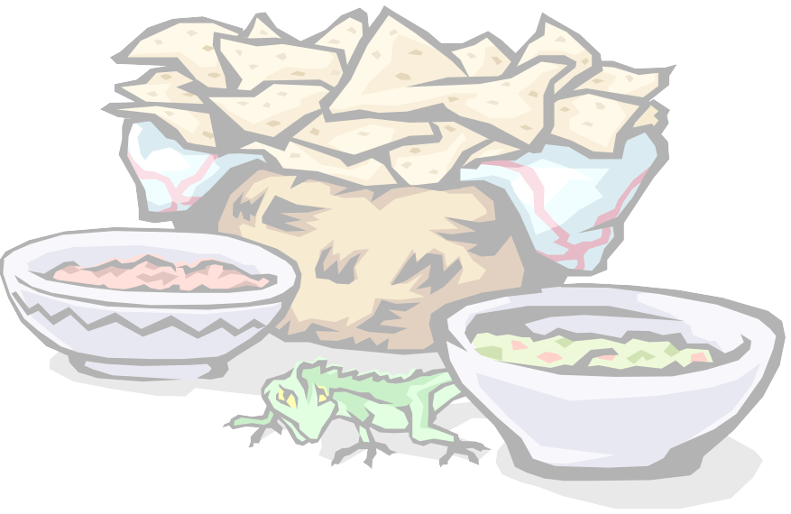
- Tortilla Chips and Salsa..................................................................... $3.00
- Fresh Fruit Tray (varies per season)...................................................... $3.50
- Fresh Veggie Tray (varies per season) Ranch dip included........................... $3.50
- Chili & Cheese Nachos...................................................................... $5.00
Top with beef or chicken fajita – additional $3.00 per person

- Hot Dog.............................................................................................. $2.00
- Popcorn.............................................................................................. $1.50
- Cheese & Cracker Tray......................................................................$4.00
- Fruit & Cheese Tray...........................................................................$6.00
- Deli Meat Tray (ham, turkey, salami & crackers).....................................$6.00

DESSERTS
~ Prices are quoted per person ~

- Cheescake (Turtle, New York, Strawberry Topping available).......................... $3.50
- Chocolate Layer Cake........................................................................$3.50



- Fruit Filled Danishes.......................................................................... $2.00
- Freshly Baked Assorted Cookies (4oz).............................................. $2.00
- Prebaked Assorted Cookies (2 oz)..................................................... $1.00
- Brownies............................................................................................ $2.00

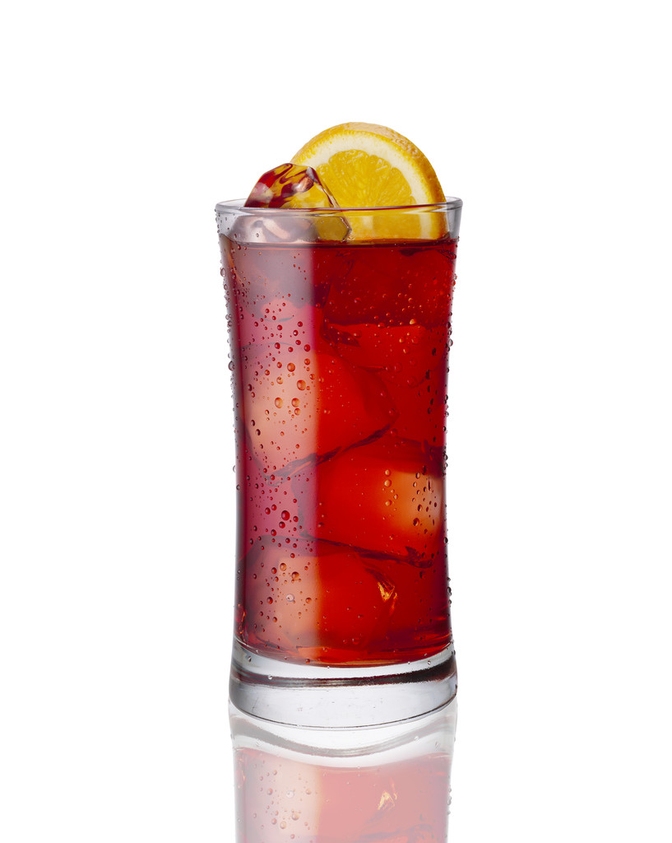
~ Prices are quoted per person ~

- Freshly Brewed Iced Tea................................................................. $1.00
- Lemonade........................................................................................ $1.00
- Fruit Punch...................................................................................... $1.50
- Orange Juice.................................................................................... $1.50
- Apple Juice...................................................................................... $2.00
- Canned Soda.................................................................................... $1.00
(Coke & Pepsi Products)
- Bottled Water (16 oz)...................................................................... $1.00
- Bottled Juices (assorted flavors)..................................................... $2.00
- Freshly Brewed Italian Coffee (Regular & Decaf)......................... $2.00

