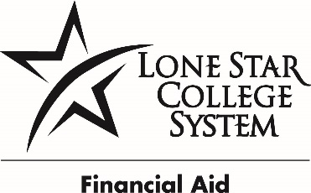
LONE STAR COLLEGE SYSTEM
COLLEGE WORK STUDY JOB DESCRIPTION

POSITION NUMBER: NH00003
JOB TITLE: Student Worker I, Call Center Specialist | College Work Study Position
DEPARTMENT: Public Relations & Community Outreach | PAY: 7.54 per/hr.
CAMPUS: LSC-North Harris | HOURS: Up to 19.5 per/wk.

POSITION SUMMARY
Provide support to Public Relations & Community Outreach Department. Under general supervision, this position will handle the switchboard during the evening hours of operation (department hours, 7:30AM-7PM). Responsibilities will include answering incoming calls as they come in to the switchboard, the Information Center, or the mini call-center (as needed). May also make copies, type “Thank You” scholarship letters, empty recycle bins, stock and hang promotional items around campus. Will work with diverse groups. May interact one-on-one with students. May interact with a high volume of customers.
PRIMARY RESPONSIBILITES
- Filing
- Copying
- Faxing
- Answering phones, taking messages, redirecting calls
- Pick up and deliver mail
- Scanning and/or shredding
- Provide general information related to the department
- Mail department information
REQUIRED QUALIFICATIONS
- High School Diploma or Equivalent
  - 0-1 year of related experience
KNOWLEDGE SKILLS AND ABILITES
  - Customer service skills
  - Interpersonal skills
  - Communication skills (written and/or oral)
  - Working knowledge of general office procedures and practices

USE OF EQUIPMENT AND MACHINERY
- Pushing or pulling carts or other such objects
- Lift objects weighing up to 20 lbs.
- Use small office equipment including copy machines or multi-line phone system
- Use computer for word processing

