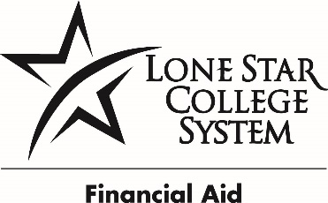
LONE STAR COLLEGE SYSTEM
COLLEGE WORK STUDY JOB DESCRIPTION

POSITION NUMBER NH0006
JOB TITLE: Student Worker I, Administrative Specialist | College Work Study Position
DEPARTMENT: Women’s Resource Center | PAY: 7.54 per hour
CAMPUS: LSC-North Harris | HOURS: up to 19.5 hours

POSITION SUMMARY
Required to provide high level information. May interact one-on-one with students. May interact with a high volume of customers. Will work with and assist diverse groups. Duties to include monitoring students checking in/out of the center, promote events, manage marketing outlets, filing, organizing, and inventory duties.
PRIMARY RESPONSIBILITES
- Filing
- Copying
- Faxing
- Answering phones, taking messages, redirecting calls
- Pick up and deliver mail
- Scanning and/or shredding
- Provide general information related to the department
- Record maintenance, preparation and review of forms, data entry
- Mail department information
- Send standardized department emails
- Provide handouts and/or forms to customers
- Maintain inventory
- Check out equipment
- Event preparation and support
- Maintain knowledge of multiple programs
REQUIRED QUALIFICATIONS
- High School Diploma or Equivalent
  - 0-1 Year experience
KNOWLEDGE SKILLS AND ABILITES
  - Customer service
  - Interpersonal skills
  - Organizational skills
  - Analytical and problem solving skills
  - Communication skills (written and/or oral)
  - Proficiency with one or more office software (Word, Excel, PowerPoint, Access)

USE OF EQUIPMENT AND MACHINERY
- Pushing or pulling carts or other such objects
- Lift objects weighing up to 20 lbs.
- Use small office equipment including copy machines or multi-line phone system
- Use computer for word processing

