
THECB (Texas Higher Education
Coordinating Board)
http://www.thecb.state.tx.us/

Texas Higher Education Accountability System– Find data for Closing the Gaps Key Measures
- Participation
- Success
- Excellence
- Institutional Effectiveness and Efficiency
- Interactive Institutional List

CIP Codes – Interactive CIP Codes Guide
Faculty Salaries – Average Faculty Salaries by Year
List of Institutions –Download lists of postsecondary institutions by category.
Course Inventory – WECM (Technical) Courses, ACGM (Academic) Courses, Academic Unique Needs Courses, Degree Programs (Clearinghouse) Awards, Texas Workforce Education (WECM)

National Community College Benchmark Project (NCCBP)

ASALFS Students Pursuing Additional Education
This report tracks students (graduates, completers and non-returners) who were enrolled in a Texas public community, state or technical college during a given academic year and were enrolled in a Texas public institution the following fall.

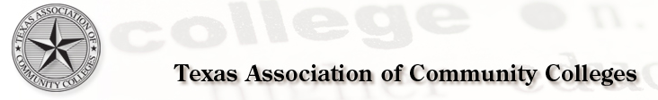

Tuition and Fee Survey
Community College Enrollment
Texas Community Colleges
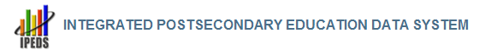
IPEDS is the primary source for data on colleges, universities, and technical and vocational postsecondary institutions in the U.S.
College Navigator – Find and compare general information for U.S. colleges and universities.

IPEDS Data Center – Look up and compare institutions by one or more variables.

Executive Peer Tool – Create comparisons between a focus institution and peer institutions using all of the data available in the printed IPEDS Data Feedback Report and additional variables from the latest collection year.

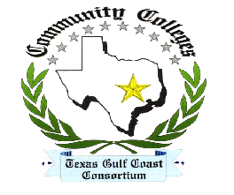
GCAIR – Gulf Coast Association for Institutional Research
This site has links to other colleges’ IR webpages.


AEIS (Academic Excellence Indicator System) – The AEIS pulls together a wide range of information on the performance of students in each school and district in Texas.
District Reports
Campus Reports
P-16
Snapshot-School District Profiles – Find statistics such as ethnicities, drop-out rates, special needs, and economically disadvantaged.
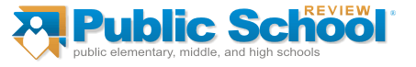
Find schools by zip code.
Enter a zip code and get a list of schools within a certain radius of that zip code (there are criteria from which to choose). Choose the desired school from the list to get the following information:
Gender, ethnicity, free lunch eligibility, migrant students and school district information.
There is also data about the zip code that the school is in, including:
Population, income, average age

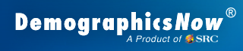
Demographic data such as gender, ethnicity and education level for geographic areas
> Geography Selection
>New Geography to set up a new dataset
> Saved Geography-Taxing Districts System-wide and each campus
Password and login are required.

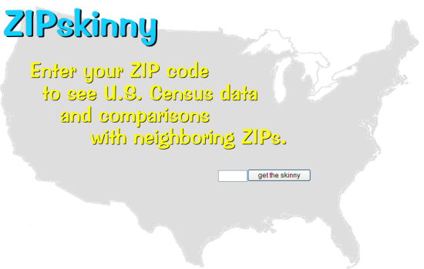
Enter 77381 or any other zip code in the box on the map.
Click on “compare 77381 with other ZIPS”.
On the next page you can enter up to 20 zip codes at a time to get demographic data for each zip entered.

