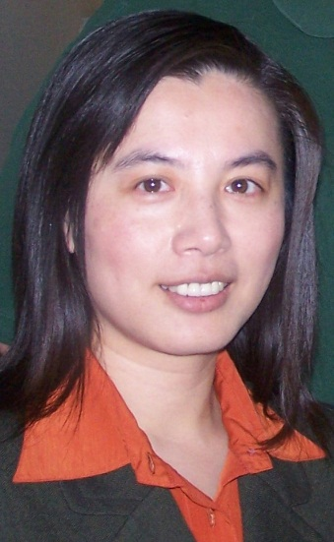
Dr. Carolyn Ho

LSC-CyFair ESOL instructor Dr. Carolyn Ho has been chosen for the 2012-2013 Fullbright U.S. Scholar Program. Ho will be teaching in her native country of Taiwan.

Ho will be working with teachers in Taiwan and training American college graduates -- also Fulbright grantees -- to teach English in a non-English environment.

Ho has been recognized for her outstanding teaching and dedication to student success as both a 2007 Faculty Excellence Award Winner and a 2009 Piper Professor nominee. Ho is also a University of Cambridge CELTA (Certificate in English Language Teaching to Adults) trainer and has volunteered with the professional organization Texas Teachers of English to Speakers of Other Languages (TexTESOL IV) as a board member and past president.

In addition, through a Faculty International Exploration Grant and in collaboration with Robert O'Brien, Ho helped develop the college system's first Study Abroad program to China in 2009. Ho has been teaching ESOL at LSC-CyFair since 2003.

Congratulations Dr. Ho!

