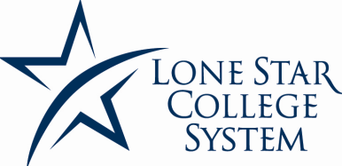
International Programs & Services
Curricular Practical Training (CPT)
Your Name: Sevis ID:
First Middle Last
Field of Study: Email:
Total credit hours required (# credit hrs) to complete program: Completed:
Completion of # of hours:
program date expected:
Date of planned internship: Begin: MM/DD/YR End: MM/DD/YR
Internship/CPT address:
Contact Person Name: Phone #:
According to the Department of Homeland Security-Immigration Services, the proposed internship must be an integral part of the established curriculum in order to be approved as CPT.
Major Requirement:
The student is required to be engaged in the proposed CPT/Internship by his/her program of studies. This requirement is published in LSCS course catalog. This internship cannot be used to fulfill open elective requirements.
# of internship credits: Course #:
Optional Course Major Requirement:
The proposed CPT is required by a specific course as an option of his/her studies and/or major. The course must be published in the LSCS course catalog and the advisor’s signature confirms that the internship course is an integral part of the student’s program.
# of internship credits: Course #:
Name of Faculty Teaching Course:
Cooperative Education Requirement:
The proposed internship is coordinated through a cooperative education agreement between LSCS and the proposed internship site and it is an integral part of the program of studies.
By signing below, I indicate that the above mention information is true based on my knowledge and information.
__________________________________________________________________________________________
(Academic Advisor or Dept Chair) (Internship Counselor)
Date Signed Date Signed
Does your department have an hrs worked credit hr equivalency?
(For Example: 75n hrs of internship work + 1 hr of internship credit)

