Chapter 2
Water and Carbon: The Chemical Basis of Life

2.1: Atoms, Ions, and Molecules: The Building Blocks of Chemical Evolution
1. 96% of living matter: hydrogen (H), carbon (C), nitrogen (N), oxygen (O)
a. element
(1) a pure substance that cannot be broken down by ordinary chemical means
(2) each element has unique chemical properties
b. atom
(1) smallest unit of matter
(2) what elements are composed of
 | LOCATION | CHARGE | MASS
Proton | Nucleus | + | 1 amu
Neutron | Nucleus | None | 1 amu
Electron | Outside nucleus | - | negligible
2. Atoms have 3 stable subatomic particles.
3. When # protons = # electrons, atom is neutral.
4. atomic number
a. # protons in nucleus of atom
- also indicates # electrons outside nucleus (in a neutral atom)
5. mass number
a. # protons plus # neutrons (mass of nucleus)
b. expressed in amu (atomic mass units; also called daltons)
- Isotopes
(1) forms of an element with different # neutrons
(2) # neutrons varies among isotopes of the same element → different atomic mass
(3) Radioactive Decay. The nuclei of some isotopes are unstable and will break down.
(a) These are radioactive isotopes (radioisotopes).
(b) Radioactive isotopes emit energy (and often a subatomic particle).
(c) Energy is detected as a form of radiation.
(d) Isotopes can be used to trace metabolic and physiologic processes.
(e) The rate of decay in a sample of radioactive isotopes is predictable.
- It is measured in half-life (the amount of time it takes for half of the radioisotope to decay.
- Uses in science determining age of some rocks and fossils; “tracers” to follow activity of an element in a cell or organism
6. An element’s unique chemical properties are determined by its number of electrons.
Remember, an element’s atomic number indicates total number of protons as well as total number of electrons (in a neutral atom).
7. Where are electrons located?
a. Electron orbitals = specific regions located outside the atomic nucleus (2 electrons/ orbital)
b. Electron shells
(1) orbitals are grouped into electron shells
(2) electron shells are numbered to show their location with respect to the nucleus
(3) 1st shell holds 2 electrons
(4) 2nd shell holds 8 electrons
8. Valence electrons
a. electrons in the outermost (valence) shell
b. Octet Rule: an atom is chemically stable when the outermost electron shell is full OR contains 8 electrons
c. valence # = number of unpaired electrons # of bonds atom will form
9. Bonding → Molecules
a. molecule = 2 or more atoms held together by attractions called bonds
NOTE: When a molecule consists of atoms of different elements, it is also called a compound.
b. Bonding occurs so that atoms achieve full valence shells maximum stability
c. 2 types of chemical bonds:
(1) covalent
(2) ionic
10. Covalent Bonding = “sharing” a pair of valence electrons
a. indicated by a solid dash in a structural formula
b. 2 types of covalent bonds
(1) type depends on electronegativity of atoms sharing electrons
electronegativity = the attraction an atom has for electrons
(2) nonpolar covalent bond = equal sharing
(3) polar covalent bond = unequal sharing
c. Single, double, triple bonds – atoms can share 1, 2 or 3 pairs of valence electrons
11. Ionic Bond
a. Ionic bonds are strong when dry but easily broken by water.
b. Ionic compounds exist in the watery bodies of organisms as anions and cations (electrolytes).
c. Ionic bond – attraction between oppositely charged ions
d. Ionic bonds are strong when dry but easily broken by water.
- Ionic compounds include acids, bases and salts.
- Ionic compounds exist in the watery bodies of organisms as anions and cations (electrolytes).

2.2: Properties of Water
1. Water a prerequisite for life
a. Cells are mostly water
(1) most cells…. 75% water
(2) humans…. 70% water
b. CHEMICAL properties of water
(1) polar molecule
(2) forms hydrogen bonds
(a) hydrogen bond – weak electrical attraction
(b) Each water molecule can form as many as 4 hydrogen bonds.
(c) Hydrogen bonds help maintain 3-D shape of various large molecules (proteins, DNA)
(d) H bonds are indicated by a dashed or dotted line
2. Unique PHYSICAL properties of water due its chemical properties: polar nature and capacity to form hydrogen bonding
a. versatile solvent
(1) Hydrophilic molecules – “water loving”
- polar important in transport of sugars for energy (in blood, sap)
- ionic includes electrolytes which are critical in muscle and nerve physiology
(2) hydrophobic molecules – “water fearing”, insoluble in water
Nonpolar no charge to attract water
b. Water is cohesive and adhesive.
(1) cohesion – binding between like molecules
- surface tension taut surface of water; result – belly flop tiny animals walking on water, skipping rocks, water beading up
- buoyant support resistance & support of water; result – boats float, organisms swim
(2) adhesion – binding between unlike molecules
(a) water will bind to any material that has charge.
(b) adhesion of water to glass + cohesion of water formation of a meniscus
c. Water is LESS dense as a solid than as a liquid.
(1) In solid water (ice), each H₂O forms 4 H bonds, resulting in a crystal with a lot of space compared to that of liquid water.
Therefore, water expands as it freezes.
(2) Because ice floats, it creates a thermal blanket which insulates water habitats in winter.
- Water has a very high specific heat.
(1) heat = thermal energy
(2) specific heat = amount of energy required to raise the temperature of 1 gram of a substance by 1ºC
(3) specific heat measures the ability of a substance to absorb energy
- Water has a very high specific heat because its hydrogen bonds must be broken to allow the molecules to move.
- Water resists temperature change heats up slowly and cools down slowly.
- Important for organisms living in water habitats as well as inside living things.
e. Water has a high heat of vaporization.
(1) Heat of vaporization = amount of energy required to change 1 gram of a substance from a liquid to a gas (evaporate).
(2) Allows evaporative cooling in terrestrial organisms (sweating, panting)
3. Acids and Bases
a. Water has a slight tendency to dissociate into a hydrogen ion and a hydroxide ion.
H₂O H⁺ + OH–
b. pure water is neutral [H⁺] = [OH⁻]
c. acid - donates protons to an aqueous solution so that [H+] > [OH-]
example: hydrochloric acid (HCl) HCl → H⁺ + Cl⁻
- base - removes protons from an aqueous solution so that [H+] < [OH-]
example: sodium hydroxide (NaOH) NaOH → Na⁺ +OH⁻
4. pH - measure of the concentration of hydrogen ions (protons) in solution
a. pH = - log [H⁺]
pure water
[H⁺] = 1 × 10^{–7}M = 0.0000001M
pH = 7
lemon juice
[H⁺] = 1 × 10^{–2}M = 0.01M
pH = 2

household ammonia
[H⁺] = 1 × 10^{–12}M = 0.000000000001M
pH = 2

b. pH scale is from 0.0 to 14.0 with 7.0 being neutral.
c. as pH increases, [H⁺] decreases and the solution becomes more basic.
d. as pH decreases, [H⁺] increases and the solution becomes more acidic.
e. pH scale is logarithmic — POWER of hydrogen
a change of one unit constitutes a change in the concentration of H⁺ by a factor of 10.
5. A buffer system works to minimize pH change.
a. A buffer system absorbs H⁺ when it is in excess and releases H⁺ when it has been depleted.
b. Buffer systems in living organism are important in homeostasis.
example: normal blood pH = 7.40; must stay within range of 7.35 – 7.45
c. example of a buffer system: bicarbonate-carbonic acid
If [H⁺] ↓ (pH ↑)
H₂CO₃ HCO₃⁻ + H⁺
If [H⁺] ↑ (pH ↓)
bicarbonate ion
carbonic acid

2.3: Chemical Reactions and Energy
1. Reactants are converted to products.
Na + Cl NaCl

Reactants product
- Chemical equations must be balanced.
- Most chemical reactions are reversible.
CO₂ + H₂O H₂CO₃

2. Energy = ability to do work
a. 2 states of energy
(1) potential energy
(a) stored energy
(b) energy at rest
(c) energy of position
(2) kinetic energy = energy of motion
(a) All molecules have kinetic energy because electrons of their atoms are moving.
(b) temperature - a measure of the kinetic energy of molecular motion.
b. Laws of Thermodynamics
(apply only to isolated systems – no energy or matter enters or exits)
(1) 1st Law: Conservation of Energy
(a) Energy cannot be created or destroyed
(b) Energy can be transformed (example: convert potential energy into kinetic energy, or vice versa)
(2) 2nd Law: Entropy
(a) entropy – disorder, randomness
(b) With every energy transformation, entropy increases.

3. Chemical reactions and entropy
a. exergonic reactions - spontaneous, energy is released and entropy increases
b. endergonic reactions – nonspontaneous, energy input required, entropy decreases

2.5: Importance of Organic Molecules
1. Carbon is the most versatile element found in organic (biological) molecules.
a. Each carbon atom will form four bonds with other molecules.
b. Organic molecules have a carbon “skeleton” or “backbone”.
(1) Carbon atoms can be linked in many ways.
(2) A wide variety of shapes are possible: chains & rings
2. Functional groups added to hydrocarbon skeleton lead to a variety of chemical properties.
a. hydrocarbon – chain of carbons with only hydrogens attached; nonpolar
b. functional group – specific group of atoms with a predictable “function” in a molecule due to its unique properties

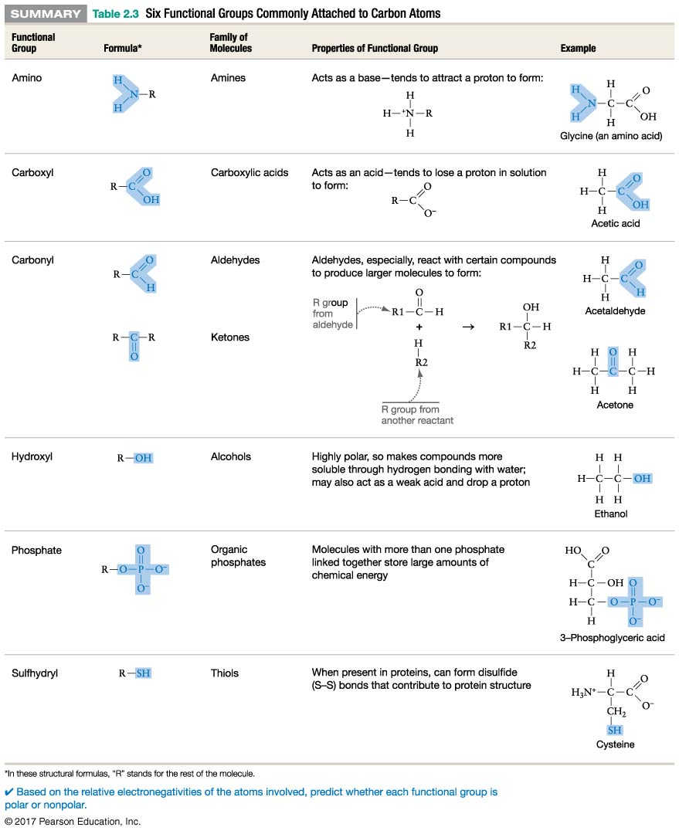

3. Small Organic Molecules Can Assemble into Large Molecules
a. Most large organic molecules (macromolecules) are made of repeating small subunits called monomers.
b. Polymerization is the process of linking monomers into polymers.
(1) condensation reaction (also called dehydration reaction) bond formation produces water molecule
(2) nonspontaneous requires energy (endothermic)
c. Polymers are broken into monomers by hydrolysis.
(1) uses 1 molecule of water for each bond broken
(2) spontaneous energetically favorable, increases entropy

