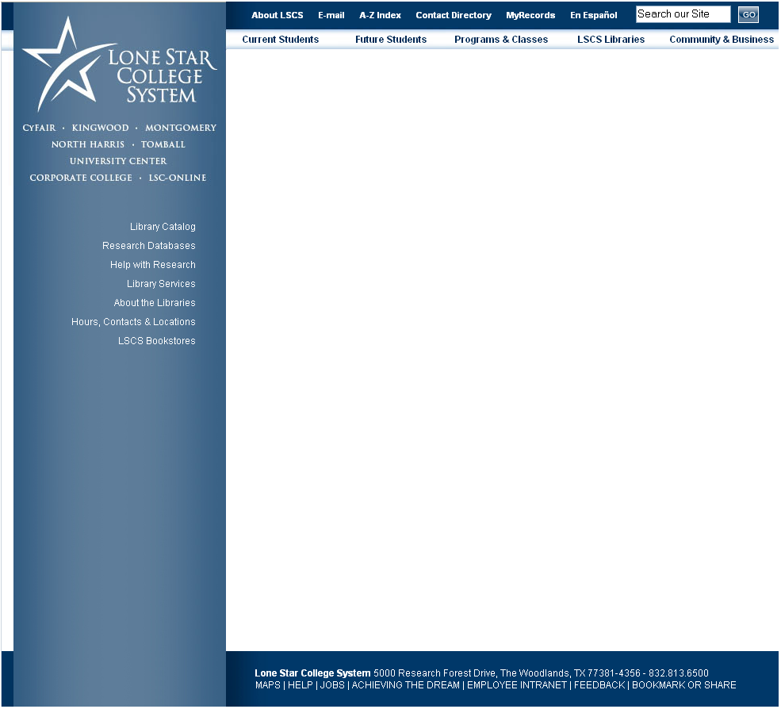
Find hours and locations for LSCS campus libraries.
Search for complete articles from magazines, journals, and newspapers, all from this link!
Go here to find books, videos, DVDs, electronic books, and more.
Look up textbooks to buy here.
See a selection of new materials at LSC-Montgomery Library.
Online students can apply for a library card here.
Learn about plagiarism and copyright here. Plus, this is the spot for help on creating citations.

