

Nursing Orientation

LSC-Montgomery Library

Gary Church
Gary.M.Church@lonestar.edu
March 2010

TABLE OF CONTENTS

Topic | Page
- Introduction ……………………………........................................... | 3
- Learning Outcomes ………………………………………................. | 3
- LSC-Montgomery Library ……………………………………………. | 3
- LSC-Montgomery Librarians ………………………………………… | 3
- Important Reminders…………………………………………………. | 4
- Myths & Misconceptions …………………………………………….. | 4
- Tour of the Library Home Page …………………………………….. | 5
- Nursing Resources from Library Home Page ................................ | 5
- Introduction to Searching Online Resources ……………………… | 5
- Searching the Online Catalog ………………………………………. | 7
- Searching the Article Databases ……………………………………. | 9
- Searching the Merck Manual Online ………………………………. | 16
- Searching Google ……………………………………………………. | 17
- Additional Websites ………………………………………………….. | 18
- Research Guides …………………………………………................. | 18
- Scholarly vs. Peer-Reviewed Journals………................................ | 19
- Online Courses ……………………………………………………….. | 19
- Career Resources…………………………………………………….. | 19

Nursing Orientation

Lone Star College–Montgomery (LSC-M)

I. Introduction: Reasons for This Handout
A. I want you to be successful!
B. I don’t have time to tell you all this.
C. You don’t have time to take detailed notes about it all either.
D. After you leave this class, you’ll have a helpful document to refer to.
E. You can apply the basic ideas in this handout to most any class you take.

II. Learning Outcomes for This Session:
After this session, the student will be able to:
- Save time doing research
- Search for books, videos, and other resources in the library
- Search for journal and magazine articles
- Use searching skills applicable to life-long learning
- Be more information literate
- Explain differences between consumer publications and scholarly publications
- Explain differences between searching article databases and searching the web with Google
- More effectively use and be less intimidated by other libraries

- The LSC–M Library
- Think of the library as “Information Headquarters,” “Information Central,” or the “Research Center.”
- Functions of Library vs. ELC (Extended Learning Center, Building C):
  - Library. The library supports and supplements the courses taught at LSC - Montgomery. This means that the library faculty members teach classes about the library’s resources and how to efficiently use them so you waste as little time as possible. It also means the library’s collection of information resources (e.g., books, journals, videos) provides additional explanations, perspectives, and details about the topics you are taught in class to help give you a broader and clearer understanding of those topics.
  - ELC. The ELC offers free tutoring, access to computer hardware and software, workshops, and professionally facilitated study groups. Tutoring and specialized computer software are offered in subjects such as allied health (e.g., nursing, radiologic technology), business, computers, math, sciences, reading, writing, and languages, including American Sign Language. Other software includes programming languages, keyboarding tutorials, and a variety of products from Microsoft, Adobe, and Macromedia.
- PLEASE NOTE: The computers in the library are for educational purposes only! Use them to work on assignments and do research.

- The LSC–M Librarians
A. Librarians are faculty members. We have to meet the same educational requirements as regular teaching faculty.
B. Each of the librarians has a master’s degree (usually an M.S.) in Library and Information Science (LIS).
C. In addition to this M.S., college and university librarians usually need a master’s degree in a second discipline.
D. Most of the full-time librarians have at least one additional master’s in disciplines such as English and biology.
E. The librarians work at the reference desk (research help), not the circulation desk (where you check out circulating materials and those on reserve, pay fines, have your new ID card activated as a library card, etc).

V. Important Reminders
A. Now is the time to build the foundation for your successful, happy future! Do it while you’re young! You’re going to move through your future much quicker than you can imagine at this point in your life!!
B. If you’re going to use a computer to write a paper, make a PowerPoint presentation, or create some other document, bring a storage device (e.g., flash drive) on which to save your work. Save often because “stuff happens”!
C. An Important Lesson to Learn: Get an early start on your assignments! Mature, serious, successful students know and apply this lesson!
D. A librarian is on duty in the reference area whenever the library is open.
E. When you come to the library, please either turn off your cell phone or put it on vibrate mode.
F. So you don’t disturb people trying to study, please make and answer cell phone calls out of the library! The patio on the south side of the library―near the newspapers, magazines, and journals―is a good place to go. It’s quiet, and you’ll have privacy and good reception.
G. Please do not eat in the library.
H. Please have a lid on any drinks you bring into the library.
I. Change for the photocopiers or print-card dispenser is available at the circulation desk.
J. Reasons you need to get your student ID activated so it serves as your library card:
- To check out books and other resources
- To request that a book or other resource in another LSCS library be sent to the LSC–M library so you can obtain it more conveniently
- To remotely access (e.g., from home or anyplace off-campus) the library’s collection of article databases.

NOTE: To activate your ID, take it to the library’s circulation desk or call 936-273-7387.

- To get to the web sites listed on this handout, enter their web address exactly as given.
- LSC–M Library Home Page = www.lonestar.edu/library

VI. Some Common Myths & Misconceptions about Information & Libraries
A. All information is not on the web. One reason is copyright restrictions.
B. You cannot locate articles in the online catalog; none are in it. SEE Part X on page 7.
C. When you search the library’s research (article) databases, you are not searching the web as you would with, say, Google. SEE Parts XI.B. on page 9 and XI.C on page 10.
D. Articles in the library’s research (article) databases provide reliable information. They are simply the electronic version of reputable magazine, journal, encyclopedia, and newspaper articles. They are the same articles as those in the paper copies of these resources.

- Tour of Library’s Home Page (www.lonestar.edu/library)

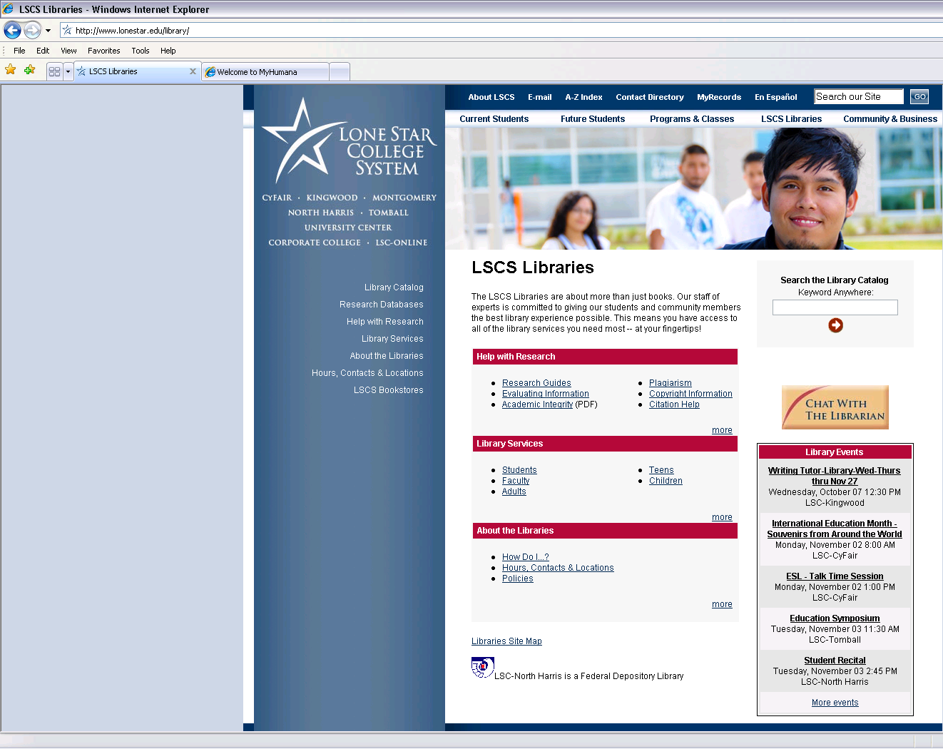

- Sample Nursing and Nursing-Related Resources (e.g., books, journals, videos, databases, good web sites)
- On the LSCS Libraries home page, under “Help with Research,” click “Research Guides.” On the next screen, click “LSC-Montgomery.” Then scroll down to and click “Anatomy & Physiology, “Biology,” “Diseases,” ”Medical Terms,” and “Nursing.”
- On these handouts, titles whose call number starts with “REF” are in the reference collection and cannot be checked out.

IX. Introduction to Searching Library Online Resources
Key Points:
A. Searching the library’s resources involves problem-solving and critical thinking.
1. Finding the information you need is a problem to solve.
2. To solve that problem, you have to think critically about the best search terms (keywords and phrases) to use.
B. Pay attention to the following search tools and tips:
1. Quotation Marks. In the online catalog (Part X) and Google (Part XIII), use quotation marks to search for a phrase. SEE search 5 on page 8 and searches 4, 6, 7, and 8 on page 17.
2. Boolean Operators. AND, OR, and NOT are Boolean operators. SEE search 7 on page 8, search 2 on page 11, and searches 4-11 on page 12.
a. AND and NOT cause retrieval of fewer results, so they narrow a search.
b. OR causes retrieval of more results, so it broadens a search. OR is useful to link synonyms together.
3. Truncation Symbol. The asterisk (*) is a truncation symbol that⎯in the sample searches⎯causes a search for results containing any word that starts with the string of letters to the left of it, and it, too, broadens a search. SEE search 10 on page 8, searches 4, 6, and 8 on page 10, and search 2 on page 14.
4. Proximity / Adjacency Operators. Near and Within are proximity operators. They are abbreviated n and w. These allow you to look for articles in which your search terms are (a) separated by a specific number of words and (b) in a certain order. SEE search 3 on page 12 and search 3 on page 13 for examples of the n operator. Proximity operators also narrow a search.
5. Nesting. For an example and brief explanation of nesting, SEE search 5 on page 12.
6. In the online catalog (Part X) and the research (article) databases (Part XI), look at Help for how to use these search techniques. Databases provided by different companies (e.g., EBSCO, Gale, ProQuest, Wilson) use different search techniques.

C. Meaning. The information you retrieve might not have the meaning you want. This can occur in at least the following two situations.
1. Using the AND Boolean Operator. Using AND in a search only ensures that the terms on both sides of it will be present in the information (e.g., journal article) you retrieve. For example, in the search dogs and bones, AND ensures that the term dogs and the term bones will be present. However, the farther apart these terms are, the less likely the meaning you want will be present. So, AND does not ensure that meaning will be present. SEE search 2 on page 11.

2. Alternative search-term meanings. Your search terms might have a meaning different from the one you intend. In other words, there might be homographs for your search term(s). A homograph is a word with the same spelling as another but with a different meaning. Examples are bear and sewer. Bear can mean “carry” or refer to the “animal.” Sewer can mean “conduit for waste” or “person who sews.”

Here’s a search that illustrates situation 2. Suppose you wanted an article that talked about Edgar Allan Poe’s fondness for alcoholic drinks. Go to the database titled Academic Search Complete. Under the light-green bar labeled “Limit your results,” click the box to the right of Full Text, type poe and alcohol in the search box at the top, then click the blue “Search” button. One of the retrieved articles is titled “Structure and rheology of semisolid o/w creams containing cetyl alcohol/non-ionic surfactant mixed emulsifier and different polymers.” Click this title and then look at the abstract. The “POE” in the abstract refers to a chemical surfactant, not the 19th-century writer.
X. Searching the Online Catalog
- To access the online catalog, click "Library Catalog" on the library's home page. See page 5.
- ATTENTION! When you access the online catalog and do a search, you are searching every library in the LSCS (i.e., all five campuses and many public libraries). If you want to search only the LSC–M Library, you must select it in the “Locations” menu as shown below.
- The online catalog is also called the library catalog and the OPAC (Online Public-Access Catalog).
- The online catalog is simply the computerized version of a card catalog. As with a card catalog, you can do Author, Title, and Subject searches, as well as other searches you cannot do with a card catalog.
- Use the online catalog to find books, videos, magazines, journals, newspapers, and other information containers in LSCS libraries.
- EXTRA IMPORTANT! You cannot use the online catalog to find journal, magazine, newspaper, or encyclopedia articles; use Article Databases to find articles (SEE Part XI on page 9).
- Record means the information about a book or other item retrieved with a search of the catalog. It’s the same information on a card-catalog card (e.g., title, author, publisher, publication date, subjects).
- When you click a retrieved item’s title to see its record, look over on the left and note its Subjects. Notice that each Subject is a hyperlink. If you click one of the Subjects, you’ll retrieve every item in all LSCS libraries that is about that Subject.

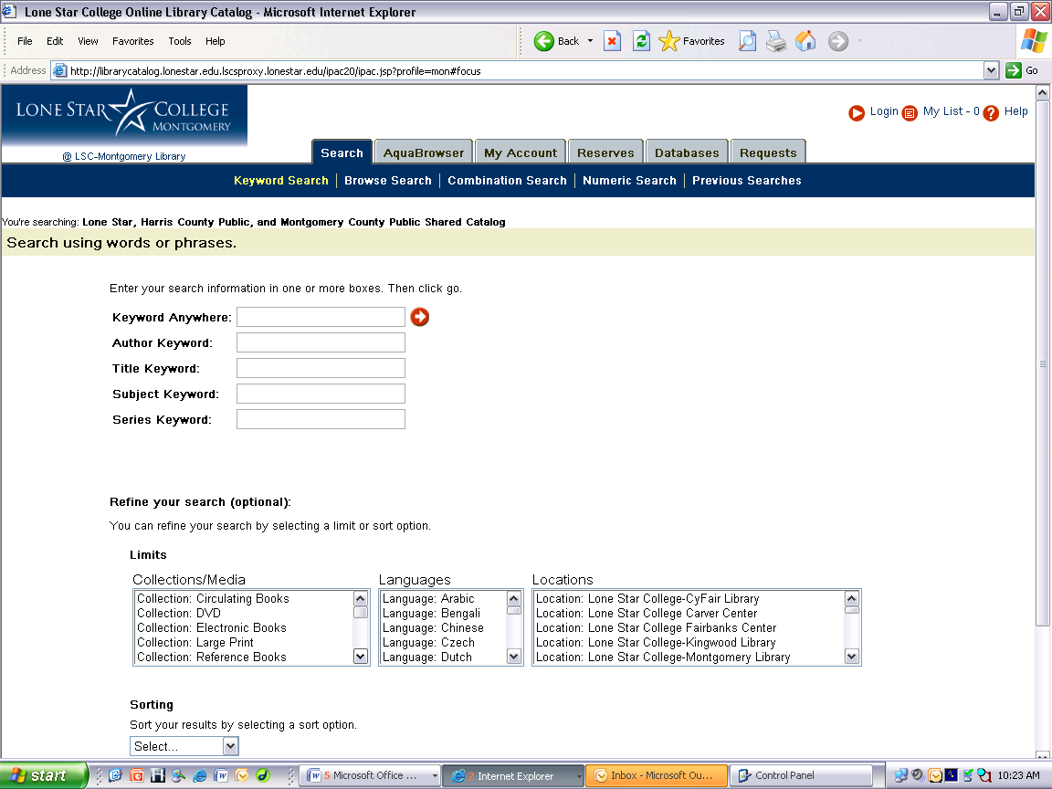
Select Lone Star College – Montgomery Library

SAMPLE SEARCHES: Searches are followed by brief explanations.
NOTE: In the following searches,
- “Limit to LSC – M Library” means to search only the LSC–M Library.
- Keyword means a main concept, not little words such as the, of, it, in, on, as, is, at, and so on.
- You will not retrieve the complete item (i.e., book, video, journal). You will only retrieve its record.

Browse Search
1. Subject Browse = nervous system diseases
This search retrieves lists of subjects you can browse related to nervous system diseases and indicates the number of titles (books, videos, etc.) about each subject in all LSCS libraries, not just the LSC–M Library.

Video Search
2. Limit to LSC–M Library. Keyword Anywhere = videorecording epilepsy
This search looks for videorecordings with epilepsy someplace in their record.

Author Search
3. Limit to LSC–M Library. Author Keyword = sally redfern
This search looks for items written by an author named Sally Redfern.

Subject Search
4. Limit to LSC–M Library. Subject Keyword = alzheimer’s disease
This search looks for items whose subject contains Alzheimer’s and disease (not necessarily the phrase).

Title Search
- Limit to LSC–M Library. Title Keyword = “dosage calculation” nurses
This search uses quotes to look for items whose title (or the Contents part of their record) contains the phrase dosage calculation and the word nurses.

Subject Search
6. Limit to LSC–M Library. Subject Keyword = nursing
This search looks for items whose subject contains nursing.

Combination Search: Keyword Anywhere & Subject Keyword
7. Limit to LSC–M Library. Keyword Anywhere = injections or medications and Subject Keyword = nursing
This search uses the Boolean OR operator to look for items with injections or medications someplace in their record and with nursing in their subject.

Journal or Magazine Search to find out what journals / magazines the library has on the shelves
8. Limit to LSC–M Library. Subject Keyword = periodicals nursing
This search looks for items (i.e., journals, magazines, other periodicals) whose subject contains periodicals and nursing. NOTE: This search does not retrieve journal and magazine articles. It simply tells you the journals, magazines, and other periodicals the library has about nursing, such as Critical Care Nursing Quarterly, Home Healthcare Nurse, and Nursing Management.

More Searches…
9. Limit to LSC–M Library. Keyword Anywhere = patient care
This search looks for items that contain patient and care (not necessarily the phrase) somewhere in their record.

- Limit to LSC–M Library. Keyword Anywhere = nurse*
This search uses the * truncation symbol to look for items that contain any word starting with n-u-r-s-e (e.g., nurse, nurses) someplace in their record. Note that n-u-r-s-e is the longest string of initial characters these two words have in common.

11. Limit to LSC–M Library. Title Keyword = muscular dystrophy
This search looks for items whose title (or the Contents part of their record) contains muscular and dystrophy (not necessarily the phrase). Since only one item is retrieved, try the next search.

12. Search all LSCS libraries. NOTE: To remove the LSC–M Library Location Limit, hold down the Ctrl key and click “Location: Lone Star College – Montgomery Library.”
Title Keyword = muscular dystrophy
This search, too, looks for items whose title (or the Contents part of their record) contains muscular and dystrophy. NOTE: You can request that books (except ebooks) at other LSCS libraries be sent to the LSC–M library.

XI. Searching the Research (Article) Databases
- To access the databases, click "Research Databases" on the LSCS Libraries home page. On the next screen, you’ll see a subject arrangement of the databases and “Find Databases by Title.” Click a subject to access a list of databases that pertain to that subject.

- SEE the database titled “A-Z List of LSCS’s Electronic Journals.” This database tells you which article databases contain full-text (complete) articles from the journals and magazines that the LSCS libraries subscribe to, the ones they have sitting on their shelves.
- Use databases to find electronic versions of reputable magazine, journal, newspaper, and encyclopedia articles.
- An article in a magazine or journal issue is more or less analogous to a chapter in a book.
- To search the databases, use keywords, not natural language. Keyword means a main concept, not little words such as the, of, at, in, is, on, it, and so on. Natural language means normal, everyday speech, such as, “How many Americans do not have health insurance?”

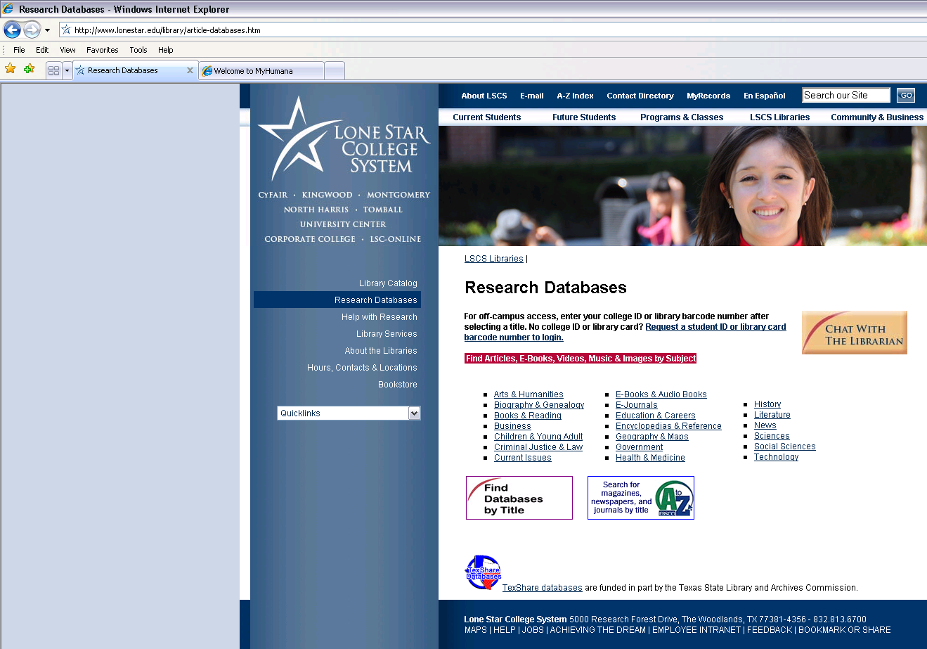

- Differences between consumer publications (popular magazines) and scholarly or peer-reviewed journals (ALSO SEE part XVI on page 19):
1. Advertisements. Consumer publications usually contain more.
2. Complexity of language. The language in journals is typically more complex than the language in consumer publications.
3. Audience (who the publication is aimed at). Consumer publications are aimed at the general public; journals are aimed at subject specialists.
4. Circulation (number of subscribers). Consumer publications generally have more subscribers.
5. Article structure. Scholarly articles typically have sections such as abstract, introduction, literature review, methods, results, conclusions, suggestions for further research, and bibliography. Consumer articles typically lack these sections.
6. References / bibliography at end of articles. Consumer publications typically lack these.
- Differences between searching library databases and searching the web with the Google search engine:
1. When you search the library’s article databases, you are not searching the (“visible”) web.
2. Google does not search the library’s article databases.
3. The techniques you can use to search article databases are much more sophisticated than Google’s.
4. Databases contain authoritative, accurate, reliable information written by people who know what they’re talking about. This is not always the case with information you retrieve with Google.
5. The results from Google and other search engines include sites that paid a fee to be included. This is not the case for the results of a library database search. See this site:
searchenginewatch.com/webmasters/article.php/2167941
- Access to databases is restricted to specific people by legally binding contracts. This is not true for Google.
- Information in databases is mainly on the “invisible” web (“invisible” to tools like Google).

NOTE: All information is not on the (visible) web (e.g., due to copyright restrictions)!

C. For information about the invisible or “deep” web, see:
1. The U.C. Berkeley Library (www.lib.berkeley.edu/TeachingLib/Guides/Internet/InvisibleWeb.html)
2. The Deep Web White Paper (www.brightplanet.com/images/uploads/DeepWebWhitePaper_20091015.pdf)
- CompletePlanet: The Deep Web Directory (aip.completeplanet.com/)

D. Accessing Article Databases from Home (or anywhere off-campus)

1. For help accessing the databases from home, go to this link: library.lonestar.edu/help.htm

2. If you’re off campus when you select a database to use, you will not go directly to it. Instead, you’ll see the screen below. At this screen, enter your library-card barcode number, the number that starts with 23136 on the back of the card. When you click the Login button, you should end up at the database you selected.

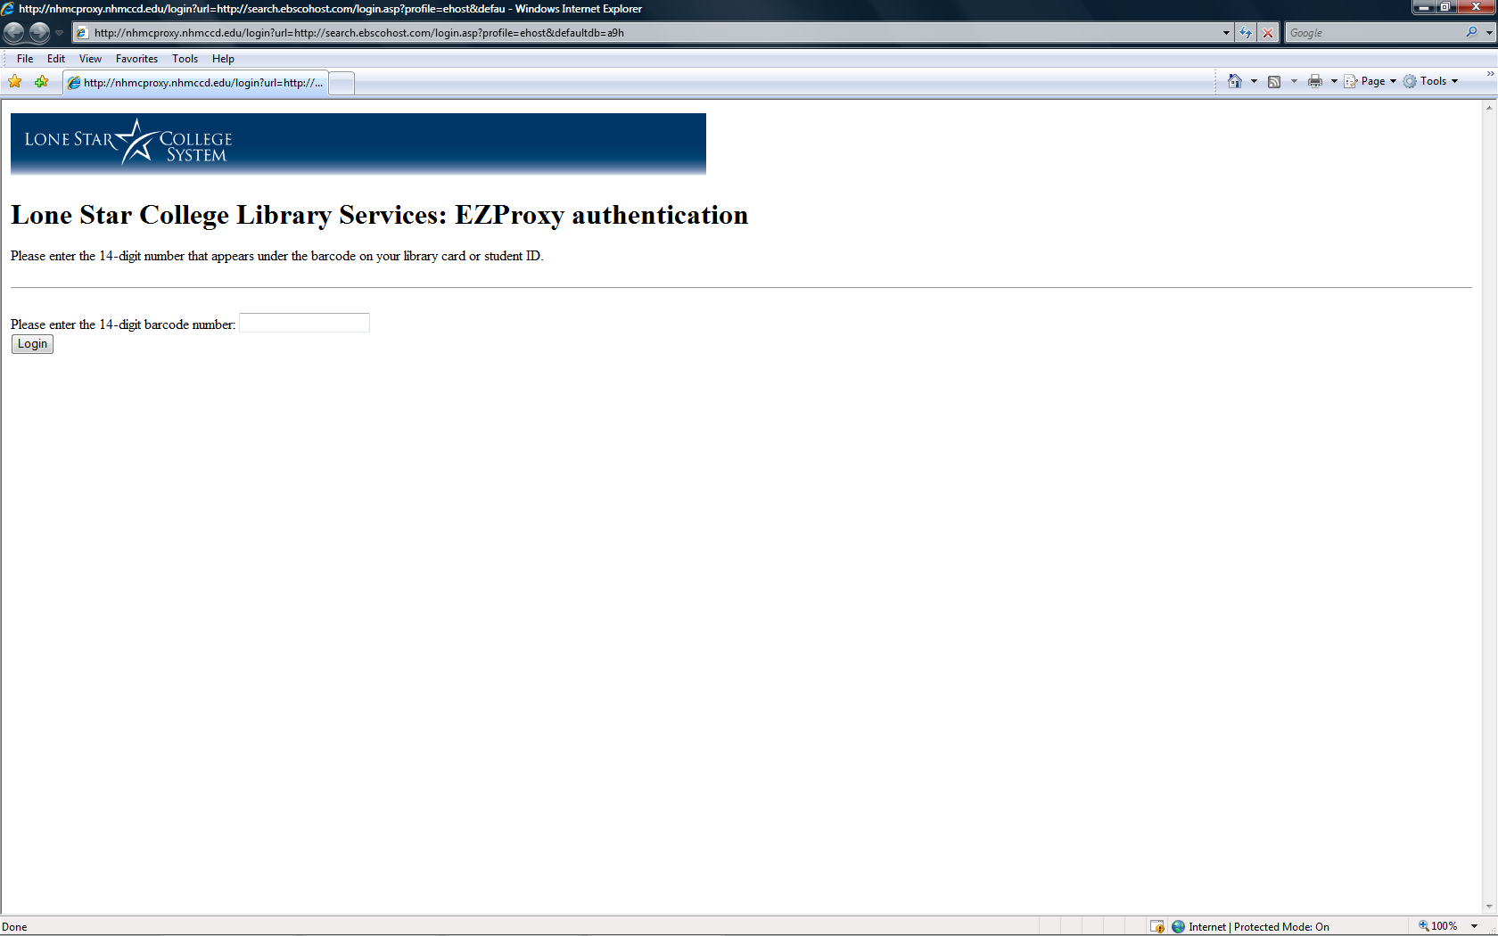
Type your barcode number into this box and then click Login.

E. Database Titles = Academic Search Complete, Health Source: Consumer Edition, Health Source: Nursing/Academic Edition (all from EBSCO)
NOTE:
- For help searching these databases, click “Help” in the upper-right corner of the screen. Then, in the far-left column under “Searching,” pay particular attention to “Booleans,” “Field Codes,” “Proximity Searches,” and “Wildcard and Truncation Symbols.”
- Here are some sample field codes and what they stand for:
ab = abstract (summary) of article
au = author
jn = journal name. SEE search 11 on page 12 and search 3 on page 15.
su = subject of article. SEE search 11 on page 12.
ti = title of article. SEE searches 9 and 10 on page 12.
- For a list of the publications from which articles were taken to compile each of these databases, click “Publications” in the blue bar across the top of the screen. You can search or browse the list.
- To retrieve complete articles (not just citations and abstracts), look below the light-green bar labeled “Limit your results” and click the box after “Full Text.”
- To retrieve articles from scholarly (peer-reviewed, refereed) publications, look below the light-green bar labeled “Limit your results” and click the box after “Scholarly (Peer Reviewed) Journals.” For an explanation of scholarly and peer-reviewed publications, see XVI on page 19.

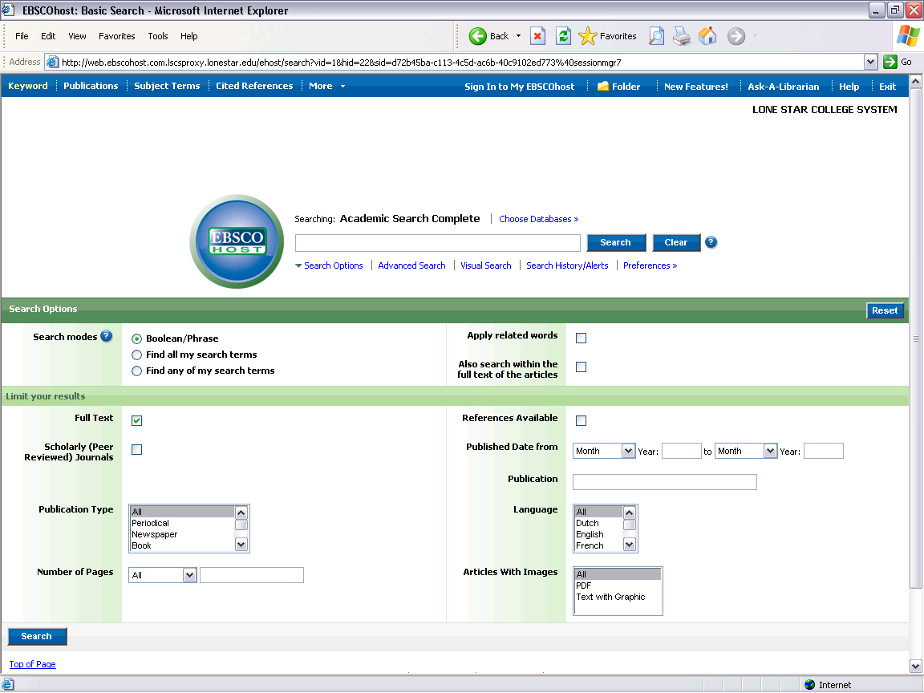
Check to retrieve
only scholarly articles.
Choose other EBSCO databases here.
Type your search in this box.
Check to retrieve only
complete articles.

SAMPLE SEARCHES: Searches are followed by brief explanations.
1. epilepsy
This search looks for articles containing epilepsy.

2. epilepsy and treatment
This search looks for articles containing epilepsy and treatment. AND is a Boolean operator that forces both search terms to be someplace in the retrieved articles, possibly pages apart. Consequently, the article might not have the meaning you’re looking for. For a way around this problem, see the next search.

3. epilepsy n5 treatment
This search uses the near proximity operator to look for articles containing epilepsy near treatment and with no more than 5 words between them. Since the words are closer together, the article is more likely to have the meaning you want. NOTE: The 5 can be any number, but the bigger the number, the more the search becomes similar to one using the Boolean AND operator. So, you wouldn’t want to use a number as large as, say, 1000. If you get no results with the number you use, make the number larger.

4. epilepsy and treat*
This search uses the * truncation symbol to look for articles containing epilepsy and any word starting with t-r-e-a-t (e.g., treat, treats, treated, treating, treatment, treatments). Note that t-r-e-a-t is the longest string of initial letters that these six words have in common.

5. epilepsy and (causes or symptoms or treatment)
In addition to the Boolean AND operator, this search uses the Boolean OR operator to look for articles containing epilepsy and either causes, symptoms, or treatment (at least one of these three terms must be present). NOTE: The use of parentheses in this search is called nesting. First, a set of articles is retrieved that contain at least one of the terms in parentheses. Then, this set is searched to create a second set of articles that also contain the word epilepsy. This second set is then displayed on the monitor for you. ALSO NOTE: Searches a and b below are not the same as search 5. See if you understand why.
a. (epilepsy and causes) or (symptoms or treatment)
b. epilepsy and (causes or symptoms) and treatment

6. epilep* and (cause* or symptom* or treat*)
This is a variation of search 5 using the * truncation symbol to broaden the search.

7. neuromuscular diseases not muscular dystrophy
This search uses the Boolean NOT operator to look for articles containing neuromuscular diseases, but not muscular dystrophy. No articles are retrieved that contain muscular dystrophy.

8. dyslexi* not (pediatric or childhood)

9. ti aphasia and ti case study
This search looks for articles whose title contains aphasia and case study. “ti” stands for title, the article’s title.

10. ti (dementia or delirium or alzheimers or alzheimer’s) and ti case study

11. su autism and jn lancet
This search looks for articles whose subject is autism, and all the articles are from the journal The Lancet. “jn” stands for journal name.

F. Database Title = Health Reference Center – Academic
NOTE:
- The “BROWSE PUBLICATIONS” link takes you to the publications from which articles were taken to compile this database.
- To retrieve complete articles (not just citations and abstracts), look below “Limit Results:” and click the box by “to documents with full text.”
- To retrieve articles from scholarly (i.e., peer-reviewed, refereed) publications, look below “Limit Results:” and click the box by “to peer-reviewed publications.”
- Click “AVANCED SEARCH” or “More search options” to get to the advanced-search screen.
- At the “Advanced Search” screen, click “Search Tips” to get tips on how to use this database.
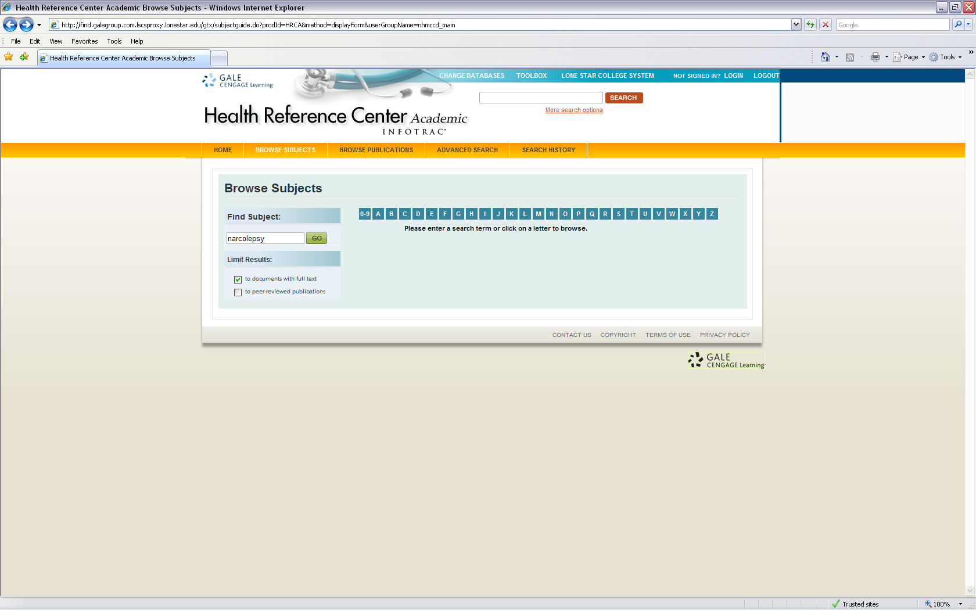

SAMPLE SEARCHES: Searches are followed by brief explanations.
Browse Subjects:
1. narcolepsy
In the results screen, notice the “RELATED SUBJECTS” link to the right of “Narcolepsy.” Also notice “View Subdivisions” below “Narcolepsy.” If you click “View Subdivisions,” you’ll see several categories into which the retrieved articles have been grouped. The number to the right of each category is the number of articles in that category.

Advanced Search:
Note: For searches 2-4, notice the options and their abbreviations in the three drop-down menus in the light-blue “Advanced Search” box. For searches 2 and 3, select Abstract (ab) from the first drop-down menu, then type the search in the box to the left.

- migraine and treatment
This search uses the Boolean AND operator to look for articles that contain the two search terms someplace in article abstracts (summaries).

- migraine n5 treatment
This search uses the near proximity operator to look for articles in which the search terms are no more than 5 words apart in article abstracts.

- In this search, select Publication Title (pu) and Keyword (ke) from the first two drop-down menus on the right, then type the search terms in the boxes to the left.
Publication Title = lancet
AND Keyword = sudden infant death syndrome
This search looks for articles that contain sudden infant death syndrome, and the articles must be from the British medical journal The Lancet.

- Database Title = Health & Wellness Resource Center (from Gale Cengage Learning)
NOTE:
- For help searching this database, click “Help” or “Search Tips” in the green bar at the top of the screen. Also notice the “Guided Tour” in this same bar.
- For a list of the publications from which articles were taken to compile this database, click “List of Sources” in the green bar at the top of the screen.
- To retrieve complete articles (not just citations and abstracts), click the box to the left of “Full text articles” below the small, green search box.
- To retrieve articles from scholarly (i.e., peer-reviewed, refereed) publications, click the box to the left of “Refereed publications” below the small, green search box.
- Notice the various sources of information (e.g., “Diseases & Conditions,” “Drug & Herb Remedies,” “Dictionary”) and other types of searches (e.g., “Drug or Herbal Remedy Name” and “Symptoms”).
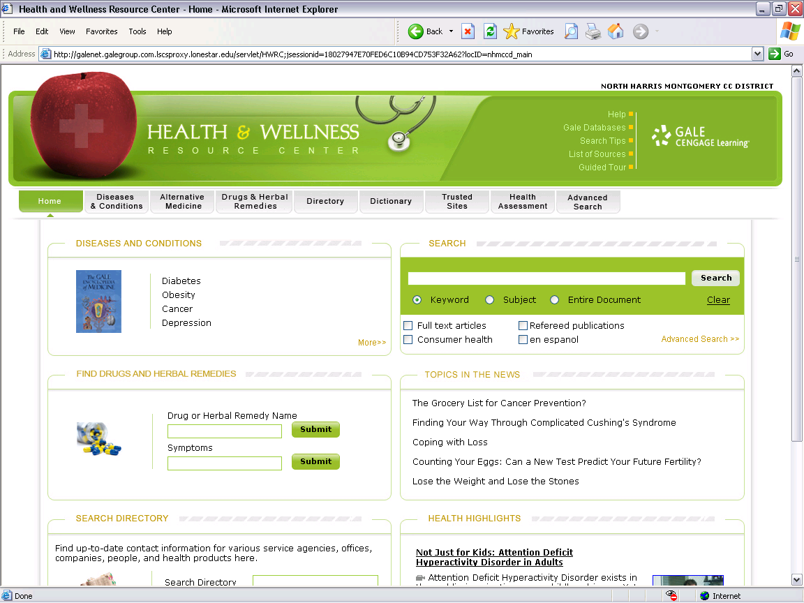
Check boxes to retrieve
only complete and/or
scholarly articles.

SAMPLE SEARCHES:
Basic Searches:
  - nursing shortage

  - nurse* and overtime

Advanced Searches:
- care in Keyword AND journal of diabetes nursing in Publication Name (click the drop-down menu to see this option). Also, below “Limit the current search,” click the appropriate boxes (e.g., Full text articles, Refereed publications).

- diabetes in Article Title/Headline AND diet* in Article Title/Headline

- For Newspaper Articles, use one or more of these databases:

- Historical New York Times (full-text back to 1859)

- Houston Chronicle

- Proquest Regional Newspapers (includes Wall Street Journal, New York Times, Los Angeles Times, Washington Post, Christian Science Monitor, and Houston Chronicle)

- Wall Street Journal

XII. Searching The Merck Manual Online (www.merck.com/mmpe/index.html)
NOTE:
- This resource provides symptoms, causes, treatments, and so on for many diseases.
- You can search or browse the manual.
- “Index,” “Sections,” and “Symptoms.”
- Under “Sections,” click “Neurologic Disorders” and browse the various illnesses.
- Paper copies of the manual are in the library’s reference collection (call number REF RC 55 .M4 2006)

SAMPLE SEARCHES:
- SIDS

- horner’s syndrome

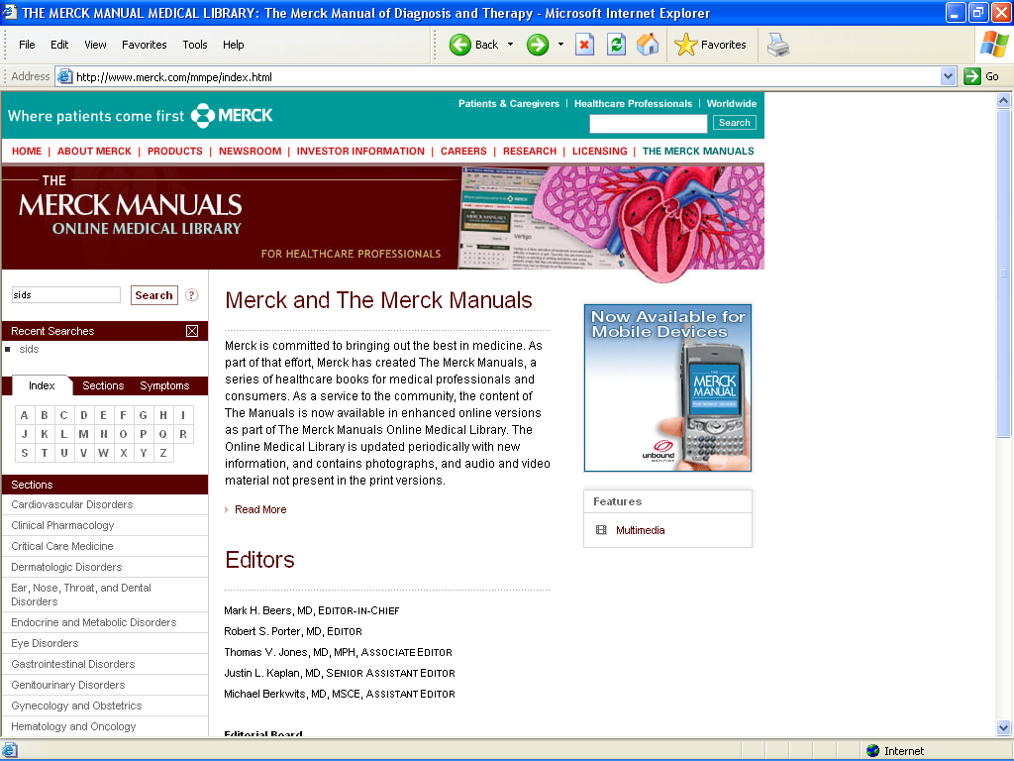
Scroll down to see all sections of the manual.
XIII. Searching the Google Search Engine (www.google.com/)
NOTE:
- The Google Directory (directory.google.com/) and Yahoo! are searchable directories, not search engines. A true search engine has no directory associated with it and can only be searched, not browsed.
- Notice the “more »,” “Advanced Search,” “Preferences,” and “Language Tools” links.

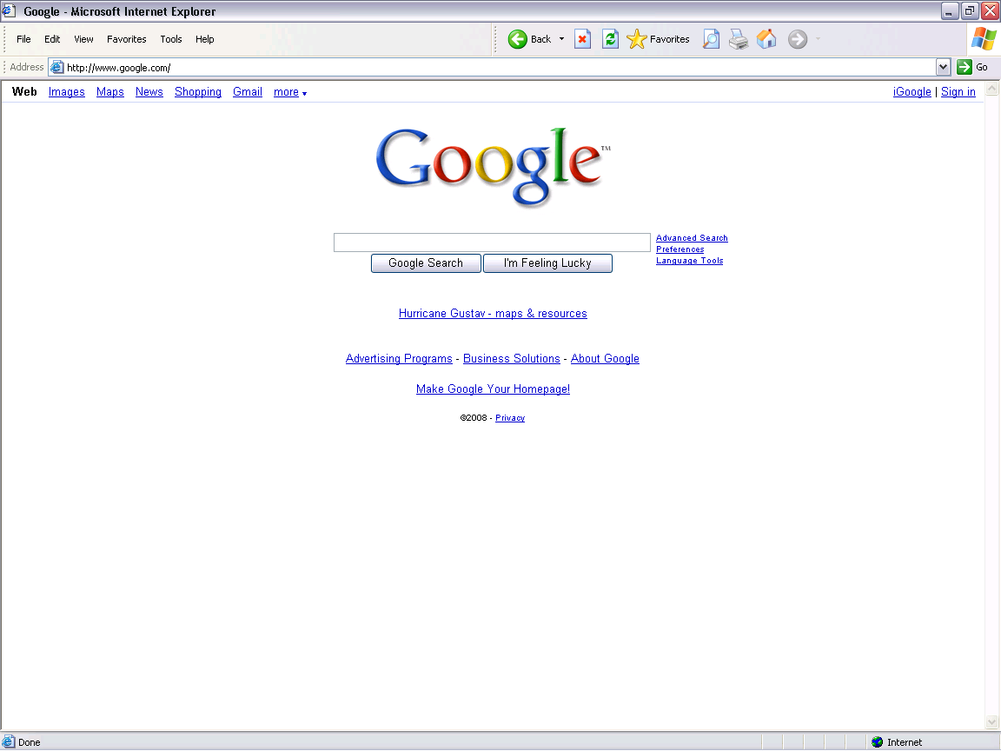

SAMPLE SEARCHES:
1. dolphins
This search for sites about the mammal looks for any site containing the word dolphins. Consequently, it will look for sites about the Miami Dolphins football team. To eliminate those sites, do the next search.
2. dolphins –football –nfl
The minus sign is equivalent to the Boolean NOT operator (SEE searches 7 and 8 on page 12.). In this search, sites containing either football or nfl will not be retrieved.
- define:als
This search looks for definitions of ALS, commonly known as Lou Gehrig’s Disease.
- define:“stem cells”
This search looks for definitions of the phrase stem cells.
- bird flu
This search looks for sites containing the words (not necessarily the phrase) bird and flu. Notice the number of results.
6. “bird flu”
This search looks for sites that contain the phrase bird flu. Notice the number of results.
7. “bird flu” “avian influenza”
This search looks for sites containing the phrase bird flu and the phrase avian influenza.
- “avian influenza” vaccine site:.edu
This search looks for sites containing the phrase avian influenza and the word vaccine, and all retrieved sites will be from the .edu domain.
- "avian influenza" “migrating birds” site:www.cidrap.umn.edu/
This search looks for sites that contain the phrase avian influenza and the phrase migrating birds, and all the sites will be from the University of Minnesota’s Center for Infectious Disease Research & Policy (CIDRAP). NOTE: The drawback of this technique is that you have to know the site’s web address. However, this search technique is good for sites that do not have a built-in search feature.
XIV. Additional Web Sites & Documents
- Landmarks Citation Machine (www.citationmachine.net)
- Purdue University’s Online Writing Lab (owl.english.purdue.edu/)
- Evaluating Information from the Web
  - On the library’s home page, click “Research Guides” under “Help with Research.” On the next screen, click “LSC-Montgomery.” Then, scroll down to the “E” and click “Evaluating Web Resources.” To score a particular web site, go to “Evaluating Information Checklist” (www.lonestar.edu/library/15264.htm).
  - University System of Georgia (www.usg.edu/galileo/skills/unit07/internet07_08.phtml)
- Plagiarism
  - On the library’s home page, under “Help with Research,” click “Plagiarism.”
  - University System of Georgia (www.usg.edu/galileo/skills/unit08/credit08_03.phtml)
- Citing Sources of Information (from the University System of Georgia)
  - Why Should You Cite? (www.usg.edu/galileo/skills/unit08/credit08_02.phtml)
  - Common Knowledge: What You Don’t Have to Cite (www.usg.edu/galileo/skills/unit08/credit08_04.phtml)
  - Citations: Where Did You Get That Information? (www.usg.edu/galileo/skills/unit08/credit08_05.phtml)
  - Style Manuals (www.usg.edu/galileo/skills/unit08/credit08_06.phtml)
  - The Styles: A Brief Showcase (www.usg.edu/galileo/skills/unit08/credit08_07.phtml)
  - Where You Give Credit (www.usg.edu/galileo/skills/unit08/credit08_08.phtml)
- Copyright (from the University System of Georgia)
  - Copyright Law: What Is It? (www.usg.edu/galileo/skills/unit08/credit08_09.phtml)
  - Public Domain (www.usg.edu/galileo/skills/unit08/credit08_10.phtml)
  - Fair Use: The Reasonable Limits of Copyright Protection (www.usg.edu/galileo/skills/unit08/credit08_11.phtml)
- TexShare Card Program (www.texshare.edu/programs/card/index.html)
- Nursing- and Health-Related Web Sites
  - Oncology Nursing Society (www.ons.org/)
  - National Association of Pediatric Nurse Practitioners (www.napnap.org/)
  - American Nurses Association (www.nursingworld.org/)
  - American Cancer Society (www.cancer.org/)
  - American Heart Association (www.americanheart.org/)
  - American Diabetes Association (www.diabetes.org/)
  - National Library of Medicine (www.nlm.nih.gov/)
  - Drug Digest (www.drugdigest.com/)
  - Drugs@FDA (www.accessdata.fda.gov/scripts/cder/drugsatfda/)
  - PDRhealth (www.pdrhealth.com/)
  - Clinical Trials (www.clinicaltrials.gov/)
- Some nursing and health portals, or gateways
  - The Librarians’ Internet Index’s Health and Medical Sciences section (lii.org/pub/topic/health)
  - The WWW Virtual Library’s Medicine and Health section (vlib.org/Medicine)
  - Martindale’s Health Science Guide (www.martindalecenter.com/HSGuide.html)
  - Hardin MD at the University of Iowa (www.lib.uiowa.edu/hardin/md/)
  - Lippincott’s Nursing Center (www.nursingcenter.com/home/index.asp)
  - The Google Directory’s Nursing section (directory.google.com/Top/Health/Nursing/)
  - Allnurses.com (allnurses.com/)
- Using Google, see if you can find the home-page web address for the following organizations:
a. American Academy of Nursing
b. American Association of Critical-Care Nurses
c. The National Cancer Institute
d. National Institutes of Health
e. Centers for Disease Control and Prevention

XV. Research Guides
NOTE: On the LSCS Libraries home page, under “Help with Research,” click “Research Guides.” On the next screen, click “LSC-Montgomery.” Then scroll down to and click the following:
- General Information
- Library of Congress Classification System
- Anatomy & Physiology
- Biology
- Diseases
- Medical Terms
- Nursing
- Searching the Library Catalog
- Accessing Databases from Home
- Online Databases by Title
- Online Databases by Subject
- EBSCO Database Search Methods
- Searching Article Databases
- APA Bibliography Style (Print & Electronic)
- Evaluating Web Resources

XVI. Scholarly vs. Peer-Reviewed Journal Articles (taken from the database Proquest Research Library)
A. Scholarly Journal Articles. A publication is considered to be scholarly if it is authored by academics for a target audience that is mainly academic, the printed format isn't usually a glossy magazine, and it is published by a recognized society with academic goals and missions.
B. Peer-Reviewed Journal Articles. A publication is considered to be peer reviewed if its articles go through an official editorial process that involves review and approval by the author's peers (people who are experts in the same subject area.) Most (but not all) scholarly publications are peer reviewed.

XVII. Online Courses (free)
- MIT Open Courseware (from the Massachusetts Institute of Technology)
ocw.mit.edu/OcwWeb/web/home/home/index.htm
- Yale University
open.yale.edu/courses/
- The Open Coursework Consortium
ocwconsortium.org/
- iTunes University (courses from Yale University, Duke University, Stanford University, and others)
www.apple.com/education/mobile-learning/
- iUniversity
www.iuniversity.com/
- AcademicEarth: “Thousands of video lectures from the world’s top scholars”
academicearth.org/

XVIII. Career Resources
- Career Clusters (www.careerclusters.org/). See the “16 Career Clusters” link in the upper-left for details about various careers, including pertinent coursework, knowledge, and skills involved.
- CareerOneStop (www.careeronestop.org/)
- Employment Projections from the Bureau of Labor Statistics (www.bls.gov/emp/empocc1.htm)
- JobStar (www.jobstar.org/)
- Job Outlook by Education, 2006-2016. Outlook, earnings, and more for people with and without a bachelor’s degree (www.bls.gov/opub/ooq/2008/fall/art01.pdf)
- Monster College (college.monster.com/?wt.mc_n=monstertrak)
- MonsterTRAK Major-to-Career Converter (content.monstertrak.monster.ca/tools/careerconverter/)
- Monthly Labor Review Online (www.bls.gov/opub/mlr/mlrhome.htm). The November 2009 issue predicts the demand for various jobs through the year 2018. Here’s the link to that issue:
www.bls.gov/opub/mlr/2009/11/home.htm
- Occupational Outlook Quarterly Online (www.bls.gov/opub/ooq/ooqhome.htm)
- Occupational Outlook Handbook (stats.bls.gov/oco/)
- O*Net OnLine: Occupational Information Network (online.onetcenter.org/)
- Texas Ahead: Biotechnology and Life Sciences Industry Cluster
(www.texasahead.org/business/biotech_ind.html)
M. Texas Workforce Commission (www.twc.state.tx.us/).
N. Jobing.com: Your Hometown Job Board (www.jobing.com/)

GMC, March 2010

