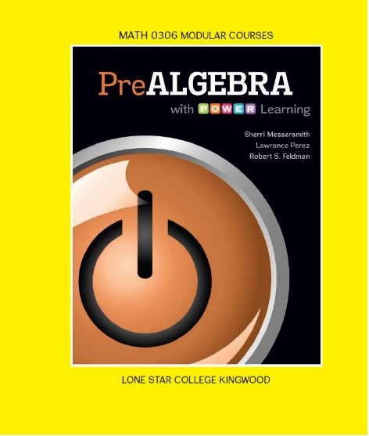
Math 0306 - PreAlgebra
PreAlgebra with P.O.W.E.R Learning

w/ ALEKS 360
Sherri Messersmith, Lawrence Perez,
and Robert S. Feldman
Paperback, McGraw-Hill; 1st edition.
Custom text for Lone Star College - Kingwood
ISBN: 9781259756238

Catalog Description:
3 Credits (3 hrs lec., 1 hr lab.) Topics for all formats include basic arithmetic operations on integers and rational numbers, order of operations, introduction to basic geometric concepts, simplification of algebraic expressions and techniques of solving simple linear equations. This course carries institutional credit but will not transfer and will not meet degree requirements. (3201045119) Prerequisite: None
Student Learning Outcomes:

The student will:
- Calculate perimeter and area of quadrilaterals, triangles, and circles. Calculate volume of rectangular solids.(ABE Level 6)
- Demonstrate basic skills in computations, estimations, order of operations and applications involving rational numbers.(ABE Level 5)
- Demonstrate basic skills in computations, estimations, order of operations, and applications involving integers.(ABE Level 5)
- Demonstrate skill using the Commutative, Associative, Distributive, and Identity Properties of Addition and Multiplications on algebraic expressions.(ABE Level 5)
- Recognize and calculate angle relationships and triangle relationships.(ABE Level 6)
- Solve linear equations in one variable.(ABE Level 5)
- Solve ratio and proportion and percent problems including applications.(ABE Level 5)

Book Sections:
Chapter 4

4.1 Introduction to Geometry
4.2 Rectangles, Squares, Parallelograms, and
Trapezoids
4.3 Triangles
4.4 Volume and Surface Area (Obj 1& 2 only)
4.5* Solving Geometry Applications Using
Algebra

Chapter 5

5.1 Reading and Writing Decimals
5.2 Rounding Decimals
5.3Adding and Subtracting Signed Decimals
5.4 Multiplying Signed Decimals
5.5 Dividing Signed Decimals and Order of
Operations
5.6 Writing Fractions as Decimals
5.7* Mean, Median, and Mode (optional)
5.8 Solving Equations Containing Decimals
5.9 Square Roots and the Pythagorean Theorem
5.10 Circles, Spheres, Cylinders, and Cones

Chapter 6

6.1 Ratios
6.2 Rates
6.3 Proportions
6.4 Solve Proportions
6.5 Solve Applications Involving Proportions
6.6 Angles
6.7 Solve Applied Problems Involving
Congruent and Similar Triangles

Chapter 8

8.1 Percents, Fractions, and Decimals
8.2 Compute Basic Percents Mentally
8.3 Use an Equation to Solve Percent Problems
8.4 Solve Applications Involving Percents
8.5* More Applications with Percent

Chapter A

A.1 Adding Whole Numbers
A.2 Subtracting Whole Numbers
A.3 Multiplying Whole Numbers
A.4 Introduction to Division and Short Division
A.5 Long Division of Whole Numbers

Chapter 1

1.1 Place Value and Rounding
1.2 Introduction to Integers
1.3 Adding Integers
1.4 Subtracting Integers
1.5 Estimating a Sum or Difference
1.6 Multiplying Integers and Estimation
1.7 Dividing Integers and Estimation
1.8 Exponents, Roots and Order of Operations

Chapter 2

2.1 Introduction to Algebra
2.2 Simplifying Expressions
2.3 Solving Linear Equations Part I
2.4 Solving Linear Equations Part II
2.5 Solving Linear Equations Part III
2.6 Solve Applied Problems Involving One
Unknown
2.7 Solve Applied Problems Involving Two
Unknowns

Chapter 3

3.1 Introduction to Signed Fractions
3.2 Writing Fractions in Lowest Terms
3.3 Multiplying and Dividing Signed Fractions
3.4 Adding and Subtracting Like Fractions and
Finding a Least Common Denominator
3.5 Adding and Subtracting Unlike Fractions
3.6 Operations with Mixed Numbers
3.7 Order Relations and Order of Operations
3.8 Solving Equations Containing Fractions

