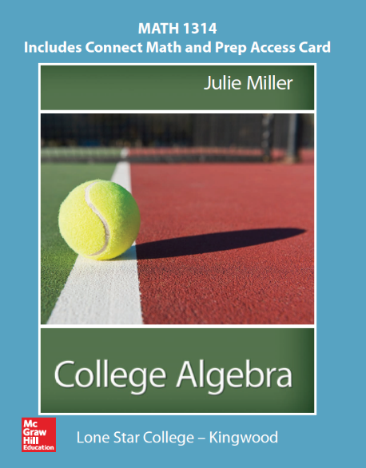
Math 1314 – College Algebra
College Algebra

Julie Miller, 1st edition
Package bundled with a ConnectMath access code card;
McGraw-Hill Publishing

ISBN-13: 978-125-9969010
(National Text ISBN 978-125-9707162)

Catalog Description:
3 Credits (3 hrs. lec.) In-depth study and applications of polynomial, rational, radical, absolute value, piecewise- defined, exponential and logarithmic functions, equations, inequalities, graphing skills and systems of equations using matrices. Additional topics such as sequences, series, probability, conics, and inverses may be included. (2701015419) Prerequisite: MATH 0310 or placement by testing.

Course Learning Outcomes:
The student will:

- Demonstrate and apply knowledge of properties of functions, including domain and range, operations, compositions, inverses and piecewise defined functions.

- Recognize, graph and apply polynomial, rational, radical, exponential, logarithmic and absolute value functions and solve related equations.

- Apply graphing techniques.

- Evaluate all roots of higher degree polynomial and rational functions.

- Recognize, solve and apply systems of linear equations using matrices.

- Solve absolute value, polynomial and rational inequalities.

Book Sections:
Chapter 1
1.1 Linear Equations and Rational Equations
1.2 Applications and Modeling with Linear Equations
1.3* Complex Numbers
1.4 Quadratic Equations
1.5 Applications of Quadratic Equations
1.6 More Equations and Applications
1.7 Linear Inequalities and Compound Inequalities
1.8 Absolute Value Equations and Inequalities
Chapter 2
2.1 The Rectangular Coordinate System and Graphing Utilities
2.3 Functions and Relations
2.4 Linear Equations in Two Variables and Linear Functions
2.5 Applications of Linear Equations and Modeling
2.6 Transformations of Graphs
2.7 Analyzing Graphs of Functions and Piecewise-Defined Functions
2.8 Algebra of Functions and Function Composition
Chapter 3
3.1 Quadratic Functions and Applications
3.2 Introduction to Polynomial Functions
3.5 Rational Functions
3.6 Polynomial and Rational Inequalities
Chapter 4
4.1 Inverse Functions
4.2 Exponential Functions
4.3 Logarithmic Functions
4.4 Properties of Logarithms
4.5 Exponential and Logarithmic Equations
4.6 Modeling with Exponential and Logarithmic Equations
Chapter 5
5.1 Systems of Linear Equations in Two Variables and Applications
5.2 Systems of Linear Equations in Three Variables and Applications
5.4 Systems of Nonlinear Equations in Two Variables
5.5 Inequalities and Systems of Inequalities in Two Variables
Chapter 6
6.1 Solving Systems of Linear Equations Using Matrices
6.2 Inconsistent Systems and Dependent Equations

