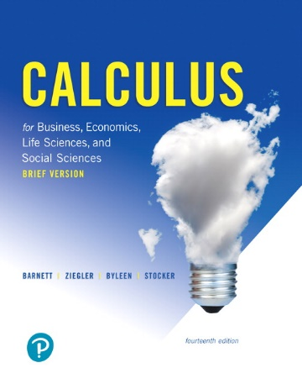
Math 1325 – Calculus for Business, Economics, Life Sciences and Social Sciences

Calculus for Business, Economics, Life Sciences, and Social Sciences, 14/e
Raymond A. Barnett, Michael R. Ziegler, and Karl Byleen
Publisher: Pearson; 14th edition
ISBN‐13: 9780134862583

Catalog Description:
A one-semester calculus course for non-science majors. Topics include limits, continuity, rates of change, differentiation and integration techniques and applications, calculus of the logarithmic and exponential functions and partial derivatives.

Course Learning Outcomes:
The student will:

- Apply calculus to solve business, economics, and social sciences problems.

- Apply appropriate differentiation techniques to obtain derivatives of various functions, including logarithmic and exponential functions.

- Solve application problems involving implicit differentiation and related rates.

- Solve optimization problems with emphasis on business and social sciences applications.

- Determine appropriate technique(s) of integration.

- Integrate functions using the method of integration by parts or substitution, as appropriate.

- Solve business, economics, and social sciences applications problems using integration techniques.

Book Sections
Chapter 1 (Review)

1.1 Functions (optional)
1.2 Graphs and Transformations (optional)
1.3 Quadratic Equations (optional)
1.4 Polynomial and Rational Functions (optional)
1.5 Exponential Functions (optional)
1.6 Logarithmic Functions (optional)

Chapter 2

2.1 Introduction to Limits
2.2 Infinite Limits and Limits at Infinity
2.3 Continuity
2.4 The Derivative
2.5 Basic Differentiation Properties
2.6 Differentials (optional)
2.7 Marginal Analysis in Business and Economics

Chapter 3

3.1 The Constant e and Continuous Interest
3.2 Derivatives of Exp and Logarithmic Functions
3.3 Derivatives of Products and Quotients
3.4 The Chain Rule
3.5 Implicit Differentiation
3.6 Related Rates
3.7 Elasticity of Demand (optional)

Chapter 4

4.1 First Derivative and Graphs
4.2 Second Derivative and Graphs
4.3 L’Hôpital’s Rule (optional)
4.4 Curve Sketching Techniques
4.5 Absolute Maxima and Minima
4.6 Optimization

Chapter 5

5.1 Anti‐derivatives and Indefinite Integrals
5.2 Integration by Substitution
5.3 Diff. Equations: Growth and Decay
5.4 The Definite Integral
5.5 The Fundamental Theorem of Calculus

Chapter 6

6.1 Area between Curves
6.2 Applications in Business and Economics
6.3 Integration by Parts

Chapter 7

7.1 Functions of Several Variables
7.2 Partial Derivatives

