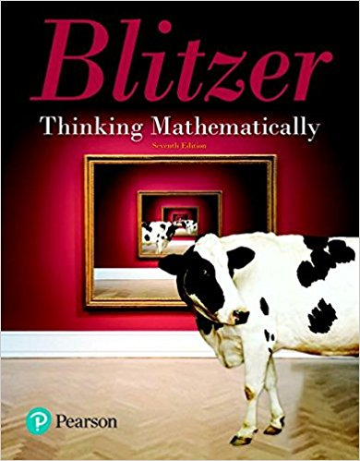
Math 1332 – College Mathematics for Liberal Arts
Thinking Mathematically, 6/E

Robert F. Blitzer, Pearson

ISBN-13: 9780135222249

Catalog Description
College Mathematics For Liberal Arts Is A Course Designed For Liberal Arts And Other Nonmathematics, Non-Science, And Nonbusiness Majors, Emphasizing An Appreciation Of The Art, History, Beauty, And Applications Of Mathematics. Topics May Include, But Are Not Limited To, Sets, Logic, Number Theory, Measurement, Geometric Concepts, And An Introduction To Probability And Statistics.

Course Learning Outcomes
The student will:

• Demonstrate A Mastery Of The Language Of Sets.
• Solve Counting Applications Using Permutation And Combinations.
• Compute Probabilities, Including Conditional Probabilities, Using Principles Of Sets And Counting.
• Identify The Use And Misuse Of Statistics In The Real World.
• Create And Interpret Various Methods Of Statistical Display.

Book Sections
Chapter 2. Set Theory
2.1 Basic Set Concepts
2.2 Subsets
2.3 Venn Diagrams and Set Operations
2.4 Set Operations and Venn Diagrams with Three Sets
2.5 Survey Problems
Chapter 3. Logic
3.1 Statements, Negations and Quantified Statements
3.2 Compound Statements and Connectives
3.3 Truth Tables for Negation, Conjunction and Disjunction
3.4 Truth Tables for the Conditional and Biconditional
3.5 Equivalent Statements and Variations of Conditional Statements
3.6 Negations of Conditional Statements and De Morgan's Laws
3.7 Arguments and Truth Tables
3.8 Arguments and Euler Diagrams
Chapter 10. Geometry
10.1 Points, Lines, Planes, and Angles
10.2 Triangles
10.3 Polygons, Perimeter, and Tessellations
10.4 Area and Circumference
Chapter 11. Counting Methods and Probability Theory
11.1 The Fundamental Counting Principle
11.2 Permutations
11.3 Combinations
11.4 Fundamentals of Probability
11.5 Probability with the Fundamental Counting Principle, Permutations and Combinations
11.6 Events Involving Not and Or, Odds
11.7 Events Involving And; Conditional Probability
Chapter 12. Statistics
12.1 Sampling, Frequency Distributions and Graphs
12.2 Measures of Central Tendency
12.3 Measures of Dispersion

