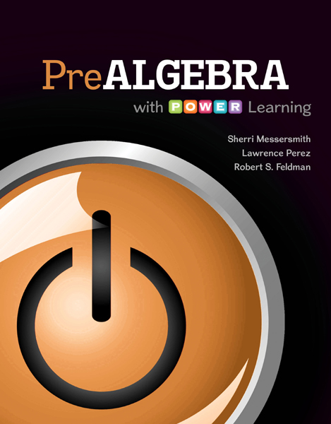
Math 0306 - PreAlgebra
PreAlgebra with P.O.W.E.R Learning

w/ConnectPlus Hosted by ALEKS
Sherri Messersmith, Lawrence Perez,
and Robert S. Feldman
Paperback, McGraw-Hill; 1st edition.
Custom text for Lone Star College - Kingwood
ISBN: 9781259569678

Catalog Description:
Topics for all formats include basic arithmetical operations on integers and rational numbers, order of operations, introduction to basic geometric concepts, simplification of algebraic expressions and techniques of solving simple linear equations. This course carries institutional credit but will not transfer and will not meet degree requirements.

Student Learning Outcomes:

The student will:
- Demonstrate basic skills in computations, estimations, order of operations, and applications involving whole numbers and decimals.
- Demonstrate basic skills in computations, estimations, order of operations, and applications involving integers.
- Demonstrate basic skills in computations, estimations, order of operations, and applications involving rational numbers.
- Perform operations using the Commutative, Associative, Distributive, and Identity Properties of Addition and Multiplication.
- Solve linear equations in one variable.
- Solve ratio and proportion and percent problems including applications.
- Recognize and Calculate angle relationships, and triangle relationships.
- Calculate perimeter and area of quadrilaterals, triangles, and circles. Calculate volume of rectangular solids.

Book Sections:
Chapter 4

4.1 Introduction to Geometry
4.2 Rectangles, Squares, Parallelograms, and
Trapezoids
4.3 Triangles
4.4 Volume and Surface Area (Obj 1& 2 only)
4.5* Solving Geometry Applications Using
Algebra

Chapter 5

5.1 Reading and Writing Decimals
5.2 Rounding Decimals
5.3Adding and Subtracting Signed Decimals
5.4 Multiplying Signed Decimals
5.5 Dividing Signed Decimals and Order of
Operations
5.6 Writing Fractions as Decimals
5.7* Mean, Median, and Mode (optional)
5.8 Solving Equations Containing Decimals
5.9 Square Roots and the Pythagorean Theorem
5.10 Circles, Spheres, Cylinders, and Cones

Chapter 6

6.1 Ratios
6.2 Rates
6.3 Proportions
6.4 Solve Proportions
6.5 Solve Applications Involving Proportions
6.6 Angles
6.7 Solve Applied Problems Involving
Congruent and Similar Triangles

Chapter 8

8.1 Percents, Fractions, and Decimals
8.2 Compute Basic Percents Mentally
8.3 Use an Equation to Solve Percent Problems
8.4 Solve Applications Involving Percents
8.5* More Applications with Percent

Chapter A

A.1 Adding Whole Numbers
A.2 Subtracting Whole Numbers
A.3 Multiplying Whole Numbers
A.4 Introduction to Division and Short Division
A.5 Long Division of Whole Numbers

Chapter 1

1.1 Place Value and Rounding
1.2 Introduction to Integers
1.3 Adding Integers
1.4 Subtracting Integers
1.5 Estimating a Sum or Difference
1.6 Multiplying Integers and Estimation
1.7 Dividing Integers and Estimation
1.8 Exponents, Roots and Order of Operations

Chapter 2

2.1 Introduction to Algebra
2.2 Simplifying Expressions
2.3 Solving Linear Equations Part I
2.4 Solving Linear Equations Part II
2.5 Solving Linear Equations Part III
2.6 Solve Applied Problems Involving One
Unknown
2.7 Solve Applied Problems Involving Two
Unknowns

Chapter 3

3.1 Introduction to Signed Fractions
3.2 Writing Fractions in Lowest Terms
3.3 Multiplying and Dividing Signed Fractions
3.4 Adding and Subtracting Like Fractions and
Finding a Least Common Denominator
3.5 Adding and Subtracting Unlike Fractions
3.6 Operations with Mixed Numbers
3.7 Order Relations and Order of Operations
3.8 Solving Equations Containing Fractions

