Math 0308 – Introductory Algebra
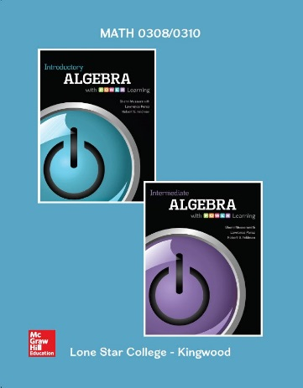
Introductory Algebra and Intermediate Algebra
with P.O.W.E.R Learning

w/ConnectPlus Hosted by ALEKS
Sherri Messersmith, Lawrence Perez, and Robert S. Feldman
Paperback, McGraw-Hill; 1st edition.
Custom text for Lone Star College - Kingwood
ISBN: 9781259413049
ISBN‐13: 9781259573941

Catalog Description:

Topics for all formats include basic algebraic operations, solving linear equations and inequalities, laws of integer exponents, factoring, rational expressions, the Cartesian coordinate system, graphing lines, finding equations of lines and solving linear systems. This course carries institutional credit but will not transfer and will not be used to meet degree requirements.

Student Learning Outcomes:

The student will:
- Solve linear equations and inequalities in one variable and compound inequalities in one variable.
- Use linear equations to solve applications.
- Sketch graphs of linear relations and determine a linear equation in two variables given pertinent information.
- Find the slope and x- and y- intercepts of a linear relation.
- Simplify expressions using definitions and laws of integer exponents.
- Add, subtract, multiply, and divide polynomials.
- Factor polynomials.
- Solve quadratic equations using the factoring method.
- Solve systems of linear equations in two variables, including applications.
- Simplify, multiply and divide rational expressions.

Book Sections:

Chapter 1
1.3 Geometry Review

Chapter 2
2.1 Solving Linear Equations Part I
2.2 Solving Linear Equations Part II
2.3 Solving Linear Equations Part III
2.4 Applications of Linear Equations
2.5* Geometry Applications and Solving Formulas
2.8 Solving Linear Inequalities in One Variable

Chapter 3
3.1 Introduction to Linear Equations in Two Variables
3.2 Graphing by Plotting Points and Finding Intercepts
3.3 The Slope of a Line
3.4 The Slope-Intercept Form of a Line
3.5 Writing an Equation of a Line

Chapter 4
4.1 Solving Systems by Graphing
4.2 Solving Systems by the Substitution Method
4.3 Solving Systems by the Elimination Method
4.4 Applications of Systems of Two Equations

Chapter 5
5.1 (Parts A and B) Basic Rules of Exponents
5.2 (Parts A and B) Integer Exponents
5.3 The Quotient Rule
5.4 Scientific Notation

Chapter 6
6.1 Addition and Subtraction of Polynomials
6.2 Multiplication of Polynomials
6.3 Dividing a Polynomial by a Monomial
6.4 Dividing a Polynomial by a Polynomial

Chapter 7
7.1 The Greatest Common Factor and Factoring by Grouping
7.2 Factoring Trinomials of the Form: x² + bx + c
7.3 Factoring Trinomials of the Form: ax² + bx + c
7.4 Factoring Special Trinomials and Binomials
7.5 Solving Quadratic Equations by Factoring
7.6 Applications of Quadratic Equations

Chapter 8
8.1 Simplifying Rational Expressions
8.2 Multiplying and Dividing Rational Expressions

