Math 0310 – Intermediate Algebra
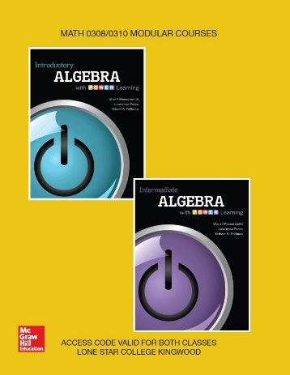
Introductory Algebra and Intermediate Algebra with P.O.W.E.R Learning

w/ ALEKS 360
Sherri Messersmith, Lawrence Perez, and Robert S. Feldman
Paperback, McGraw-Hill; 1st edition.
Custom text for Lone Star College - Kingwood
ISBN‐13: 9781259758553

Catalog Description:

Topics for all formats include basic algebraic operations, solving linear equations and inequalities, laws of integer exponents, factoring, rational expressions, the Cartesian coordinate system, graphing lines, finding equations of lines and solving linear systems. This course carries institutional credit but will not transfer and will not be used to meet degree requirements.

Student Learning Outcomes:

The student will:
- Define, represent, and perform operations on real and complex numbers.
- Recognize, understand, and analyze features of a function.
- Recognize and use algebraic (field) properties, concepts, procedures (including factoring), and
algorithms to combine, transform, and evaluate absolute value, polynomial, radical, and
rational expressions.
- Identify and solve absolute value, polynomial, radical, and rational equations.
- Identify and solve absolute value and linear inequalities.
- Model, interpret and justify mathematical ideas and concepts using multiple representations.
- Connect and use multiple strands of mathematics in situations and problems, as well as in
the study of other disciplines.
- Solve quadratic equations and applications using methods including the quadratic formula,
factoring, completing the square, and extracting roots.
Note: Some of the topics involved in reaching these outcomes may have been taught in a prerequisite course.

Book Sections:
Chapter 3
3.1. Linear Inequalities in One Variable
3.2. Compound Inequalities in One Variable
3.3. Absolute Value Equations and Inequalities

Chapter 4
4.1. Introduction to Linear Equations in Two Variables
4.2. Slope of a Line and Slope-Intercept Form
4.3. Writing an Equation of a Line
4.4. Linear and Compound Linear Inequalities in Two Variables
4.5. Introduction to Functions

Chapter 7
7.1. The Greatest Common Factor and Factoring by Grouping
7.2. Factoring Trinomials
7.3. Special Factoring Techniques
Putting It All Together
7.4. Solving Quadratic Equations by Factoring
7.5. Applications of Quadratic Equations

Chapter 8
8.1. Simplifying, Multiplying, and Dividing Rational Expressions and Functions
8.2. Adding and Subtracting Rational Expressions
8.3. Simplifying Complex Fractions
8.4. Solving Rational Equations
Putting It All Together
8.5. Applications of Rational Equations

Chapter 9
9.1. Radical Expressions and Functions
9.2. Rational Exponents
9.3. Simplifying Expressions Containing Square Roots
9.4. Simplifying Expressions Containing Higher Roots
9.5. Adding, Subtracting, and Multiplying Radicals
9.6. Dividing Radicals
Putting It All Together
9.7. Solving Radical Equations
9.8. Complex Numbers
Chapter 10
10.1. The Square Root Property and Completing the Square
10.2. The Quadratic Formula
Putting It All Together
10.3. Equations in Quadratic Form
10.4. Formulas and Applications
10.5. Quadratic Functions and Their Graphs

