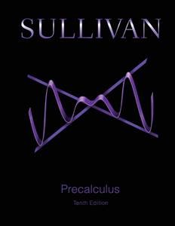
Math 1316 – Trigonometry
Textbook: PreCalculus 10/e

Michael Sullivan, Addison Wesley, 10th ed,
ISBN-10: 0134026640; ISBN-13: 978-0134026640

Catalog Description:
Trigonometric functions and their applications, solutions of right and oblique triangles, trigonometric identities and equations, inverse trigonometric functions, graphs of the trigonometric functions, vectors and polar coordinates

Course Learning Outcomes:
The student will:

- Compute the values of trigonometric functions for key angles in all quadrants of the unit circle measured in both degrees and radians.

- Compute values of the six basic inverse trigonometric functions.

- Graph trigonometric functions and their transformations.

- Prove trigonometric identities.

- Solve trigonometric equations.

- Solve right and oblique triangles.

- Use the concepts of trigonometry to solve applications.

- Compute operations of vectors.

- Represent complex numbers in trigonometric form.

Book Sections:

Chapter 6

6.1 Angles and Their Measure
6.2 Trigonometric Functions: Unit Circle Approach
6.3 Properties of the Trigonometric Functions
6.4 Graphs of the Sine and Cosine Functions
6.5 Graphs of the Tangent, Cotangent, Cosecant, and Secant Functions
6.6 Phase Shift; Sinusoidal Curve Fitting

Chapter 7

7.1 The Inverse Sine, Cosine, and Tangent Functions
7.2 The Inverse Trigonometric Functions (continued)
7.3 Trigonometric Equations
7.4 Trigonometric Identities
7.5 Sum and Difference Formulas
7.6 Double-angle and Half-Angle Formulas
7.7 Product-to-Sum and Sum-to-Product Formulas

Chapter 8

8.1 Applications Involving Right Triangles
8.2 Law of Sines
8.3 Law of Cosines
8.4 Area of a Triangle

Chapter 9

9.1 Polar Coordinates (optional)
9.2 Polar Equations and Graphs
9.3 The Complex Plane; DeMoivre’s Theorem
9.4 Vectors
9.5 The Dot Product
9.6 Vectors in Space
9.7 The Cross Product (optional)

