Math 1351 – Foundations of Mathematics II
Mathematical Reasoning for Elementary School Teacher
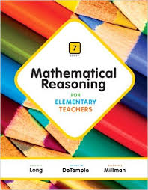
Calvin T. Long, Duane W. De Temple, Richard S. Millman
Addison Wesley; 7th edition

ISBN-13: 978-0321914743

Catalog Description:
This is designed specifically for students who seek elementary and middle school teacher certification. Topics include set theory, functions, numerations systems, number theory, emphasis on problem solving and critical thinking.

Course Learning Outcomes:
The student will:
- Explore the geometric attributes of physical objects in order to classify and to form definitions.
- Analyze spatial characteristics such as direction, orientation, and perspective.
- Connect geometric ideas to numbers and measurement.
- Use geometric models to solve problems.
- Explore and understand measurement and estimation.
- Analyze data and statistics.
- Use probability with simple and complex experiments.
- Understand surface area and volume through discovery.

Book Sections

Chapter 9
9.1 Graphical Representation of Data
9.2 Measures of Central Tendency and Variability
9.3 Statistical Inference and Sampling

Chapter 10
10.1 Empirical Probability
10.2 Principles of Counting
10.3 Permutations and Combinations
10.4 Theoretical Probability

Chapter 11
11.1 Figures in the Plane
11.2 Curves and Polygons in the Plane
11.3 Figures in Space
11.4 Networks

Chapter 12
12.1 The Measurement Process
12.2 Area and Perimeter
12.3 The Pythagorean Theorem
12.4 Surface Area and Volume

Chapter 13
13.1 Rigid Motions and Similarity Transformations
13.2 Patterns and Symmetries
13.3 Tilings and Escher-like Design

Chapter 14
14.1 Congruent Triangles
14.2 Constructing Geometric Figures
14.3 Similar Triangles

