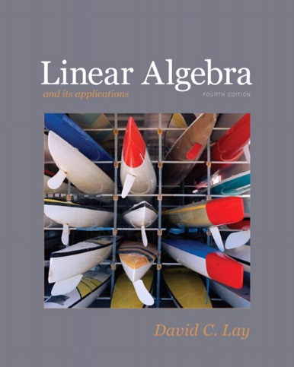
Math 2318 – Linear Algebra
Linear Algebra and Its Applications

4/E, David C. Lay, University of Maryland
2012, Pearson

ISBN13: 978-0321385178
ISBN10: 0321385179
ISBN-10: 0321399145 • ISBN-13: 9780321399144

Course Description:
Matrices and linear systems, determinants, vector spaces, linear independence, basis and dimension, change of basis, linear transformations, similarity, inner product spaces, eigenvalues and eigenvectors, and diagonalization. Applications of these concepts will also be considered.

Course Learning Outcomes:

The student will:

- Be able to solve systems of linear equations using multiple methods, including Gaussian elimination and matrix inversion.
- Be able to carry out matrix operations, including inverses and determinants.
- Demonstrate understanding of the concepts of vector space and subspace.
- Demonstrate understanding of linear independence, span, and basis.
- Be able to determine eigenvalues and eigenvectors and solve problems involving eigenvalues.
- Apply principles of matrix algebra to linear transformations.
- Demonstrate application of inner products and associated norms.
- Construct proofs using definitions and basic theorems.

Book Sections:
1.1 Systems of Linear Equations
1.2 Row Reduction and Echelon Forms
1.3 Vector Equations
1.4 The Matrix Equation Ax = b
1.5 Solution Sets of Linear Systems
1.6 Applications of Linear Systems
1.7 Linear Independence
1.8 Introduction to Linear Transformations
1.9 The Matrix of a Linear Transformation
1.10 Linear Models in Business, Science, and Engineering

2.1 Matrix Operations
2.2 The Inverse of a Matrix
2.3 Characterizations of Invertible Matrices
2.4 Partitioned Matrices
2.5 Matrix Factorizations
2.7 Applications to Computer Graphics
2.8 Subspaces of R^{n}
2.9 Dimension and Rank

3. 1 Introduction to Determinants
3.2 Properties of Determinants
3.3 Cramer's Rule, Volume, and Linear Transformations

4.1 Vector Spaces and Subspaces
4.2 Null Spaces, Column Spaces, and Linear Transformations
4.3 Linearly Independent Sets; Bases
4.4 Coordinate Systems
4.5 The Dimension of a Vector Space
4.6 Rank
4.7 Change of Basis

5.1 Eigenvectors and Eigenvalues
5.2 The Characteristic Equation
5.3 Diagonalization
5.4 Eigenvectors and Linear Transformations
5.5 Complex Eigenvalues

6.1 Inner Product, Length, and Orthogonality
6.7 Inner Product Spaces

