Math 2320 –Differential Equations
A First Course in Differential Equations with Modeling Applications, 10/E
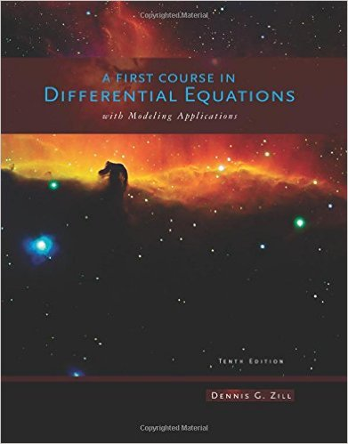
Dennis G. Zill, Cengage

ISBN: 978-1111827052

Course Description:
Linear equations, solutions in series, solutions using Laplace transforms, systems of differential equations and applications to problems in engineering and allied fields.

Course Learning Outcomes:

The student will:

- Identify Homogeneous Equations, Homogeneous Equations With Constant Coefficients, And Exact And Linear Differential Equations.

- Solve Ordinary Differential Equations And Systems Of Equations Using:
A) Direct Integration
B) Separation Of Variables
C) Reduction Of Order
D) Methods Of Undetermined Coefficients And Variation Of Parameters
E) Series Solutions
F) Operator Methods For Finding Particular Solutions
G) Laplace Transform Methods.

- Determine Particular Solutions To Differential Equations With Given Boundary Conditions Or Initial Conditions.

- Analyze Real-World Problems In Fields Such As Biology, Chemistry, Economics, Engineering, And Physics, Including Problems Related To Population Dynamics, Mixtures, Growth And Decay, Heating And Cooling, Electronic Circuits, And Newtonian Mechanics.
Book Sections:

Chapter 1: Introduction to Differential Equations
1.1: Definitions and Terminology
1.2: Initial-Value Problems
1.3: Differential Equations as Mathematical Models

Chapter 2: First-Order Differential Equations
2.1: Solution Curves Without a Solution
2.2: Separable Equations
2.3: Linear Equations
2.4: Exact Equations
2.5: Solutions by Substitutions
2.6: A Numerical Method

Chapter 4: Higher-Order Differential Equations
4.1: Preliminary Theory-Linear Equations
4.2: Reduction of Order
4.3: Homogeneous Linear Equations with Constant Coefficients
4.4: Undetermined Coefficients-Superposition Approach
4.5: Undetermined Coefficients-Annihilator Approach
4.6: Variation of Parameters
4.7: Cauchy-Euler Equation
4.8: Green's Functions
4.9: Solving Systems of Linear DEs by Elimination
4.10: Nonlinear Differential Equations

Chapter 6: Series Solutions of Linear Equations
6.1: Review of Power Series
6.2: Solutions About Ordinary Points
6.3: Solutions About Singular Points
6.4: Special Functions

Chapter 7: The Laplace Transform
7.1: Definition of the Laplace Transform
7.2: Inverse Transforms and Transforms of Derivatives
7.3: Operational Properties I
7.4: Operational Properties II
7.5: The Dirac Delta Function
7.6: Systems of Linear Differential Equations

Chapter 8: Systems of Linear First-Order Differential Equations
8.1: Preliminary Theory—Linear Systems
8.2: Homogeneous Linear Systems
8.3: Nonhomogeneous Linear Systems
8.4: Matrix Exponential

Chapter 9: Numerical Solutions of Ordinary Differential Equations
9.1: Euler Methods and Error Analysis
9.2: Runge-Kutta Methods
9.3: Multistep Methods
9.4: Higher-Order Equations and Systems
9.5: Second-Order Boundary-Value Problems

