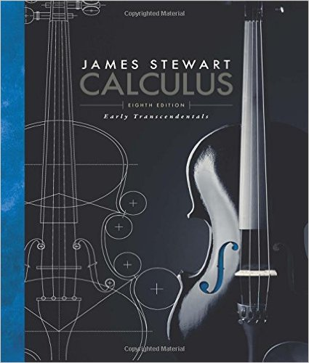
Math 2414 – Calculus II
Calculus: Early Transcendentals, 8th ed.

Alternate Edition with EWA, James Stewart
Brooks Cole; 8th edition; ISBN-13: 978-1285741550

Course Description:
Differentiation and integration of exponential and logarithmic functions, techniques of integration, applications of the definite integral, the calculus of transcendental functions, parametric equations, polar coordinates, indeterminate forms and L’Hopital’s Rule, improper integrals, sequences and series.

Course Learning Outcomes:
The student will:
- Use the concepts of definite integrals to solve problems involving area, volume, work, and other physical applications.
- Use substitution, integration by parts, trigonometric substitution, partial fractions, and tables of anti-derivatives to evaluate definite and indefinite integrals.
- Define an improper integral.
- Apply the concepts of limits, convergence, and divergence to evaluate some classes of improper integrals.
- Determine convergence or divergence of sequences and series.
- Use Taylor and MacLaurin series to represent functions.
- Use Taylor or MacLaurin series to integrate functions not integrable by conventional methods.
- Use the concept of parametric equations and polar coordinates to find areas, lengths of curves, and representations of conic sections.
- Apply L'Hôpital's Rule to evaluate limits of indeterminate forms.

Book Section:
Chapter 4
4.4 Indeterminate Forms

Chapter 5
5.5 The Substitution Rule

Chapter 6
6.1 Areas between Curves
6.2 Volumes
6.3 Volumes by Cylindrical Shells
6.4 Work

Chapter 7
7.1 Integration by Parts
7.2 Trigonometric Integrals
7.3 Trigonometric Substitution
7.4 Integration of Rational Functions by Partial Fractions
7.5 Strategy for Integration
7.7 Approximate Integration
7.8 Improper Integrals

Chapter 10
10.1 Curves Defined by Parametric Equations
10.2 Calculus with Parametric Curves
10.3 Polar Coordinates
10.4 Areas and Lengths in Polar Coordinates

Chapter 11
11.1 Sequences
11.2 Series
11.3 The Integral Test and Estimates of Sums
11.4 The Comparison Tests
11.5 Alternating Series
11.6 Absolute Convergence and the Ratio and Root Tests
11.7 Strategy for Testing Series
11.8 Power Series
11.9 Representations of functions as Power Series
11.10 Taylor and Maclaurin Series
11.11 Applications of Taylor Polynomials

