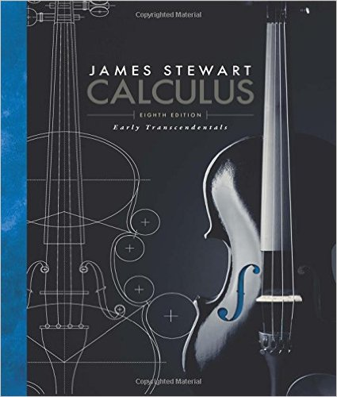
Math 2415 – Calculus III
Calculus: Early Transcendentals, 8th ed.

Alternate Edition with EWA, James Stewart
Brooks Cole; 8th edition; ISBN-13: 978-1285741550

Course Description:
Advanced topics in calculus, including three dimensional coordinate systems, limits and continuity of multivariable functions, partial derivatives, directional derivatives, the gradient, extreme values, multiple integration, the calculus of vector valued functions and line and surface integrals.

Course Learning Outcomes:

The student will:

- Perform calculus operations on vector-valued functions, including derivatives, integrals, curvature, displacement, velocity, acceleration, and torsion.
- Perform calculus operations on functions of several variables, including partial derivatives, directional derivatives, and multiple integrals.
- Find extrema and tangent planes. Solve problems using the Fundamental Theorem of Line Integrals, Green's Theorem, the Divergence Theorem, and Stokes' Theorem.
- Apply the computational and conceptual principles of calculus to the solutions of real-world problems.
- Explore selected topics of solid analytic geometry pertaining to lines and planes.
- Use the cylindrical and spherical coordinate systems.
- Use three space vector operations.
- Acquire a graphic and algebraic understanding of quadratic surfaces.
- Analyze and apply the concepts of limits and continuity to multivariable functions.

Book Sections:

Chapter 10

10.1 Review, Curves Defined by Parametric Equations
10.2 Review, Calculus with Parametric Equations
10.3 Review, Polar Coordinates
10.4 Areas and Lengths in Polar coordinates

Chapter 12

12.1 Three-Dimensional Coordinate Systems
12.2 Vectors
12.3 The Dot Product
12.4 The Cross Product
12.5 Equations of Lines and Planes
12.6 Cylinders and Quadric Surfaces

Chapter 13

13.1 Vector Functions and Space Curves
13.2 Derivatives and Integrals of Vector Functions
13.3 Arc Length and Curvature
13.4 Motion in Space: Velocity and Acceleration

Chapter 14

14.1 Functions of Several Variables
14.2 Limits and Continuity
14.3 Partial Derivatives
14.4 Tangent Plane and Linear Approximations
14.5 The Chain Rule
14.6 Directional Derivatives and the Gradient Vector
14.7 Maximum and Minimum Values
14.8 Lagrange Multipliers

Chapter 15

15.1 Double Integrals over Rectangles
15.2 Iterated Integrals
15.3 Double Integrals over General Regions
15.4 Double Integrals in Polar Coordinates
15.5 Applications of Double Integrals
15.6 Surface Area
15.7 Triple Integrals
15.8 Triple Integrals in Cylindrical Coordinates
15.9 Triple Integrals in Spherical Coordinates
15.10 Change of Variables in Multiple Integrals
Chapter 16

16.1 Vector Fields
16.2 Line Integrals
16.3 The Fundamental Theorem for Line Integrals
16.4 Green's Theorem
16.5 Curl and Divergence
16.6 Parametric Surfaces and Their Areas
16.7 Surface Integrals
16.8 Stokes’ Theorem
16.9 The Divergence Theorem
16.10 Summary

