Instructions for using AV Equipment in Touch Screen Classrooms:
- Turn on computer if it is not already on and log in using your LCSC account or the classroom login account which can be located on the bulletin board or wall in your room. Username= cf-(hsc, tec, or lrc)-(room #) Password= (leave blank) Domain =LSCS-INST or LSCS Example: cf-hsc-100 ***check bulletin board for exact login***
- You will see this screen on the touch pad panel -  . Touch anywhere on the screen to start system.
- Press YES when the screen asks “Do you want to power on the system?” 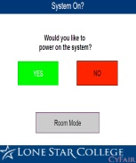. It will take approx. two minutes to power up. Do not press anything until the power on message stops flashing!
3. A By default the rooms are in single mode, and should remain on this setting (classrooms Art 212/215, Tech 203/204; Tech 112/113, HSC 122,124; HSC 116, 118, & 119; HSC205, 206). To combine a set of paired rooms, please select “room mode” from the power on screen and then choose “combine mode”
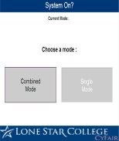
4. You can choose the PC, DVD/VCR, or Laptop selections located on the side of the screen to select your desired output 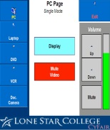.
- To use a laptop, press the “Laptop” selection on the touch screen. There are network, VGA, power, and audio cables on the instructor’s desk for connection to your laptop. 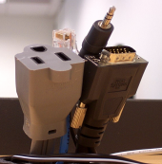
- Press MUTE VIDEO to temporarily black out (mute) the projection image. Press DISPLAY to return your selected image on the screen.
- For proper sound, on the far right of the touch screen panel press the “Up” or “Down” arrows to control sound output.
- To turn projector system off, press the EXIT button at the top right corner. The system will ask, “Power off the system?” Press “turn system off”. It will take approximately 2 minutes for the system to completely power down. Do not press anything until the power down message stops flashing. If you want to turn the system back on, you will have to wait for the cooling down session to complete.
Please power off the projector at the conclusion of your class. Need Help? Contact the OTS Servicedesk @ 866-614-5014 or https://lonestar.service-now.com

