How to Change your Signature in Outlook 2003

- On the Menu bar, click Tools - Options

2. Choose the “Mail Format” Tab
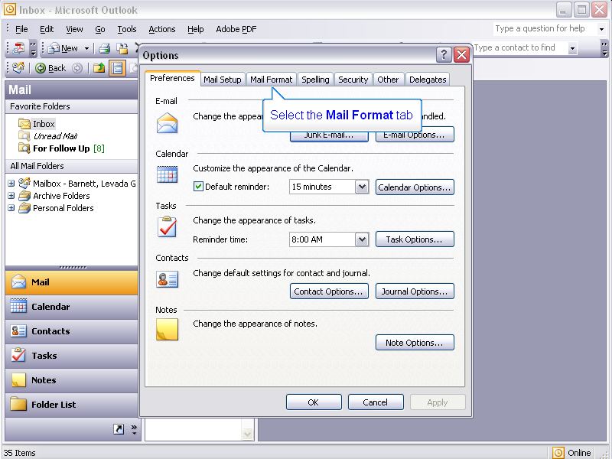

3. Click the “Signatures…” button.
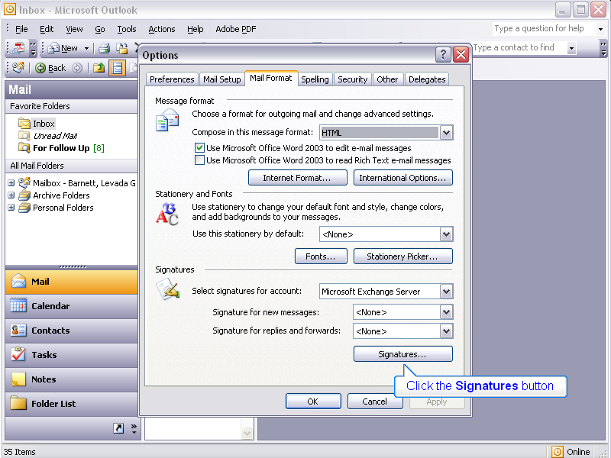

4. Select the appropriate Signature and click “Edit”
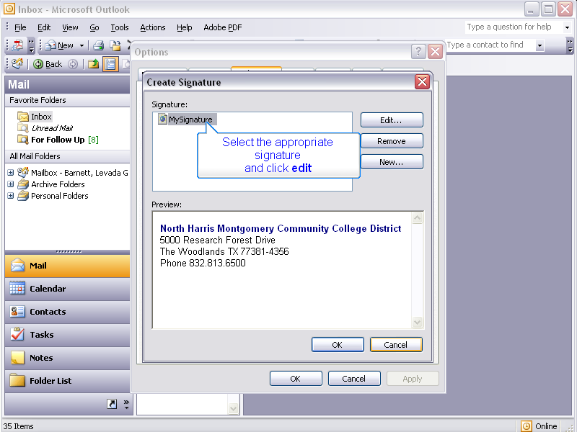

- Below your signature type “NHMCCD is becoming Lone Star College System” Use Franklin Gothic Medium in 12 point. If you do not have Franklin Gothic Medium, it is recommended that you use a san serif font, such as Arial.
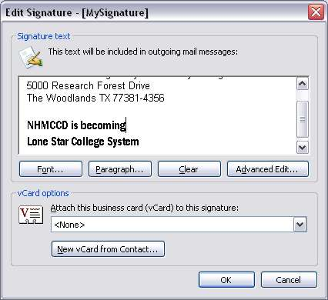

6. Click OK

How to Change Your Signature in Outlook 2007

- Select signature then click the Signatures and Stationary dialog box.
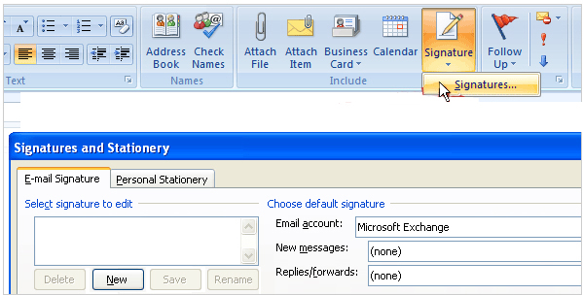

- Name your signature
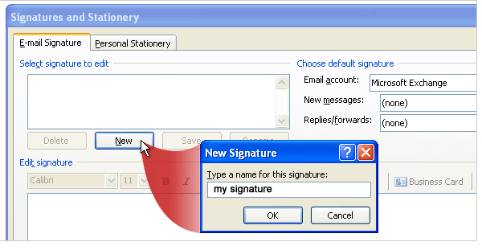

- Below your signature type “NHMCCD is becoming Lone Star College System” Use Franklin Gothic Medium in 12 point. If you do not have Franklin Gothic Medium, it is recommended that you use a san serif font, such as Arial.
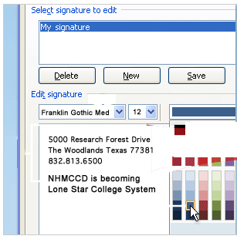

- Click Save

How to create a signature in Entourage

- From the Menu bar, click on Tools – Signatures

- In the Signatures window, click on New
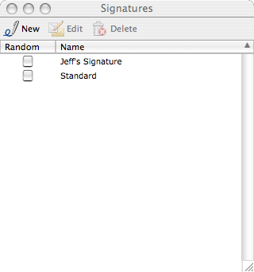

- Type a name in the Name box to identify the signature
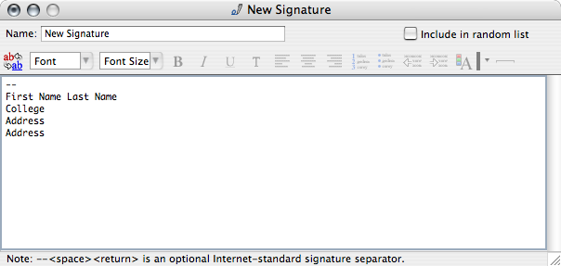

- Below your signature type “NHMCCD is becoming Lone Star College System” Use Franklin Gothic Medium in 12 point. If you do not have Franklin Gothic Medium, it is recommended that you use a san serif font, such as Arial.
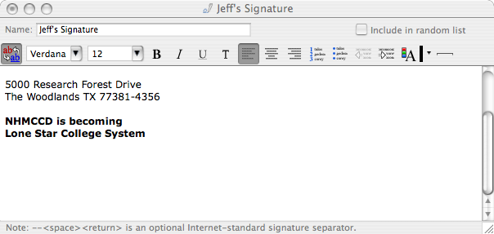

- To enable the format tools in the signature, click the red and blue button on the left-hand side of the format tools.

- Click “File – Save”

