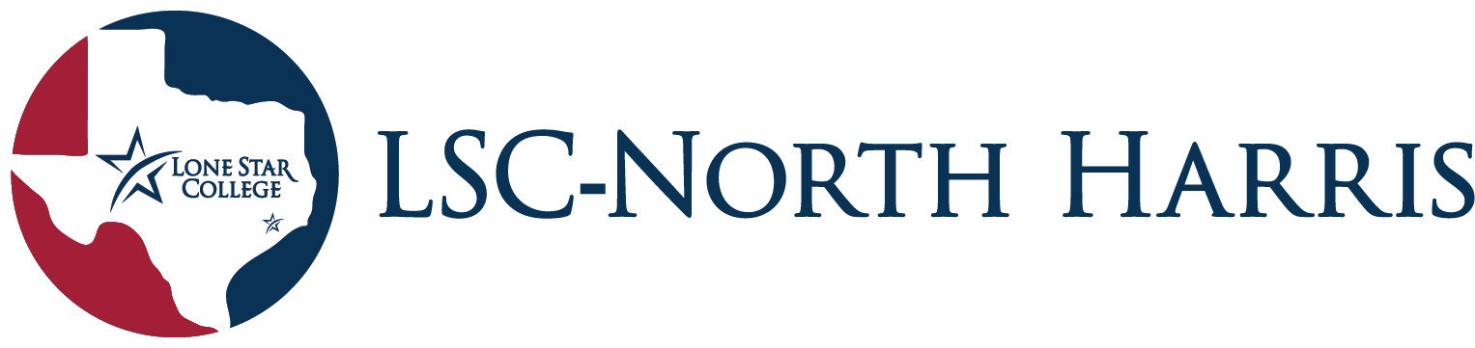
Student Government Association (SGA)

SGA General Assembly Meeting Agenda
October 11th, 2023
12:00 pm – 12:45 pm
Student Center 2nd Floor, Room 204
- Call To Order-12:05
- Icebreaker
- If you could eat one food for the rest of your life, what would it be?
- Roll Call In-
- Guest Speaker ~ Genarrio Williams and John Vazquez with TRIO Student Support Services
- The Federal TRIO Programs (TRIO) are outreach and student services programs designed to identify and provide services for students from disadvantaged backgrounds. TRIO helps first-generation college students, low-income students, and students with disabilities progress through the academic pipeline from middle school to post-baccalaureate programs.
~ Erin Cominotti with NH Counseling /ACAD 217
- Lone Star College counselors are master’s level counseling professionals who are trained to assist you in meeting your academic, career and personal goals. Change, stress and personal growth are all elements of the college experience. We are dedicated to helping you succeed through a variety of services.
- Staff & Faculty Reports-
Dr. T – Recruitment for The Human Library
-November 7th & November 8th 9 AM & 3 PM.
-email cleopatre.thelus@lonestar.edu , if interested in participating.
Dean Craft – Bookstore update
-The LSC virtual bookstore is now available via lonestar.textbookx.com

Director Jackson – New RSO Processes and Polices
-All RSO officers are required to fill out the RSO process forms and policy guidelines. Sign in sheets requiring student ID now mandatory for student organizations.

- New Business
-none
- Open Floor
-Chess club announcing meeting changes to Tuesdays and Thursdays.
-Support our teams at the rec sport games.
- Announcements
- The Prom You Never Had-October 26
- Roll Call Out
- Adjournment-12:47

