FACTORING POLYNOMIALS
- Is there a GCF?
Example:
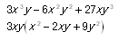
- How many terms does it have?
  - If there are two terms:
    - Is it a Difference of Squares ?
      - Are both terms perfect squares?
      - Are the two terms being subtracted?
Example:
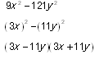
    - A sum of two squares is prime in the real number system.
    - Is it a sum or difference of cubes (both terms are perfect cubes)?
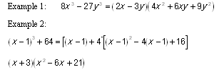
  - If there are three terms:
    - Is it a perfect square trinomial?
      - First and last terms are perfect squares.
      - The coefficient of the middle term is an even number.
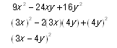
    - Is the lead coefficient one?
      - Look at the possible factors of the last term.
      - Is the product negative or positive?
      - Is the middle term negative or positive?
Example: x ²+ 3xy - 18y²
The factors of 18 are: 1·18, 2·9, 3·6
The product is negative so we need the set of factors that yields a differenceof 3.
(x + 6y)(x - 3y)
Check: x² - 3xy + 6xy -18y²
    - If it is a general trinomial :
      - Factor the coefficients of the first and last terms.
      - Determine whether the middle term is a sum or a difference (was it O + I or O – I )

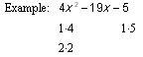
The product is negative so the middle term of –19x represents a difference of the possible factor combinations.
(4x + 1)(x - 5)
  - If there are four terms and no GCF :
i. Group the first two terms together and the last two terms together
6ab² - 3ab - 14b + 7
(6ab² - 3ab) + (-14b + 7)
ii. Factor out the GCF for each group
3ab(2b - 1) + (-7)(2b - 1)
iii. The binomial factor from each group should be the same and therefore is the GCF
(2b - 1)(3ab - 7)

