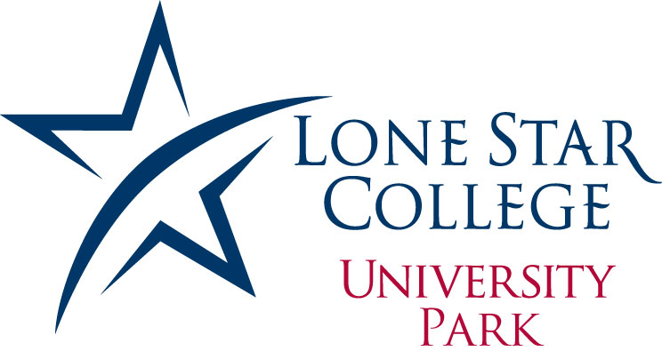
College Relations

Oct. 5, 2012
FOR IMMEDIATE RELEASE

Media Contacts:
Stephanie March
Director of College Relations
Lone Star College-University Park
281.290.2753 desk
stephanie.march@lonestar.edu

Stephanie Knific
College Relations
Lone Star College-University Park
281.2902746 desk
281.744.4096 cell
stephanie.knific@lonestar.edu

Lone Star College-University Center at University Park to hold open house

HOUSTON (Oct. 5, 2012) – Lone Star College-University Center at University Park will host an open house for students interested in transferring to one of the center’s four-year university partners: Sam Houston State University–Northwest Houston Campus, Texas Southern University-Northwest Campus, University of Houston-Northwest Campus, and University of Houston Downtown-Northwest.

The open house will be held Tuesday, Oct. 16, from 4 to 7 p.m. at LSC-University Center at University Park, Bldg. 12, second floor.

Faculty members, student advisors, financial aid and admissions officers from each partner university will be available to answer questions from students interested in transferring to one of the four-year institutions. Additionally, there will be food, games, and giveaways.

LSC-University Center at University Park offers junior, senior and graduate-level classes through its university partnerships. Students who enroll with one of the partner universities on-site are able to complete a bachelor’s or master’s degree (or teaching certificate) without traveling to the university campuses.

The Lone Star College-University Center model allows Lone Star College-University Park students a smooth transition process from the two-year college to a four-year university. Specific programs, such as the 2+2 program, allow students to take their first two years of classes at LSC--University Park and then the second two years of upper-level courses at one of the four partner universities, without having to reapply.

For more information on the open house or on one of LSC-University Park’s partner university, please contact the college relations department at 281.290.2600.

LSC-University Park is the newest LSCS campus and includes one of the two LSCS university centers. The campus is located at the corner of State Highway 249 and Louetta Road across from Vintage Park. For more information on the open house or on one of LSC-University Park’s partner universities, please contact the college relations department at 281.290.2600 or visit LoneStar.edu./UP
With 78,000 students in credit classes, and a total enrollment of more than 90,000, Lone Star College System is the largest institution of higher education in the Houston area and fastest-growing community college system in the nation. Dr. Richard Carpenter is the chancellor of LSCS, which consists of six colleges including LSC-CyFair, LSC-Kingwood, LSC-Montgomery, LSC-North Harris, LSC-Tomball and LSC-University Park, five centers, LSC-University Center at Montgomery, LSC-University Center at University Park, Lone Star Corporate College, and LSC-Online. To learn more visit LoneStar.edu.

###

