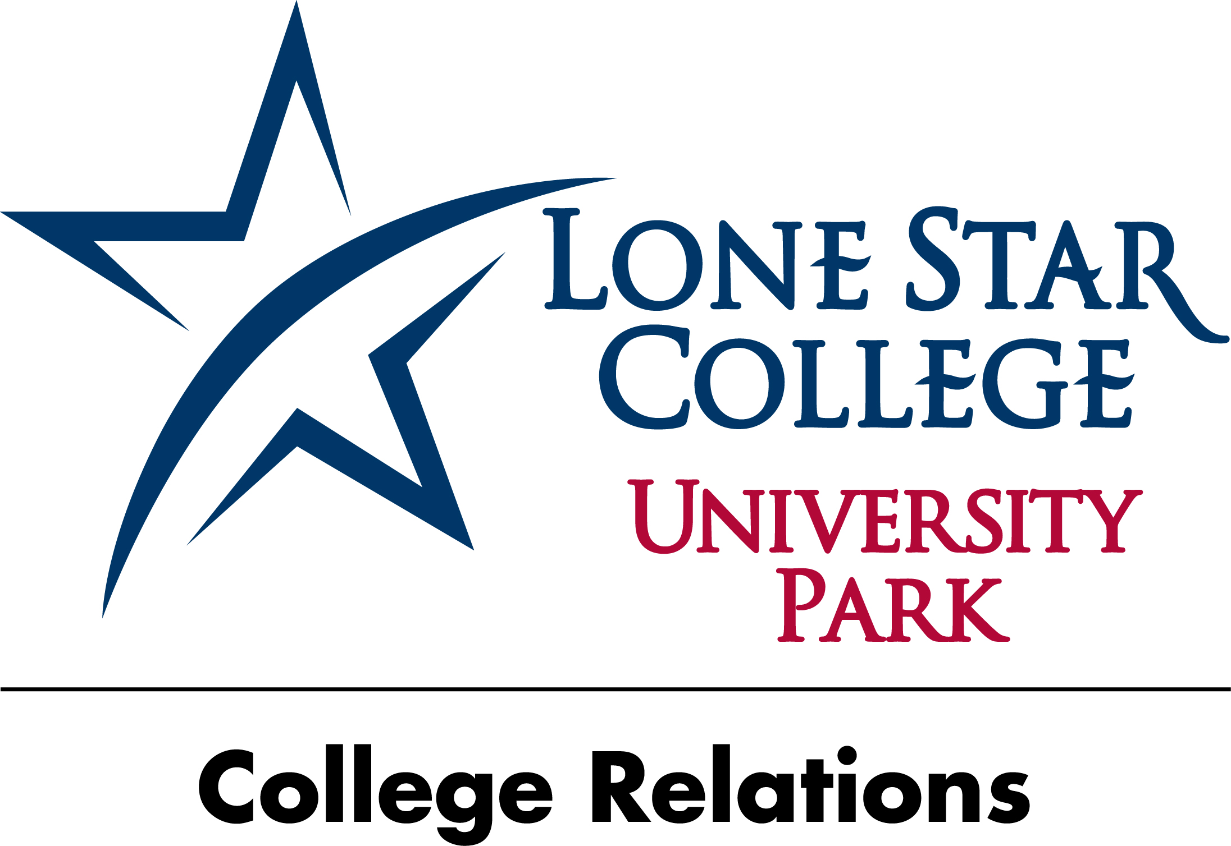

Nov. 8, 2012
FOR IMMEDIATE RELEASE

Media Contacts:
Stephanie March
Director of College Relations
Lone Star College-University Park
281.290.2753 desk
stephanie.march@lonestar.edu

Stephanie Knific
College Relations
Lone Star College-University Park
281.290.2746 desk
281.744.4096 cell
stephanie.knific@lonestar.edu

Earn a college degree on weekends at LSC-University Park

HOUSTON (Nov. 8, 2012) – Students at Lone Star College-University Park can now earn one of three degrees simply by attending weekend classes. Beginning in the spring 2013 semester, LSC-University Park students will be able to earn an Associate of Arts degree in Business, Teaching or a general associate degree through the campus’ weekend college.

Weekend classes provide flexibility and alternate scheduling for students who work or have other commitments. Students can choose from online, face-to-face or hybrid classes. According to Mary Anne Figueroa, LSC-University Park operations manager, “Through our weekend college, you can go to school just one day a week on the weekend and still take a full load of classes.”

Weekend classes will be offered each semester beginning in the spring 2013 semester and during the summer term as well. Figueroa stated that all classes are guaranteed for students who pre-register. Registration began Nov.7.

“Today’s students need more flexibility in their scheduling. There are students of all ages and backgrounds attending classes here. This is just another example of how LSC-University Park continues to meet the needs of its students by offering a variety of traditional and non-traditional avenues for students to earn college credits.” Lawrence Brandyburg, vice president instruction and student services added.
For more information on LSC-University Park’s weekend college offerings, contact Diana Doughman-Massie, advising and admissions manager, at 281-401-5332.
LSC-University Park is the newest LSCS campus and includes one of the two LSCS university centers. The campus is located at the corner of State Highway 249 and Louetta Road across from Vintage Park. For more information about LSC-University Park, call 281-290-2600 or visit LoneStar.edu./UP.
With 78,000 students in credit classes, and a total enrollment of more than 90,000, Lone Star College System is the largest institution of higher education in the Houston area and fastest-growing community college system in the nation. Dr. Richard Carpenter is the chancellor of LSCS, which consists of six colleges including LSC-CyFair, LSC-Kingwood, LSC-Montgomery, LSC-North Harris, LSC-Tomball and LSC-University Park, five centers, LSC-University Center at Montgomery, LSC-University Center at University Park, Lone Star Corporate College, and LSC-Online. To learn more visit LoneStar.edu.
###

