

Setup Employee Email on iOS devices

Step 1. Locate and open **Settings** on the IOS device.

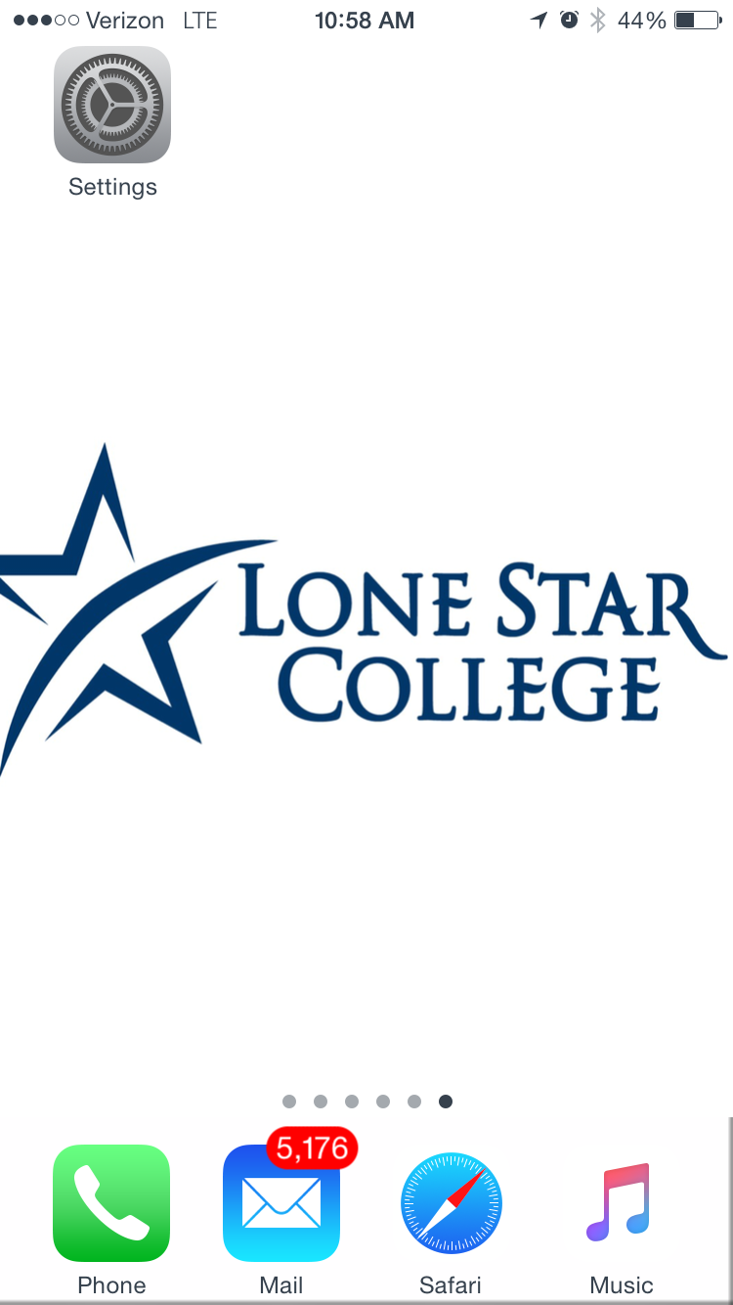

Step 2. Select **Mail**

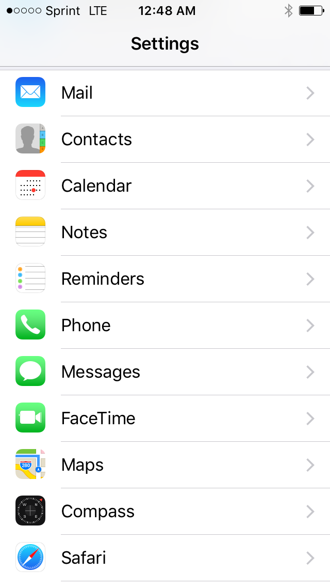

Step 3. Select **Accounts**

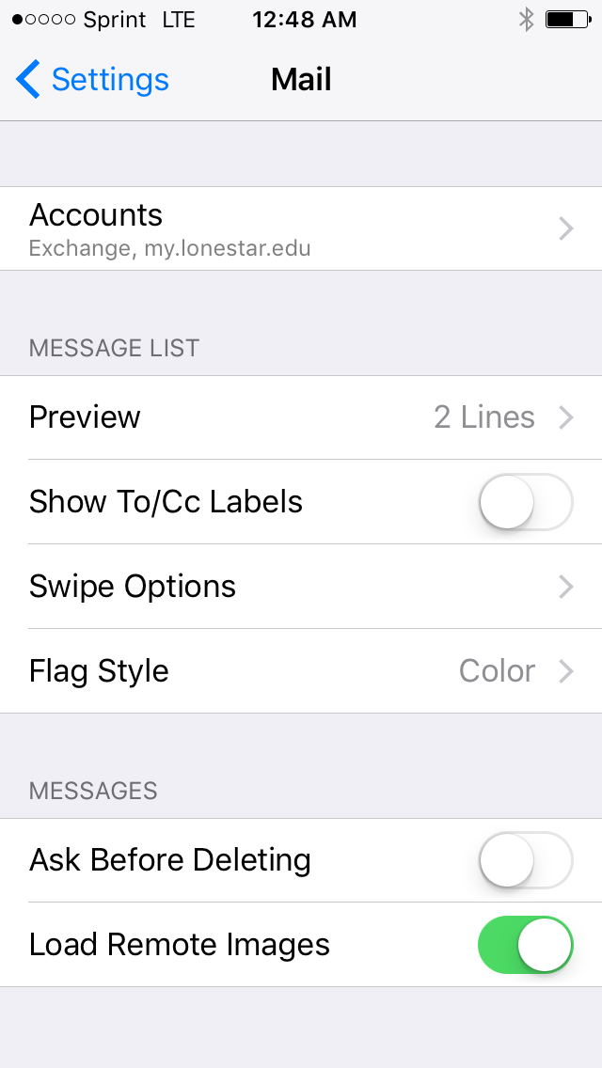

Step 4. Select **Add Account**

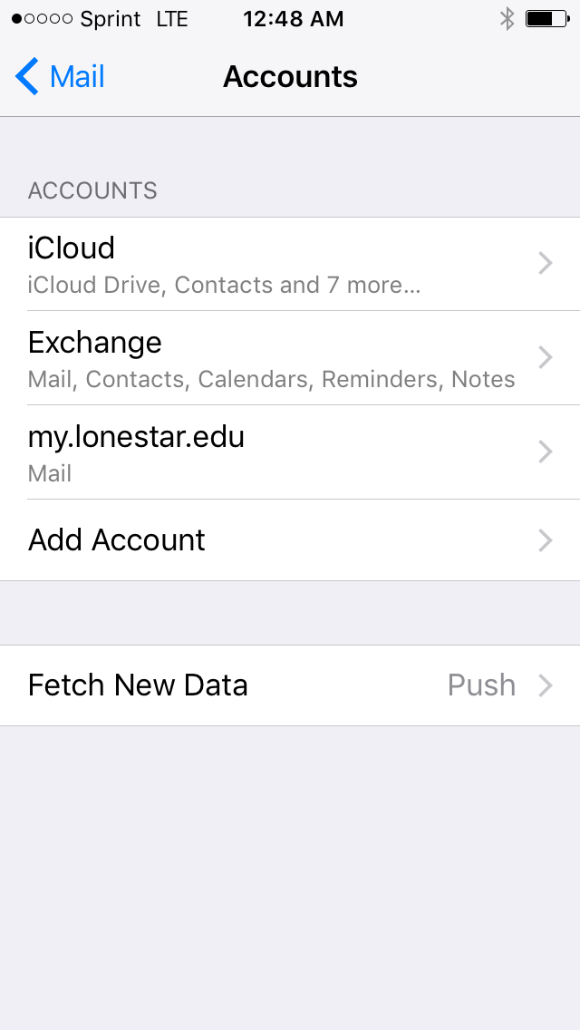

Step 5. **Select Exchange**

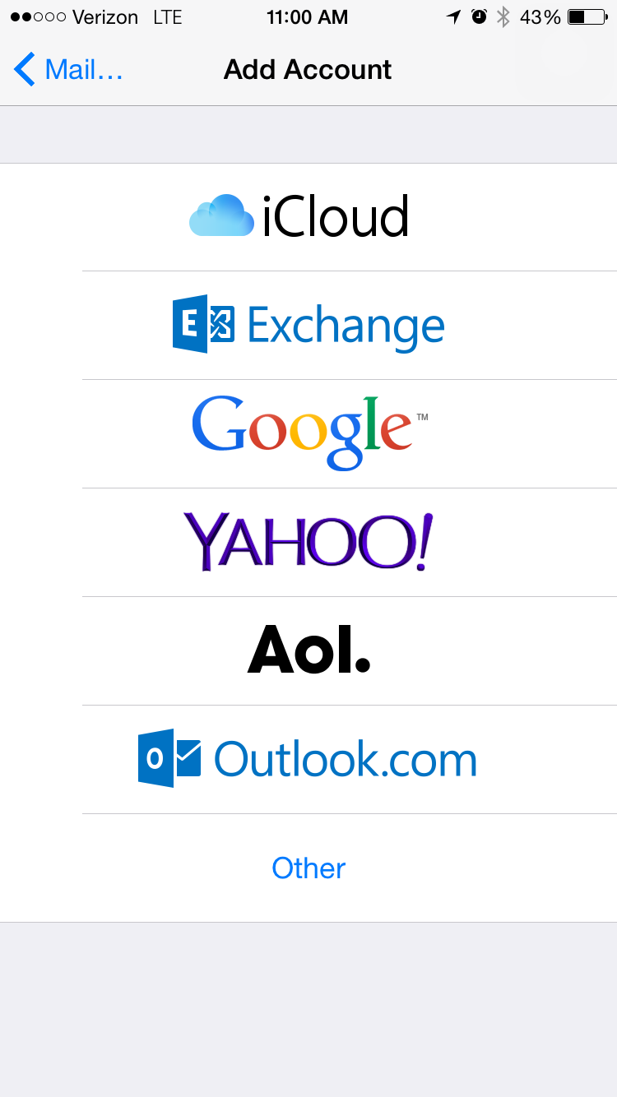

Step 6. Enter your **Lonestar College Employee email address and password,** then click **next.**

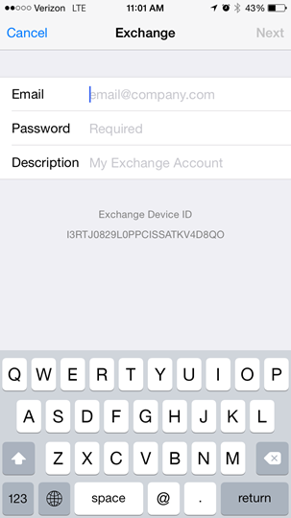

Step 6. Type in your **Lonestar College Employee email address,** **server name**, **domain**, **username**, and **password**. (Use picture below for Domain and Server name.) Then click **next**

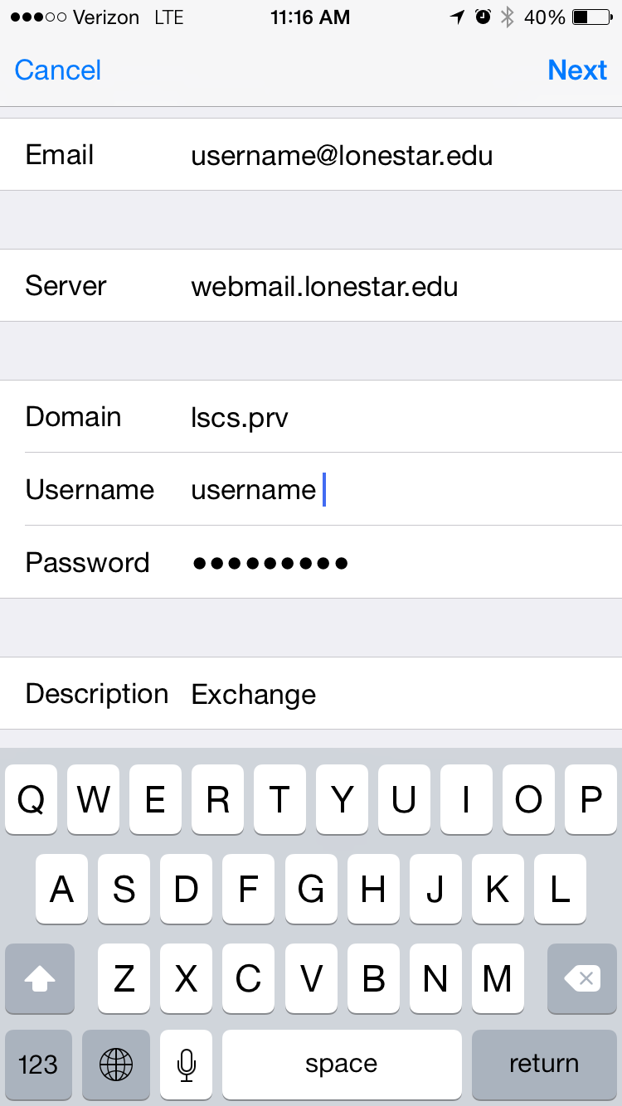

If all information is entered correctly you should get a check mark next to all sections. This means the email account is now added to your IOS device. And can be accessed by clicking the Mail icon on your home screen.