Office Use Only
Received
IRB File Number
Reviewer
IRB Decision
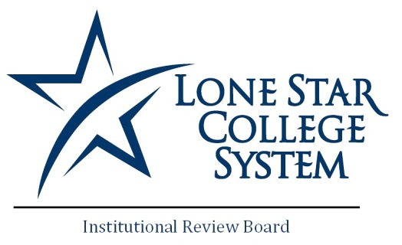

Institutional Review Board
Research Application Form
Note: IRB approval may be granted only for human subjects research conducted by Lone Star College System faculty, staff, students (on or off-campus), and eligible external applicants.

E-mail completed form along with any attachments to IRB@LoneStar.edu.

Check One: |  | New |  | Continuing |  | Modification

Project Title:
Principal Investigator :
(may not be an undergraduate student at LSCS)
Investigator connection to LSCS (if any):
Investigator E-Mail Address:
Investigator Phone Number:

Project Type: check one

Faculty Research Student Research Student class project
(under faculty direction) (under faculty direction)

LSCS Honors Project Federal grant Non-federal grant

Thesis or dissertation Other ________________________

Institution Conducting Study:
Faculty Sponsor (if outside institution):
Proposed Start Date:
Duration of Study (months):
Research Locations:

 | Name: | E-Mail | Primary Phone
Co-Investigator(s):
Student Investigator(s):
Other:
- Project Description: Check yes or no | Yes | No
- Will you be requesting data from the LSCS Office of Research & Institutional Effectiveness (ORIE)?
- Does this project or study involve collection of data that identifies individuals (e.g., cohort databases include SSN# data on individuals, surveys, or interviews identifiable by name or student number etc.)?
- Will data identifiable by individual be shared with anyone (such as in a performance report for a funding source, conference presentations, published articles and reports, etc.)?
- Are the participants being offered one or more of the incentives to participate (such as money, extra credit for the class, etc.)? If yes, list the incentive(s) here.
- Is participation in this project or study voluntary for the individuals participating in the program or study?
Will participants be videotaped during the project or study?
- Will participants be fully informed about the benefits and any risks?
Will participants’ privacy and personal information be protected?
- Will participants be debriefed following completion of the project or study?
Will participants, prior to the project, indicate informed consent to participate by completing and signing a written form?
Are data sources clearly identified (such as interviews, survey, existing project data such as services received, reports, grades, existing school records, focus group, etc.)?

Please answer all questions below.
(There is no character limit – field will expand as you type.)

1. State the overall objectives and specific aims of the research.

2. Who are the subjects and how will they be recruited?

3. Describe the procedures to be used for data collection and whether data collection will be confidential, private or anonymous. Describe who will have access to the records and what will happen to data after completion of study.

4. What risks are faced by subjects participating in this research, e.g., injury, pain, emotional distress, or invasion of privacy? What measures will be taken to minimize these risks?

5. Will there be any costs to be borne by subjects by virtue of their participation in this research?

6. Will there be any compensation or reimbursement to subjects in this research (i.e. monetary payments, course credit, services etc.)?

7. What are the likely benefits of this research to the subjects as well as to public knowledge?
.

8. How will information be disseminated at the close of the study (i.e. dissertation, presentation, publication). If information is for classroom or institutional use, please describe.
ATTACHMENTS:

Please attach all documents that apply to your proposal here.

- Informed Consent Form (first page on letterhead of organization sponsoring study)
- Surveys, questionnaires, or other data gathering forms
- Any disclosures explaining risks or procedures
- Letters of approval from cooperating entities
- Any approvals or documentation from external IRBs
- Letters, flyers, questionnaires distributed to subjects or posted to recruit
- NOI-IRB: Notice of Intent is required, to be signed by president(s) of LSCS college(s) at which you will collect data or conduct research
- Principal Investigators are required to submit a Human Subject Protection Training certificate with their application. NIH offers a 1-2 hour online training course, which can be found at
http://phrp.nihtraining.com/users/login.php. Please attach your certificate here. Applications without training certificates will not be reviewed until the training is complete. Training from NIH must be renewed every year, so please be sure your certificate is up-to-date.

Do not write below this Section.

This section intended for IRB Representative Use ONLY.

IRB
IRB Process |  | Exempt
 |  | Expedited Review
 |  | Full Review
IRB Decision |  | Approved
 |  | Not Approved
 |  | Conditionally Approved
 |  | (see attached)

Comments: (attach additional sheets as necessary)
 | ________________________  IRB Chair or Representative |  | ___________________  Date

By filling in my name and the date I assert that I have reviewed the above document and made an official recommendation on behalf of the LSC-Institutional Review Board.

