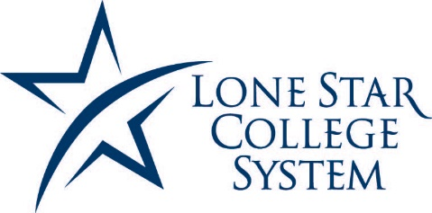

LONE STAR SPORT CLUB CONFERENCE
TENNIS LEAGUE SCHEDULE
FALL 2015

Saturday, September 26th
LSCS Team Matches
LSC-Kingwood (11 am)

Saturday, October 10th
LSCS Team Matches
Lee College, Baytown Texas (11 am)

Saturday, October 17th
LSCS Team Matches
Sam Houston State University (11 am)

Saturday, October 24th
USTA Texas Regional
McFarlin Tennis Center - San Antonio, Texas

Friday-Saturday, November 6th-7th
CyFair Invitational
LSC-CyFair (times TBA)

Saturday, November 14th
USTA Texas Regional
Homer Ford Tennis Center, Houston Texas

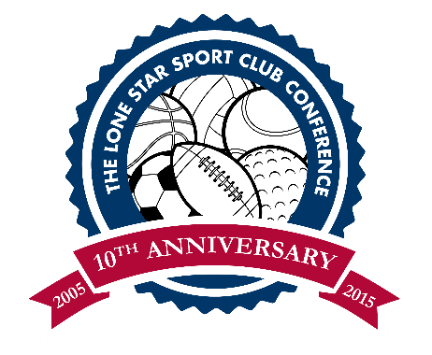
Saturday, November 21st
LSCS Conference Tennis Tournament
LSC-Montgomery (9 am)

