PeopleSoft Campus Solutions
Financial Aid
UPD918158 – COD 2015-2016 and Other Critical Updates
User Documentation (9.0)

March 2015

Contents

- Student Eligibility (ATB) Code and COD Reporting 3
- PLUS Loan Applicant with Adverse Credit History 9
- DLSAS Disbursement Detail On Demand Message Class 14
- Verification Tax, Credits, and Payments Changes 15

Student Eligibility (ATB) Code and COD Reporting:

- Manage Ability to Benefit Component

Navigation: Financial Aid > Ability to Benefit > Manage Ability to Benefit

  - The Ability to Benefit field has been renamed to Student Eligibility Code (for ease, we will refer to this as SEC value), and the picklist has been expanded to support the 2016 COD expanded taxonomy for this field.

  - The field Aid Year has been added to the page to designate an "Aid Year-specific" SEC value (e.g., a 2016-only acceptable 08, 09, or 10 code). This allows customers to designate an SEC value to a particular Aid Year and forward.

Note: Aid Year is an optional field – customers are not required to populate this field as part of the student's Ability to Benefit record. An example of your not needing to populate the Aid Year field is when the student's SEC value is the same across multiple Aid Years (e.g., 01 – Testing Completed).

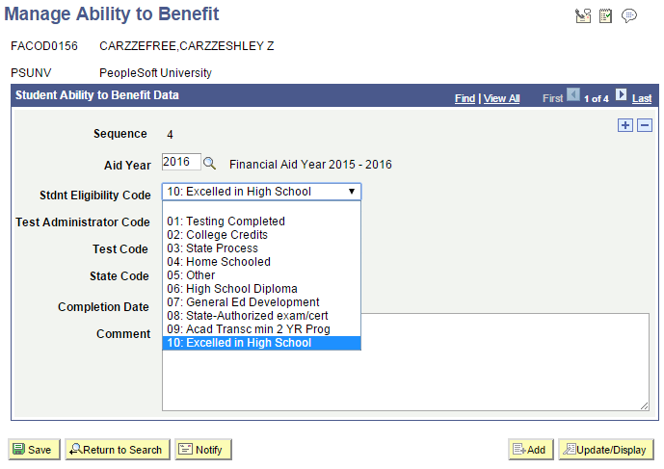

- Create Ability to Benefit Run Control

Navigation: Financial Aid > Ability to Benefit > Create Ability to Benefit

    - The Ability to Benefit field has been renamed to Student Eligibility Code, and the picklist has been expanded to support the 2016 COD expanded taxonomy for this field.

    - The field Aid Year has been added to the page to designate an "Aid Year-specific" SEC value (e.g., a 2016-only acceptable 08, 09, or 10 code).

Note: This is an optional value – customers are not required to populate this field as part of the student's Ability to Benefit record. An example of your not needing to populate the Aid Year field is when the student's SEC value is the same across multiple Aid Years (e.g., 01 – Testing Completed).

If there is an Aid Year value on this Run Control page, it will populate the ATB record for all Population Selection cohorts whose Aid Year value is blank.

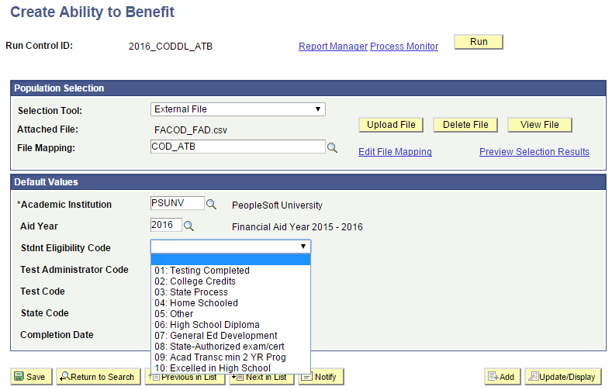

- COD Processing

The various COD processes that require ATB reporting have been enhanced with a new Aid Year match routine that incorporates the Aid Year value on the Run Control in conjunction with the presence or absence of the Aid Year value on the student's ATB record. These various COD processes include:

- Pell Origination
- Pell Disbursement
- DL Origination
- DL Change (for changes to ATB)

The system will locate the highest sequenced row on the student's ATB record and interrogate the Aid Year value, and depending on whether the field is blank or matches the Aid Year on the "process name" Run Control will determine what SEC value is used for COD transmission. Specifically:

- If the Aid Year is blank for the highest sequenced number row on the student's ATB record, then the designated SEC value for that row will be used for ALL Aid Years being processed regardless of the Aid Year value on the corresponding Run Control

- If the Aid Year is not blank for the highest sequenced number row on the student's ATB record, then the system will always evaluate the Aid Year on the student's ATB record against the Aid Year specified on corresponding Run Control and:
- if the student's highest sequenced number row's Aid Year is less than or equal to the Run Control Aid Year value, then that Aid Year's SEC value will be used.
- if the student's highest sequenced number row is greater than the Run Control Aid Year, then:
  - then the system will search the student's ATB record for the next highest sequenced row, and go through the same process as above, namely,
    - if the Aid Year is blank (on that next highest sequenced row), then the designated SEC value for that row will be used for the Aid Year on the Run Control;
    - if the Aid Year is not blank, and:
      - if it's less than or equal to the Run Control Aid Year, then that Aid Year's SEC value will be used.
      - If it's greater than the Run Control Aid Year, then the system will search for the next highest sequenced row, and go through the same process as above, etc.

Essentially the designated Aid Year will govern which SEC value will be used for that Aid Year and forward. Once the system has resolved which sequenced row to use on the student's ATB record, it will then conduct the "normal and necessary" Validation edits to ensure only valid SEC values for a given year are submitted to COD either as Origination (DL and Pell) or Origination Change (DL) or Disbursement (Pell) records.

Note: Depending on whether Originations (DL and Pell) versus Origination Change (DL) and Disbursements (Pell) is being generated will dictate whether an outbound transaction will be generated directly or whether the COMPARE (e.g., Validation) results will require that an outbound transaction be generated.

We will now walk through several examples illustrating which SEC values will be used for interrogation, validation, and transmission based on the makeup of the student's ATB record and the Aid Year being processed.

Example 1

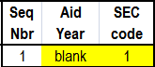

In this scenario, because the Aid Year on the highest sequenced number row (1) on the student's ATB record is blank, it is that row's SEC value that will be used for ALL Aid Years when processing COD transactions.

Result:
- For Aid Year 2016, since "1" is a valid SEC value, it would pass validation and the record would be transmitted.
- For Aid Year 2015, since "1" is a valid SEC value, it would pass validation and the record would be transmitted.

Example 2

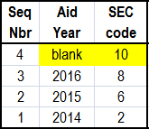

In this scenario, because the Aid Year on the highest sequenced number row (4) on the student's ATB record is blank, it is that row's SEC value that will be used for ALL Aid Years when processing COD transactions.

Result:
- For Aid Year 2016, since "10" is a valid SEC value, it would pass validation and the record would be transmitted.
- For Aid Year 2015, since "10" is an invalid SEC value, it would fail validation and the record would not be transmitted.

Example 3

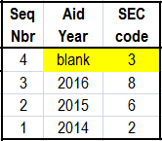

In this scenario, because the Aid Year on the highest sequenced number row (4) on the student's ATB record is blank, it is that row's SEC value that will be used for ALL Aid Years when processing COD transactions.

Result:
- For Aid Year 2016, since "3" is an invalid SEC value, it would fail validation and the record would not be transmitted.
- For Aid Year 2015, since "3" is an invalid SEC value, it would fail validation and the record would not be transmitted.

Example 4

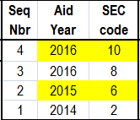

In this scenario:
- the highest sequenced number row on the student's ATB record is 4, and the Aid Year associated with Seq Nbr 4 is 2016 – this will be used for all 2016 COD processing.
- The next highest sequenced number row (3) is also associated with Aid Year 2016 so this will not be considered for jobs that you're trying to run in Aid Year 2015 or earlier.
- The next highest sequenced number row is 2, and the Aid Year associated with this sequence number is 2015 – this will be used for all 2015 COD processing.

Result:
- For Aid Year 2016 (Seq Nbr 4), since "10" is a valid SEC value, it would pass validation and the record would be transmitted.
- For Aid Year 2015, the Run Control value is "2015", so the routine will search for either a "blank" or an Aid Year value equal to or less than "2015" among the student's ATB rows.
  - Since Sequence Number 2's Aid Year matches the Run Control Aid Year of 2015, that SEC value will be used.
  - Since "6" is a valid SEC value for Aid Year 2015, it would pass validation and the record would be transmitted.

Example 5

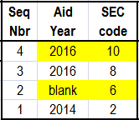

In this scenario:
- the highest sequenced number row on the student's ATB record is 4, and the Aid Year associated with Seq Nbr 4 is 2016.
- The next highest sequenced number row (3) is also associated with Aid Year 2016 so this will not be considered for jobs that you're trying to run in Aid Year 2015 or earlier.
- The next highest sequenced number row is 2, and the Aid Year associated with this sequence number is blank so it is that row's SEC value that will be used for ALL Aid Years 2015 or earlier when processing COD transactions.

Result:
- For Aid Year 2016 (Seq Nbr 4), since "10" is a valid SEC value, it would pass validation and the record would be transmitted.
- For Aid Year 2015, the Run Control value is "2015", so the routine will search for either a "blank" or an Aid Year value equal to or less than "2015" among the student's ATB rows.
  - Since Sequence Number 2's Aid Year is blank, that SEC value will be used.
  - Since "6" is a valid SEC value for Aid Year 2015, it would pass validation and the record would be transmitted.

Example 6

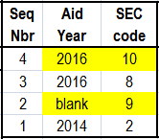

In this scenario:
- the highest sequenced number row on the student's ATB record is 4, and the Aid Year associated with Seq Nbr 4 is 2016.
- The next highest sequenced number row (3) is also associated with Aid Year 2016 so this will not be considered for jobs that you're trying to run in Aid Year 2015 or earlier.
- The next highest sequenced number row is 2, and the Aid Year associated with this sequence number is blank The next highest sequenced number row is 2, and the Aid Year associated with this sequence number is blank so it is that row's SEC value that will be used for ALL Aid Years 2015 or earlier when processing COD transactions

Result:
- For Aid Year 2016 (Seq Nbr 4), since "10" is a valid SEC value, it would pass validation and the record would be transmitted.
- For Aid Year 2015, the Run Control value is "2015", so the routine will search for either a "blank" or an Aid Year value equal to or less than "2015" among the student's ATB rows.
  - Since Sequence Number 2's Aid Year is blank, that SEC value will be used.
  - Since "9" is an invalid SEC value for Aid Year 2015, it would fail validation and the record would not be transmitted.

Example 7

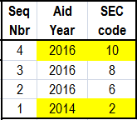

In this scenario:
- the highest sequenced number row on the student's ATB record is 4, and the Aid Year associated with Seq Nbr 4 is 2016.
- The next highest sequenced number row (3) is also associated with Aid Year 2016 so this will not be considered for jobs that you're trying to run in Aid Year 2015 or earlier.
- The next highest sequenced number row (2) is also associated with Aid Year 2016 so this will not be considered for jobs that you're trying to run in Aid Year 2015 or earlier.
- The next highest sequenced number row is 1, and the Aid Year associated with this sequence number is 2014 – even though this is an earlier Aid Year than that which is on the COD Run Control (2015), it will be used for Aid Year 2015.

Result:
- For Aid Year 2016 (Seq Nbr 4), since "10" is a valid SEC value, it would pass validation and the record would be transmitted.
- For Aid Year 2015, the Run Control value is "2015", so the routine will search for either a "blank" or an Aid Year value equal to or less than "2015" among the student's ATB rows.
  - Since Sequence Number 1's Aid Year is less than 2015, that SEC value will be used.
  - Since "2" is a valid SEC value for Aid Year 2015, it would pass validation and the record would be transmitted.

Example 8

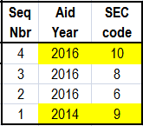

In this scenario:
- the highest sequenced number row on the student's ATB record is 4, and the Aid Year associated with Seq Nbr 4 is 2016.
- The next highest sequenced number row (3) is also associated with Aid Year 2016 so this will not be considered for jobs that you're trying to run in Aid Year 2015 or earlier.
- The next highest sequenced number row (2) is also associated with Aid Year 2016 so this will not be considered for jobs that you're trying to run in Aid Year 2015 or earlier.
- The next highest sequenced number row is 1, and the Aid Year associated with this sequence number is 2014 – even though this is an earlier Aid Year than that which is on the COD Run Control (2015), it will be used for Aid Year 2015.

Result:
- For Aid Year 2016 (Seq Nbr 4), since "10" is a valid SEC value, it would pass validation and the record would be transmitted.
- For Aid Year 2015, the Run Control value is "2015", so the routine will search for either a "blank" or an Aid Year value equal to or less than "2015" among the student's ATB rows.
  - Since Sequence Number 1's Aid Year is less than 2015, that SEC value will be used.
  - Since "9" is an invalid SEC value for Aid Year 2015, it would fail validation and the record would not be transmitted.

Example 9

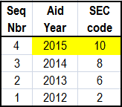

In this scenario:
- the highest sequenced number row on the student's ATB record is 4, and the Aid Year associated with this sequence number is 2015 – it will be used for Aid Years 2016 and 2015.

Result:
- For Aid Year 2016 (Seq Nbr 4), since "10" is a valid SEC value, it would pass validation and the record would be transmitted.
- For Aid Year 2015, since "10" is an invalid SEC value, it would fail validation and the record would not be transmitted.
PLUS Loan Applicant with Adverse Credit History

The system has been expanded to support the receipt of PLUS credit-related information that reflects whether the PLUS borrower (parent or graduate/professional student) has satisfied the PLUS credit check requirements.

The COD Inbound routine supports the loading of a new Credit Status Response file (Document Type = CS). The COD Inbound routine will continue to determine whether or not the PLUS loan is eligible to be disbursed depending on whether the borrower has met federally prescribed PLUS credit requirements.

The Regular PLUS Response file will contain (among other things) the following credit-related fields:

- Credit Decision Status
- Credit Decision Date
- Credit Requirements Met

The new Credit Status Response file will contain the following credit-related fields:

- Credit Action Choice
- Credit Action Status
- Credit Appeal Status
- Credit Balance Option
- Credit Decision Date
- Credit Decision Expiration Date
- Credit Requirements Met
- Endorser Amount
- Endorser Approved
- Original Credit Decision Status
- PLUS Counseling Completed
- PLUS Counseling Complete Date
- PLUS Counseling Exception
- PLUS Counseling Expiration Date
- Reconsideration Eligible

On the COD Staging table (SFA_COD_AWARD), the both the Credit Decision and the Counseling Information group boxes have been enhanced:

Navigation: Financial Aid > File Management > View COD Data > COD Award

Credit Decision group box:

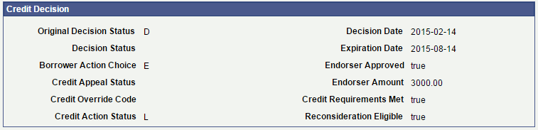

The following fields have been added:

Credit Action Status Decision regarding Endorser.

D = Credit denied as a result of an endorser's denial
N = Credit denied after pending
L = Endorsed for a Lesser Amount*

* = If Credit Action Status = L, check to see if Edit 184 is present. If it is, this means that the loan is endorsed for less than the Award Amount, and the institution must submit an Origination Change transaction that reflects an Award Amount equal to or less than the Endorsed Amount. Once COD accepts the Origination Change transaction for the lesser Award Amount (equal to or less than the Endorsed Amount), it will send an Acknowledgment with Edit 183.

Endorser Approved Indicates an Endorser Addendum was received and whether the Endorser was approved.

True
False

Credit Requirements Met Borrower has met all of the credit requirements for the PLUS loan. If the loan was originally denied, this also includes the PLUS Credit Counseling. Must be True before the loan may be disbursed.

True
False

Reconsideration Eligible Indicates whether the applicant is eligible for reconsideration of the PLUS loan when the PLUS was originally denied.

True
False

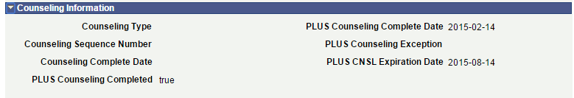

PLUS Counseling Completed Indicates whether the borrower has completed the requisite PLUS Counseling directly with COD – required for PLUS applicants (a) who were initially denied their PLUS loan and (b) who have obtained an approved endorser or an approved credit appeal due to extenuating circumstances. Must be complete before the loan may be disbursed.

True
False

PLUS Counseling Completed Date Date on which PLUS Counseling was completed by the borrower.

PLUS Counseling Exception Reserved for future use by COD.

PLUS Counseling Expiration Date Date on which PLUS Counseling expires.

On the Loan Origination record (PS_LOAN_ORIGNATN), the Loan Credit Information group box has been renamed to PLUS Loan Credit Information, and it has been expanded.

Navigation: Financial Aid > Loans > Direct Lending Management > Application Misc Data

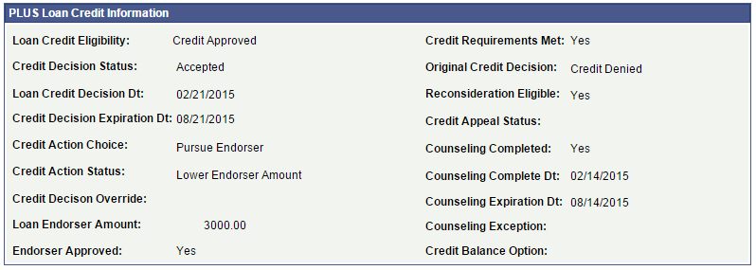

The following fields have been added:

Credit Decision Status The status of the PLUS credit decision for the loan on COD.

A = Accepted
D = Denied
P = Pending

Credit Decision Expiration Date Indicates the date on which a potential borrower’s credit decision will expire, necessitating the need for another credit check prior to originating a PLUS loan.

Credit Action Choice Indicates the action a borrower plans once the borrower has failed the credit check

A = Appeal Decision
E = Pursue Endorser
N = Not Pursue PLUS Loan (Process Additional Unsubsidized Loan if
Eligible)
U = Undecided

Credit Action Status Status of Endorser Pursuit:

D = Credit denied as a result of an endorser's denial
N = Credit denied after pending
L = Endorsed for a Lesser Amount*

* = If Credit Action Status = L, check to see if Edit 184 is present. If it is, this means that the loan is endorsed for less than the Award Amount, and the institution must submit an Origination Change transaction that reflects an Award Amount equal to or less than the Endorsed Amount. Once COD accepts the Origination Change transaction for the lesser Award Amount (equal to or less than the Endorsed Amount), it will send an Acknowledgment with Edit 183.

Endorser Approved Indicates an Endorser Addendum was received and whether the Endorser was approved.

True
False

Credit Requirements Met Borrower has met all of the credit requirements for the PLUS loan. If the loan was originally denied, this also includes the PLUS Credit Counseling. Must be True before the loan may be disbursed.

True
False

Original Credit Decision The initial credit decision for a PLUS borrower. If denied, the borrower may choose to appeal the decision due to extenuating circumstances or seek an endorser for the loan.

A = Accepted
D = Denied

Reconsideration Eligible Indicates whether the applicant is eligible for reconsideration of the PLUS loan when the PLUS was originally denied.

True
False

Credit Appeal Status Indicates current status of a credit appeal.

A = Appeal Accepted
D = Appeal Denied
P = Appeal Pending
R = Appeal Closed Without Final Decision

Counseling Completed Indicates whether the borrower has completed the requisite PLUS Counseling directly with COD – required for PLUS applicants who have obtained an approved endorser or an approved credit appeal due to extenuating circumstances. Must be complete before the loan may be disbursed.

True
False

Counseling Completed Date Date on which PLUS Counseling was completed by the borrower

Counseling Expiration Date Date on which PLUS Counseling expires.

Counseling Exception Reserved for future use by COD.

Credit Balance Option Indicates whether a credit balance on a loan should be directed to the student or the borrower.

B = Borrower
S = Student

COD Inbound Processing

In addition to the existing Loan Credit Eligibility field, the COD Inbound routine will interrogate the new Credit Requirements Met field to see if the loan is eligible to be disbursed. Based on the type of candidate being evaluated, the system will use the following criteria for disbursement eligibility:

Credit Appeal Candidate: This is an applicant who pursued an appeal for extenuating circumstances for an originally denied PLUS Loan. If Loan Credit Eligibility equals Credit Approved and Credit Requirements Met equals Yes, the loan is eligible to be disbursed from a PLUS Credit Check perspective.

Credit Action Candidate: This is an applicant who pursued an Endorser for an originally denied PLUS Loan. If Loan Credit Eligibility equals Credit Approved, Credit Requirements Met equals Yes, and Edit 184 is not present, the loan is eligible to be disbursed from a PLUS Credit Check perspective. However, if Edit 184 is present, then this indicates that COD endorsed the loan for an amount less than Award Amount. The institution must submit an Origination Change transaction that reflects an Award Amount reduction equal to or less than the Endorsed Amount. Once COD accepts the Origination Change transaction for the lesser Award Amount (equal to or less than the Endorsed Amount), it will send an Acknowledgment Response file with Edit 183. Edit 183 will replace Edit 184. The loan is then eligible to be disbursed from a PLUS Credit Check perspective.

In addition to the above PLUS Credit Check evaluation, the system will conduct the "normal and necessary" disbursement criteria checks on the PLUS loan in order to determine whether the PLUS loan is eligible to be disbursed (e.g., MPN satisfied if required, Credit Check is Accepted if required, etc.).

NOTE: The results of the borrower's PLUS Credit Counseling will be included as part of the Credit Status Response file, and no additional action is required in order to see the results (see the COD Staging table and the Direct Lending Management > Application Misc Data page for PLUS Credit Counseling results).

DLSAS Disbursement Detail On Demand Message Class

The system has been enhanced to support the loading of the Direct Loan School Account Statement Disbursement Detail On Demand Message Class beginning with the 2016 Aid Year. This report is limited to the Disbursement Detail Section.

The supported Activity Types are:

Activity Type Message Class
Date Range DSRFxxOP
Month To Date DSMFxxOP
Year To Date DSYFxxOP

The supported format for these Activity Types is fixed length.

Navigation: Financial Aid > Loans > DL School Account Summary > DLSAS Import 2015-2016

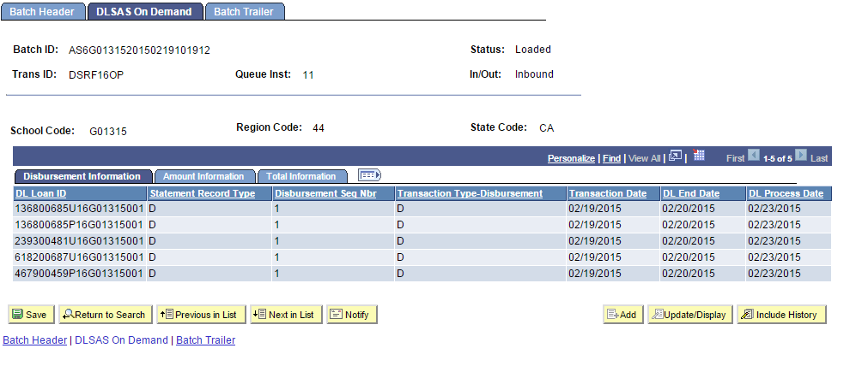

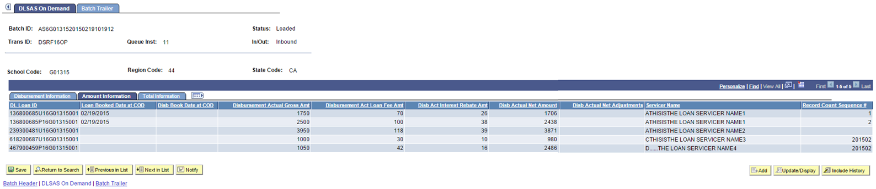
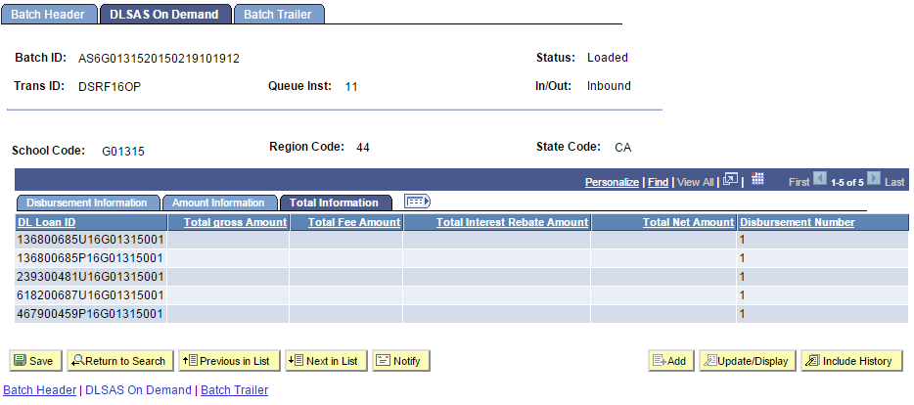

Verification Tax, Credits, and Payments Changes

This item is not related to COD 2015-16 Updates – rather this item addresses Verification Bug 20640426.

ATTENTION: A data mover script (dms) for the Verification feature has been delivered with
this Critical. Run this script after applying the Critical.

NOTE: Assumptions made with creation of the dms is that schools have entered the correct
US Tax Paid Amount on the Tax Form Data page. The dms takes this amount and copies it
to "Line xx Income Tax Amount" (formerly Line xx Tax Total Less Credits). Upon completion
of the Critical Update installation, Line xx Income Tax Amount will be the field used to populate
US Tax Paid.

Entering Tax, Credits, and Payments

Access the Tax, Credits, and Payments page (click the Tax, Credits, and Payments link on the Tax Form Data page).

Tax Credits and Payments allows entry of pertinent data from forms 1040, 1040A, and 1040EZ. It captures Line xx Income Tax Amount and uses that value to update U.S. Tax Paid on the Tax Form Data entry page for use in the compare process. Other fields used in compare available in Tax, Credits, and Payments are Schedule A itemized Deductions (1040 only), Education Credits, Additional Medicare Form 8959, Earned Income Credit, and Additional Child Tax Credit.

