Drop & Withdraw Policy

If a student decides they want to drop or withdraw from a course, it is the student’s responsibility to complete & submit an official LSC-Tomball ‘Dual Credit Course Drop Form.’
(NOTE: High School students may obtain a drop form from their designated high school counselor so that the counselor may sign-off on the form before submitting it to LSC-Tomball. We will not accept drop forms that are not signed by the ‘High School Designee’)
*Obtain a ‘DC Course Drop Form’ at: www.lonestar.edu/TomballDualCredit
*If a student does not submit the proper drop form, he/she will not officially be dropped or withdrawn from the requested course(s).
(Sample ‘Dual Credit Course Drop Form’ shown below)
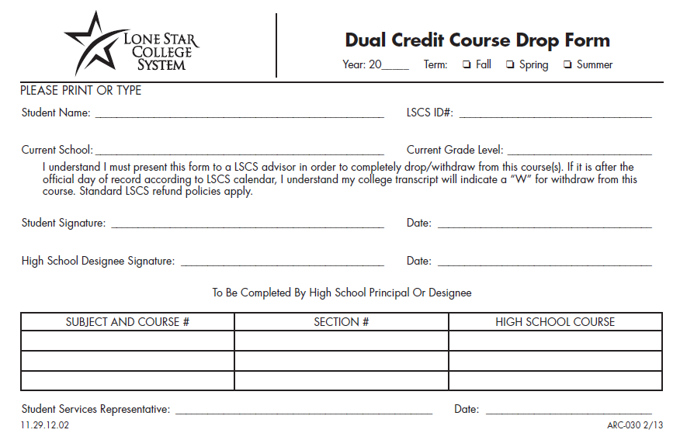
Questions about payment or refunds?
Cashier’s Office C120
(281)357-3754

Please submit all drop forms to:
TC-DualCredit@lonestar.edu

Or drop it off in person at:
LSC-Tomball
Advising Office C100
30555 Tomball Parkway
Tomball, Texas 77375
**PLEASE NOTE: These dates are only VALID for courses that begin: 01/16/2018-05/13/2018
$$$ Last Day to Receive a Refund $$$

Last Day for 100% refund | Friday, January 12, 2018
Last Day for 70% refund & drop a course without a grade of ‘W’ | Monday, January 29, 2018
Last Day for 25% refund | Friday, February 2, 2018
Last Day to Drop & Withdrawal
Last Day to drop a course without a grade of ‘W’ | Monday, January 29, 2018
Last day to withdrawal with a grade of ‘W’ | Friday, April 6, 2018

*Please note refunds are not immediate:
- Refunds are only processed by our System Office on Mondays and Thursdays.
- Cash or Check: Cash, check, or debit card then it goes to a refund profile. (If they have one on file, if not then a check is processed and those aren’t mailed until Thursday).
- Credit Cards: If paid with a credit card then the refund goes back to the credit card.

