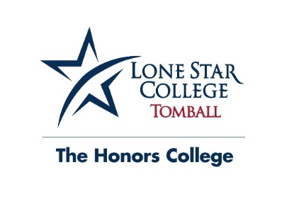
The Honors College Frequently Asked Questions
About the Honors College
The Honors College offers an innovative curriculum for highly motivated, academically capable students. Students enjoy the freedom to work independently and collaboratively with faculty who encourage lively, engaging discourse. Conducting original and substantive research is the cornerstone of Honors courses.
FAQs about Honors Courses
How much time commitment does The Honors College require?
Each student in The Honors College is required to take at least one honors course per semester, to attend three workshops per semester (typically two hours each) and to attend Honors Undergraduate Research Day each semester. There are many additional opportunities for Honors College students to be involved, and each student determines their own level of involvement. For example, students may choose to be involved in the Honors College Student Organization, they may choose to volunteer to help organize events, and a few may be able to work in the Honors College Office.
How much time commitment do Honors courses require? Honors class time and additional preparation/study time is similar to that of a regular class. Many honors students participate in a study group formed on their own initiative. Study groups may be via a group text or face-to-face meetings. Interaction with other Honors students provides invaluable feedback and often serves as a catalyst for new ideas. The more involved Honors students are during class and outside of class, the more successful they are in their Honors courses.
What makes a class “Honors”? Honors classes are characterized by enriched curricula that emphasize critical thinking and in-depth analysis, and are interdisciplinary in nature. Honors education is not defined as “more work.” In other words, an Honors literature class does not necessarily require more readings than a regular literature class. In fact, fewer texts may be studied, but students may spend more time critically analyzing the text through social, historical, or economical perspectives. Students in an Honors class will conduct research culminating in a paper and an in-class or local presentation. Honors projects must fit within the parameters of the class’s discipline. For example, in an Honors history class students will conduct historical research, but the projects are customizable to meet the student’s interest.
But won’t Honors classes negatively impact my GPA? No. Our data, which mimics national data, shows that students who participate in Honors see their GPA go up rather than down. It isn’t uncommon for students to receive higher grades in their Honors classes than in their non-Honors classes. Why?
- Honors classes are smaller, which allows for more class discussion, which helps students understand a discipline more thoroughly.
- Because the classes are smaller, students get to know their professor better and are therefore mentored by the faculty.
- Because the classes are smaller, students get to know each other better and share research and ideas, which ultimately helps make a better project.
- The projects are interesting; therefore, the students want to complete this work.
For more information about the LSC-Tomball Honors College, email TomballHonorsCollege@lonestar.edu.
Information about eligibility requirements and The Honors College application are available here: http://www.lonestar.edu/HonorsCollegeAdmissions.htm

