Part III: Confirm Major
(Program and Plan) in iStar

Pilot Program Spring 2012: EDUC 1300 Best Start Activities

Outcome I:
100% of students in the Best Start Program will participate in career
exploration and an enrollment planning activity, confirm their major
(Program/plan) and sub-plan (if applicable) in iStar, and select courses
to input into iStar’s My Planner before the end of the semester.

Part III: Confirm Major (Program and Plan) in iStar
- QEP Best Start Activity: Confirm or Change Major in iStar
- “How to Confirm Major” in iStar Powerpoint

Part III: Confirm Major (Program and Plan) in iStar
Tips for Instructors

- Included in this activity is a copy of “A Reference Guide Requesting Program/Plan Change” edited from an iStar “How-to” document created by Nicole Aboltin. This handout can be used to guide students step by step through requesting a change in their plan (major) in iStar’s MyLoneStar. Students should confirm their major in iStar near the end of the semester once they have completed their career exploration (Career Research Paper).

- Tip: Hand out the reference guide and have students follow the directions. You can also use the power point, “Confirm Your Major in iStar” and have students follow along. It is especially important for undecided students to revisit this site. By the end of the semester, undecided students may have chosen a major and wish to pursue an Associate of Arts (AA) or an Associate of Science (AS) degree. If they are planning to transfer, they will choose either the AA or the AS with no sub-plan. They basically keep choosing AA or AS in every drop down. The Associate of Arts (AA) is the Program for the majority of majors who will be transferring to a university.

- Students pursuing nursing degrees and other competitive health programs at LSCS will not choose nursing as their Plan or Major as they have not been accepted into the program. They should choose Associate of Science (AS) and then add their sub-plan once they are accepted into the program. It is necessary that they attend an information session usually listed on the program website to gain more information about admission into the program.

- This activity initiates a request at the appropriate campus to change the student’s major in iStar. Someone will manually change the student’s plan therefore it does not take effect immediately. If students have more in depth questions about changing their plan, they should make an appointment with an advisor or counselor. They may also ask questions during their mandatory appointment with an advisor.

5. Degrees:
AA- Associate of Arts degree, for transfer to a university.
AS- Associate of Science degree, for transfer to a university.
AAS- Associate of Applied Science. Students usually enter workforce.
Certificate- Students usually enter workforce.

Students will only be able to request a change of their major via an online form. Processing of the request will be done at the appropriate campus.

Requesting Program/Plan Change

- Go to my LoneStar.edu, and log in
- Click the Self Service Link
- Click the Student Center Link
- Click the Change Your Major (Prog/Plan) link under the Student Services section.
- A new window will open. Click the Maximize/Restore button to expand your
viewing area.
- Two options will be offered in the new window. You could either Change Plan
or Add Plan. To Change you plan, click the Change Plan Option.
- Click the Change Plan drop down list to select your current plan that you are
interested in changing.
- Click the Select Campus Location drop down list.
- Select your primary campus.
- Click the Academic Program drop down list.
- Select an academic program you are interested in.
- Click the Select Plan of Interest drop down list.
- Select a degree plan you are interested in.
- Click the submit button.
- After you have submitted your change request, an e-mail will be sent to your
primary campus of choice. They will process your request and send you a confirmation to your Lone Star e-mail account.
- To add a plan, click Add Plan option.
- Click the Select Campus Location drop down list.
- Select your primary campus.
- Click the Academic Program drop down list.
- Select an academic program you are interested in.
- Click the Select Plan of Interest drop down list.
- Select a degree plan you are interested in.
(Edited from the “How-to” Documents by Nicole Aboltin).
Change or Add a Major
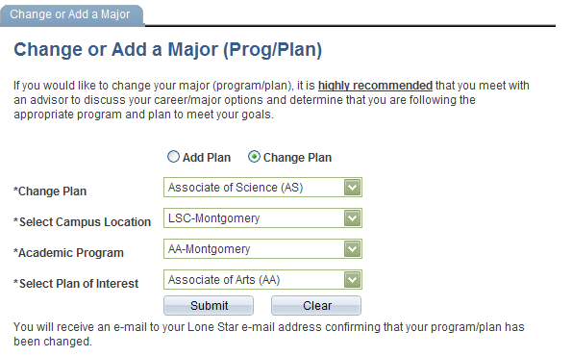
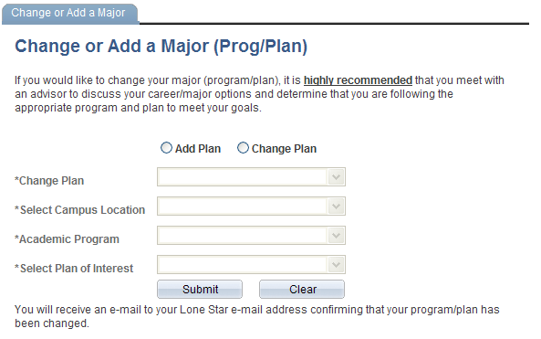
In iStar Student Center

