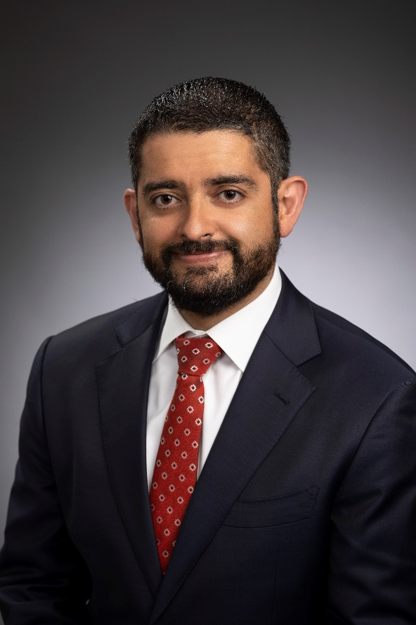
Mario K. Castillo
Mario is the Lone Star College Chief Operating Officer and General Counsel. Mario began his career at Lone Star as the General Counsel in 2015, became Vice Chancellor & General Counsel in 2016, and in 2017 he became the Chief Operating Officer and General Counsel. From 2020-2021, Mario was also the Interim College President at Lone Star College—Kingwood in addition to his other duties.
As the Chief Operating Officer and General Counsel, Mario oversees virtually all day-to-day activities of the Lone Star College System, including day-to-day management of the College’s COVID-19 response.
Prior to joining the College, Mario served as a Labor & Employment Partner at Monty & Ramirez in Houston, with his practice focused on labor disputes, employment litigation, wage and hour litigation, and employee benefits compliance. During this time, he also effectively represented the College as outside counsel in various matters, including contract disputes and employment discrimination claims. Mario’s experience also includes litigation on cases in state and federal courts, various appellate courts, and the Texas Supreme Court; serving as a briefing attorney for the Honorable Felix Recio of the Southern District of Texas; and teaching criminal law as an Adjunct Instructor at the University of Texas, Brownsville. While there, he wrote an article for the Baylor Law Review, Immigration Consequences: A Primer for Texas Criminal Defense Attorneys in Light of Padilla v. Kentucky.
In addition to his successful litigation practice, Mario has extensively written about the Affordable Care Act and considered a leading expert on this topic. His article, Independent Contractor Misclassification Penalties Under the Affordable Care Act, was published in the highly regarded Houston Journal of International Law. Mario is also Board Certified in Labor and Employment Law by the Texas Board of Legal Specialization. Mario has been interviewed and quoted in the New York Times, Forbes Magazine, and Houston Chronicle, and is routinely asked to speak at seminars, conventions, as well as other events.
Mario received his Juris Doctorate from the Maurer School of Law at Indiana University in Bloomington, his Bachelor of Arts in Government from the University of Texas in Austin, and is Board Certified in Labor and Employment Law by the Texas Board of Legal Specialization.

