COSMETOLOGY & ESTHETICS

General Information
- The LSC-KW Cosmetology Program prepares the student for the Texas
Licensing Exam.
  - Upon successful completion of the 1000-hour certificate program, the
graduate will be eligible to sit for the Texas licensing exam and to apply for a Cosmetology Operator License.
- The LSC-KW Facial/Esthetics Program prepares the student for the Texas
Licensing Exam.
  - Upon successful completion of the 750-hour certificate program, the graduate will be eligible to sit for the Texas licensing exam and apply for an Esthetician License.
- LSC-KW also offers Associate of Applied Science Degree (AAS) in Cosmetology
And Facial*
(*AAS degrees require additional academic credits. This is optional and courses may be taken before or after the certificate)

Entrance Requirements for the Operator and Facial Certificate:
- High school diploma or GED
- Minimum age 17 years (Must be 18 years at the time of licensing exam)
- Attendance at mandatory orientation Aug 12, 2024.

Additional Information
- To remain in good academic standing, students must earn C or higher in each course.
- It is recommended that students work no more than 20 hours per week while in the program.
- Students who withdraw may be readmitted one time only with Faculty/Dean approval.
-----------------------------------------------------------------------------------------------------------------------------
Start Dates:
- Cosmetology Operator – Fall
- Facial Specialist – Fall
-----------------------------------------------------------------------------------------------------------------------------
Schedule:
Operator Certificate* August - August (3 semesters)
2 Schedule Options:
- Session 1- M-Th 8:30-12:30
- Session 2 - M-Th 10:00-2:00
- Hybrid Theory

Facial Specialist -: August – May (2 semesters)
2 Schedule Options:
- Session 1 - M-Th 8:30- 1:00
- Session 2 -M-Th 1:30- 6:00
- Hybrid Theory

LSC-Kingwood Cosmetology Application Checklist

________Submit online application for Lone Star College (see the last page for help choosing the
correct degree option)

________Complete online Cosmetology Application form. (This does not guarantee acceptance)

________Complete a New Student orientation if you have not previously attended LSC.

________Complete bacterial meningitis requirement http://www.lonestar.edu/meningitis if
applicable.

________If applicable, send Official* college transcripts to:
Admissions
Lone Star College-Kingwood
20000 Kingwood Drive
Kingwood TX 77339

________Attend a virtual information session. All sessions will be held at 1pm on Webex.
The link for the sessions is on the CSME website.

2024 Session Dates

Feb 5

Mar 4

Apr 1

May 6

________ Meet with advisor Samantha.DeLeon@lonestar.edu for registration after application checklist is complete. Acceptance is on a first come, first served basis once all application requirements are met. Once programs are at full enrollment, waitlists are available.

________ Apply for Financial Aid

________Pay for classes by LSC Fall payment deadline

________Attend mandatory in person Orientation August 12, 2024. Time TBA
- Student kit and book bundle information will be provided
- Students must purchase kits and book bundle by the first day of class.

*Official transcripts should be sent directly from the college/university to LSC Admissions. If you bring an official transcript directly to the college, the envelope must be unopened.
(An unofficial transcript is acceptable for this visit; however, LSC-Kingwood must have an official transcript as requested above)

For more information: Samantha.DeLeon@lonestar.edu

Specific information on tuition, books, and kit and other costs for the Cosmetology Program will be available at the information sessions.

LSC – KINGWOOD COSMETOLOGY

CERTIFICATE OF COMPETENCY

ESTIMATED COST

First Semester
*CSME 1501 Orientation to Cosmetology 5 Credit Hours

*CSME 1410 Introduction to Haircutting & Related 4 Credit Hours
Theory
*CSME 1543 Manicuring and related Theory 5 Credit Hours
Semester Total 14 Credit Hours
Second Semester
*CSME 1553 Chemical Reformation & Related Theory 5 Credit Hours

*CSME 2501 Principles of Hair Coloring & Related
Theory 5 Credit Hours
*CSME 1547 Principles of Skin Care/Facials and Related
Theory 5 Credit Hours
Semester Total 15 Credit Hours
Third Semester
*CSME 2337 Advanced Cosmetology Techniques 3 Credit Hours

*CSME 1354 Artistry of Hair Design 3 Credit Hours

Semester Total 6 Credit Hours

ESTIMATED COST LIST

First Semester in District Out-of-District International
*Tuition &Technology Fees (14 credit hours) $ 1,344.00 $ 2,996.00 $ 3,766.00
Kits A & B $ 1,663.00 $ 1,663.00 $ 1,663.00
Textbooks and MindTap Access Code $ 300.00 $ 300.00 $ 300.00
Scrubs $ 40.00 $ 40.00 $ 40.00
TDLR Permit Fee (credit card accepted Fall week 1) $ 25.00 $ 25.00 $ 25.00
________ ________ _________
$ 3,072 .00 $ 5,024 .00 $ 5,794.00

Second Semester
*Tuition & Technology Fees (15 credit hours) $ 1,440.00 $ 3210.00 $ 4035.00

Third Semester
*Tuition & Technology Fees (6 credit hours) $ 576.00 $ 1,284.00 $ 1,614.00

TOTAL ESTIMATED COSTS (35 credit hours) $ 5,088 .00 $ 9,518.00 $ 11,443.00

In-District – includes the independent school districts: Aldine, Conroe, Humble, Spring, New Caney, Tomball, Willis, Splendora, Cy-Fair, Klein and Magnolia.

LSC-KINGWOOD FACIAL SPECIALIST

CERTIFICATE OF COMPETENCY
ESTIMATED COST

1st Semester
CSME 1420 Orientation to Facial Specialist 4 Credit Hours
CSME 1421 Principles of Facial/Esthetic Technology I 4 Credit Hours
CSME 1248 Principles of Skin Care 2 Credit Hours
Semester Total 10 Credit Hours
2nd Semester
CSME 1547 Principles of Skin Care/Facials & Related Theory 5 Credit Hours
CSME 1445 Principles of Facial/Esthetic Technology II 4 Credit Hours
CSME 2431 Principles of Facial/Esthetic Technology III 4 Credit Hours
Semester Total 13 Credit Hours

____________________________________________________________________________

ESTIMATED COST LIST

1st Semester in District Out of District International
Tuition and Fees (10 semester hours) $ 960.00 $ 2140.00 $ 2690.00
Kit A & B $ 832.00 $ 832.00 $ 832.00
Textbooks & MindTap Access Code $ 333.00 $ 333.00 $ 333.00
Scrubs $ 40.00 $ 40.00 $ 40.00
TDLR Permit Fees (credit card accepted Fall week 1) $ 25.00 $ 25.00 $ 25.00
_________ ______ ________

Total: $ 2,190 .00 $ 3,370.00 $ 3,920.00

2nd Semester
Tuition and Fees (13 semester hours) $ 1,248.00 $ 2,782.00 $ 3,497.00

___________________________________________________________________________________
Total Estimated Costs (23 credit hours) $ 3,438 .00 $ 6,152.00 $ 7,417.00

In-District – includes the independent school districts: Aldine, Conroe, Cypress-Fairbanks, Humble, Klein, Magnolia, New Caney, Splendora, Spring, Tomball, Willis Independent School Districts.

Choosing the Cosmetology or Facial Certificate or AAS in My Lonestar Application

- Create account
- Begin application
- Once you reach the degree and certificate option page, you will see the certificate option
- Choose the campus
- Choose Cosmetology Operator or Facial Specialist (see screen shot) OR
- Choose

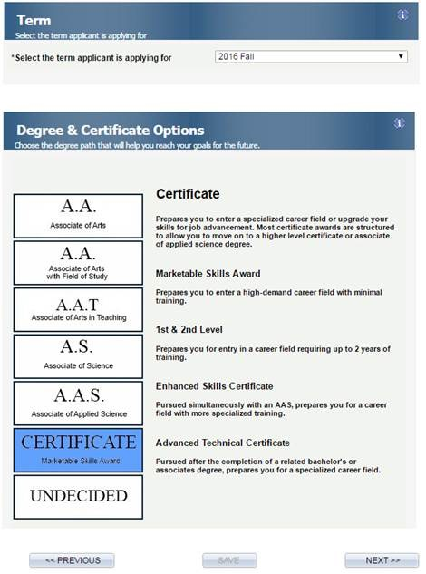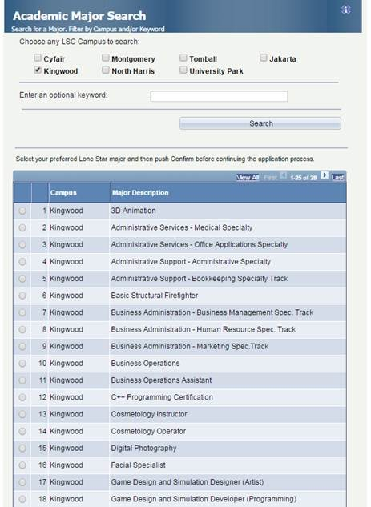

Notice for All Schools and Educational Programs Licensed by TDLR
As of September 1, 2017, House Bill 1508 requires that all entities providing educational or instructional programs that prepare a student for an occupation or vocation requiring a TDLR license to:
  - Inform the student or program participant that eligibility for a TDLR license could be affected by the person’s criminal history;
  - Notify students and participants that TDLR is responsible for having in place guidelines regarding a license applicant's criminal history, and to include information on an applicant's ability to be licensed under those guidelines;
  - Provide students with information on other state or local restrictions that would affect the student’s eligibility for an occupational license issued by TDLR;
  - Inform students of the student's right to request a criminal history evaluation letter from TDLR;
  - Provide all persons who enroll in their program with notice of the requirements as described above, regardless of whether the person has been convicted of a criminal offense.
An educational entity or training program operator who fails to provide this information to a person who is enrolled in their course may be liable for tuition or application fees paid by any student who is denied a TDLR license due to the existence of a criminal conviction.

Frequently Asked Questions
1. Why does my school need to provide this notice?
During the 85th Legislative Session, the Legislature passed House Bill 1508 that requires notice be provided to students in an educational program that prepares individuals for issuance of an occupational license. House Bill 1508 takes effect on September 1, 2017. (Chapter 53, Texas Occupations Code). Entities and schools that provide educational programs to prepare an individual for issuance of an initial occupational license must provide this notice.

2. What information should the notice include?
Section 53.152 of the Occupations Code requires entities or schools to notify each applicant to and enrollee in the educational program of the following information:

The potential ineligibility of an individual who has been convicted of an offense for issuance of an occupational license after completion of the educational program;
The current criminal history guidelines issued under Section 53.025, Occupations Code, by any licensing authority that may issue an occupational license to an individual who completes the educational program;
Any other state or local restriction or guideline used by a licensing authority described by Subdivision (2) to determine the eligibility of an individual who has been convicted of an offense for an occupational license issued by the licensing authority; and
The right to request a criminal history evaluation letter under Section 53.102, Occupations Code.
3. Who needs to receive this notice?
House Bill 1508 requires notice to each enrollee in and applicant to an educational program. Notice must be provided to individuals who are enrolled in an educational program subject to the notice requirement on or after September 1, 2017, and to individuals who apply for enrollment in the program on or after September 1, 2017.
4. How do we provide this notice?
Each entity or school required to provide notice is responsible for determining how best to provide the notice information to applicants and enrollees. TDLR has developed a suggested notice and acknowledgement form to provide guidance on how to provide this information. The form is available for download.
5. What happens if this notice is not provided?
If TDLR determines that the entity or school providing the educational program failed to provide the notice required by Section 53.152, Occupations Code, to an individual entitled to receive the notice and that individual was denied a license because the individual has been convicted of an offense, the law requires TDLR to order the entity or school to:
- refund the amount of any tuition paid by the individual to the entity or school; and
- pay to the individual an amount equal to the total of the following, as applicable:
  - the amount of any application fees paid by the individual to TDLR; and
  - the amount of any examination fees paid by the individual to TDLR or an examination provider approved by TDLR.
6. Do these requirements apply only to programs regulated by TDLR?
No. House Bill 1508 requires all entities or schools that provide educational or training programs that prepare students for occupations that require an occupational license to provide the notice to its enrollees and persons who apply for enrollment in the programs. The information given here simply refers to schools and entities regulated by TDLR. For information regarding a school or educational entity not regulated by TDLR, refer to the agencies that regulate those programs.

