Faculty Senate Agenda for August 2021
Item 1# Guests
Dr. Blanson 1:00
-Cafeteria will open next week
Michael McFarland- Mentoring program 1:10
-Title V Grant ended
-Short Webex meeting in early October
-Visit a faculty member’s class and discuss about their style of teaching
-Write a brief paragraph about the program
-There is a guide for the program
-Enroll with Michael McFarland
Billy Hoya- Makerspace and more. 1:15
-Billy Hoya is collecting pictures form covid- please add them to the link he provided. https://nhresearch.lonestar.edu/Pandemic/Image
-Archival collection of photos of how faculty, students, and staff have been affected by the pandemic
-photos are published in the Library’s Flickr account
-New Laser Cutter in the Makerspace
-SLA printer
-Sound booth is available
Christine Ramsey- Library services 1:20
-Extended hours
-Students can check out books
-Services are available for students
https://nhresearch.lonestar.edu/NH-Archives
https://www.lonestar.edu/nh-tutors.htm
https://nhresearch.lonestar.edu/FacultyServices
https://nhresearch.lonestar.edu/NH-Archives/OCS

Chris Viser- Accommodations 1:25
-Paper accommodations are not done anymore
-Instead, virtual forms are submitted
Magdalena Mendoza- Interim VP Student Success 1:30- is out sick today
Holly Heil- CIS 1:35
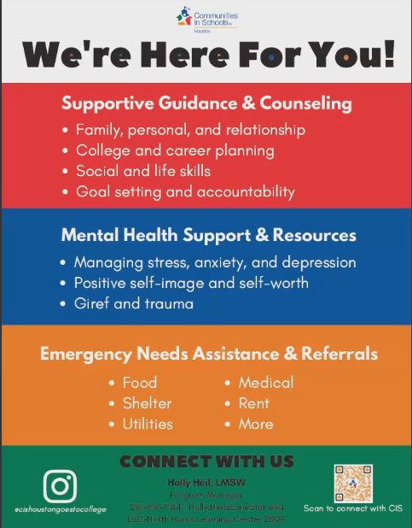
-Office: 281-618-7144
-Email: Holly.Heil@LoneStar.edu
-https://www.lonestar.edu/cis
Tara Edwards- Writing Center 1:40
-Available for tutoring online
-it is important for the students to be prepared before the tutoring session
-students must make an appointment
-https://www.lonestar.edu/nh-tutors.htm
Randall Paulk- OTS Changes and updates 1:45
-call OTS
-832-813-6600
-https://www.lonestar.edu/ots.htm
-M-F of 7 am to 7 pm, Saturday 8 am to 2 pm, no Sunday hours
-classroom checks to make sure the tech work
-everything will be collapsed in one domain
-lonestar.edu/techconnect (for students)
-cameras available in certain classrooms where they can host or record a session- see room list below
Dr. McMillion 1:50
-number of credentials awarded increased last academic year
Questions for Dr McMillion- email questions to Casey or me and we will ask those questions.
North Harris Counselors- We lost our one Counselor to the SIP and it seems like there is no plan to replace her. Is this true? What can we do to address the students need for counselors on our campus?
-no more remaining faculty counselors left at North Harris
-Dr. Head’s intention was that CIS would take over that type of service
-awareness problem: some people are not aware of what CIS does
-Rhonda’s position will not be replaced
-CIS is contracted with the college
-Holly Heil’s credentials: Licensed Master Social Worker (LMSW) currently working on my clinical supervision. I've been with CIS for a year and a half now. Prior to this, I worked with victims/survivors of violent crimes at the Harris County District Attorney's Office.
-Available counselors now are Holly Heil and Victoria Medina who assists our program part-time. We have posted a position for another CIS counselor. Hoping to have another person hired in September/October. Also, we have CIS counselors on each campus who are able to assist.

-Dr. Blanson is also looking into this issue as well. Counselors are trained LPCs and provide career counseling and other counseling. Very important for first gen students. CIS can connect people with resources in the community but cannot do these things. Student success and enrollment have been impacted and we as faculty believe that our limited supply of counselors is a major factor in these declines. Other campuses have 7 or 8 and we will have none.
Will we be limited two Fac Excellence awards winners this year?
Item 2# Chair updates
Erin- Cat V and Student Emergency Funds
-No resolution was addressed concerning the mental health concerns of the students
-Food Pantry is operating on a limited-basis
-the most requested items are single serving "meals" - mostly ramen cups, mac and cheese cups, single cereal servings, then toiletries (toothpaste, deodorant, etc.)
erin.e.ranft@lonestar.edu
Food Pantry (Cat-5 Cupboard) times for fall: Wednesdays and Thursdays, 12pm – 1pm (ACAD 108)
-grab and go
-Refer students to Erin or Kimberlee about the student emergency funds
-looking at the inventory
-donation provided for the Food Pantry

Shirley- Faculty Emergency Funds
-there is a limit to how much can be given
-Giving Campaign will happen Fall 2021
Janice- Fac Excellence Award
-all awards are being done in the Fall semesters
-nomination forms will be sent out around the 4th week of the semester
-no observations anymore
-need a representative from every department
Julie- Faculty Institute/ Adjunct Bootcamp/ Professional Development Series
-Teaching and Learning in the 21st Century, from 8 am to 2 pm
-email sent out by Sandra Velaquez
-Adjunct Boot Camp this Saturday
-Monday and Tuesday Professional Development
Traqina- New Champion of Diversity and Inclusion Award Committee members
-Brand new committee that includes Faculty and Staff
-add additional members
-developing criteria and questions
- traqina.q.emeka@lonestar.edu
Diversity Task Force- continuing the discussion about DEI concerns and implementing real change. Anyone is welcome to join- reach out to Casey Garcia or Bruce Martin. They will be reviewing the DEI survey results among other things.
Item 3# Other news
Permit less carry bill- will there be any changes to our syllabus policy in response to the changes in the law?- No
Covid 19 regulations- encourage you to wear masks and get vaccinated. Classrooms have been modified to allow for 3 feet spacing for the fall. We are still supposed to report covid.
Cesar Chavez Holiday- it will require a change in the class schedule like we do for Thanksgiving or losing a day of Christmas holiday to make this happen. Dr. Head is willing but wants consensus from the faculty across the system. I will be sending out a poll to ask our faculty- please watch for it.
Item 4# Q&A Questions and concerns among faculty
Covid procedures and labs without being able to require masks. Suggested informing the students day one with the realities of Covid and hope they come to the conclusion that wearing a mask is a good idea. Many of them aren’t really aware of the serious nature of the illness.

Camera ready classrooms, mentioned by Randall Pualk
North Harris:

ACAD 138
ACAD 139
ACAD 263
ACAD 269
DTEC 104
DTEC 114
DTEC 203
DTEC 211
DTEC 212
WNSP 156
WNSP 158

East Aldine Center:

EAC 202
EAC 206
EAC 211

-

