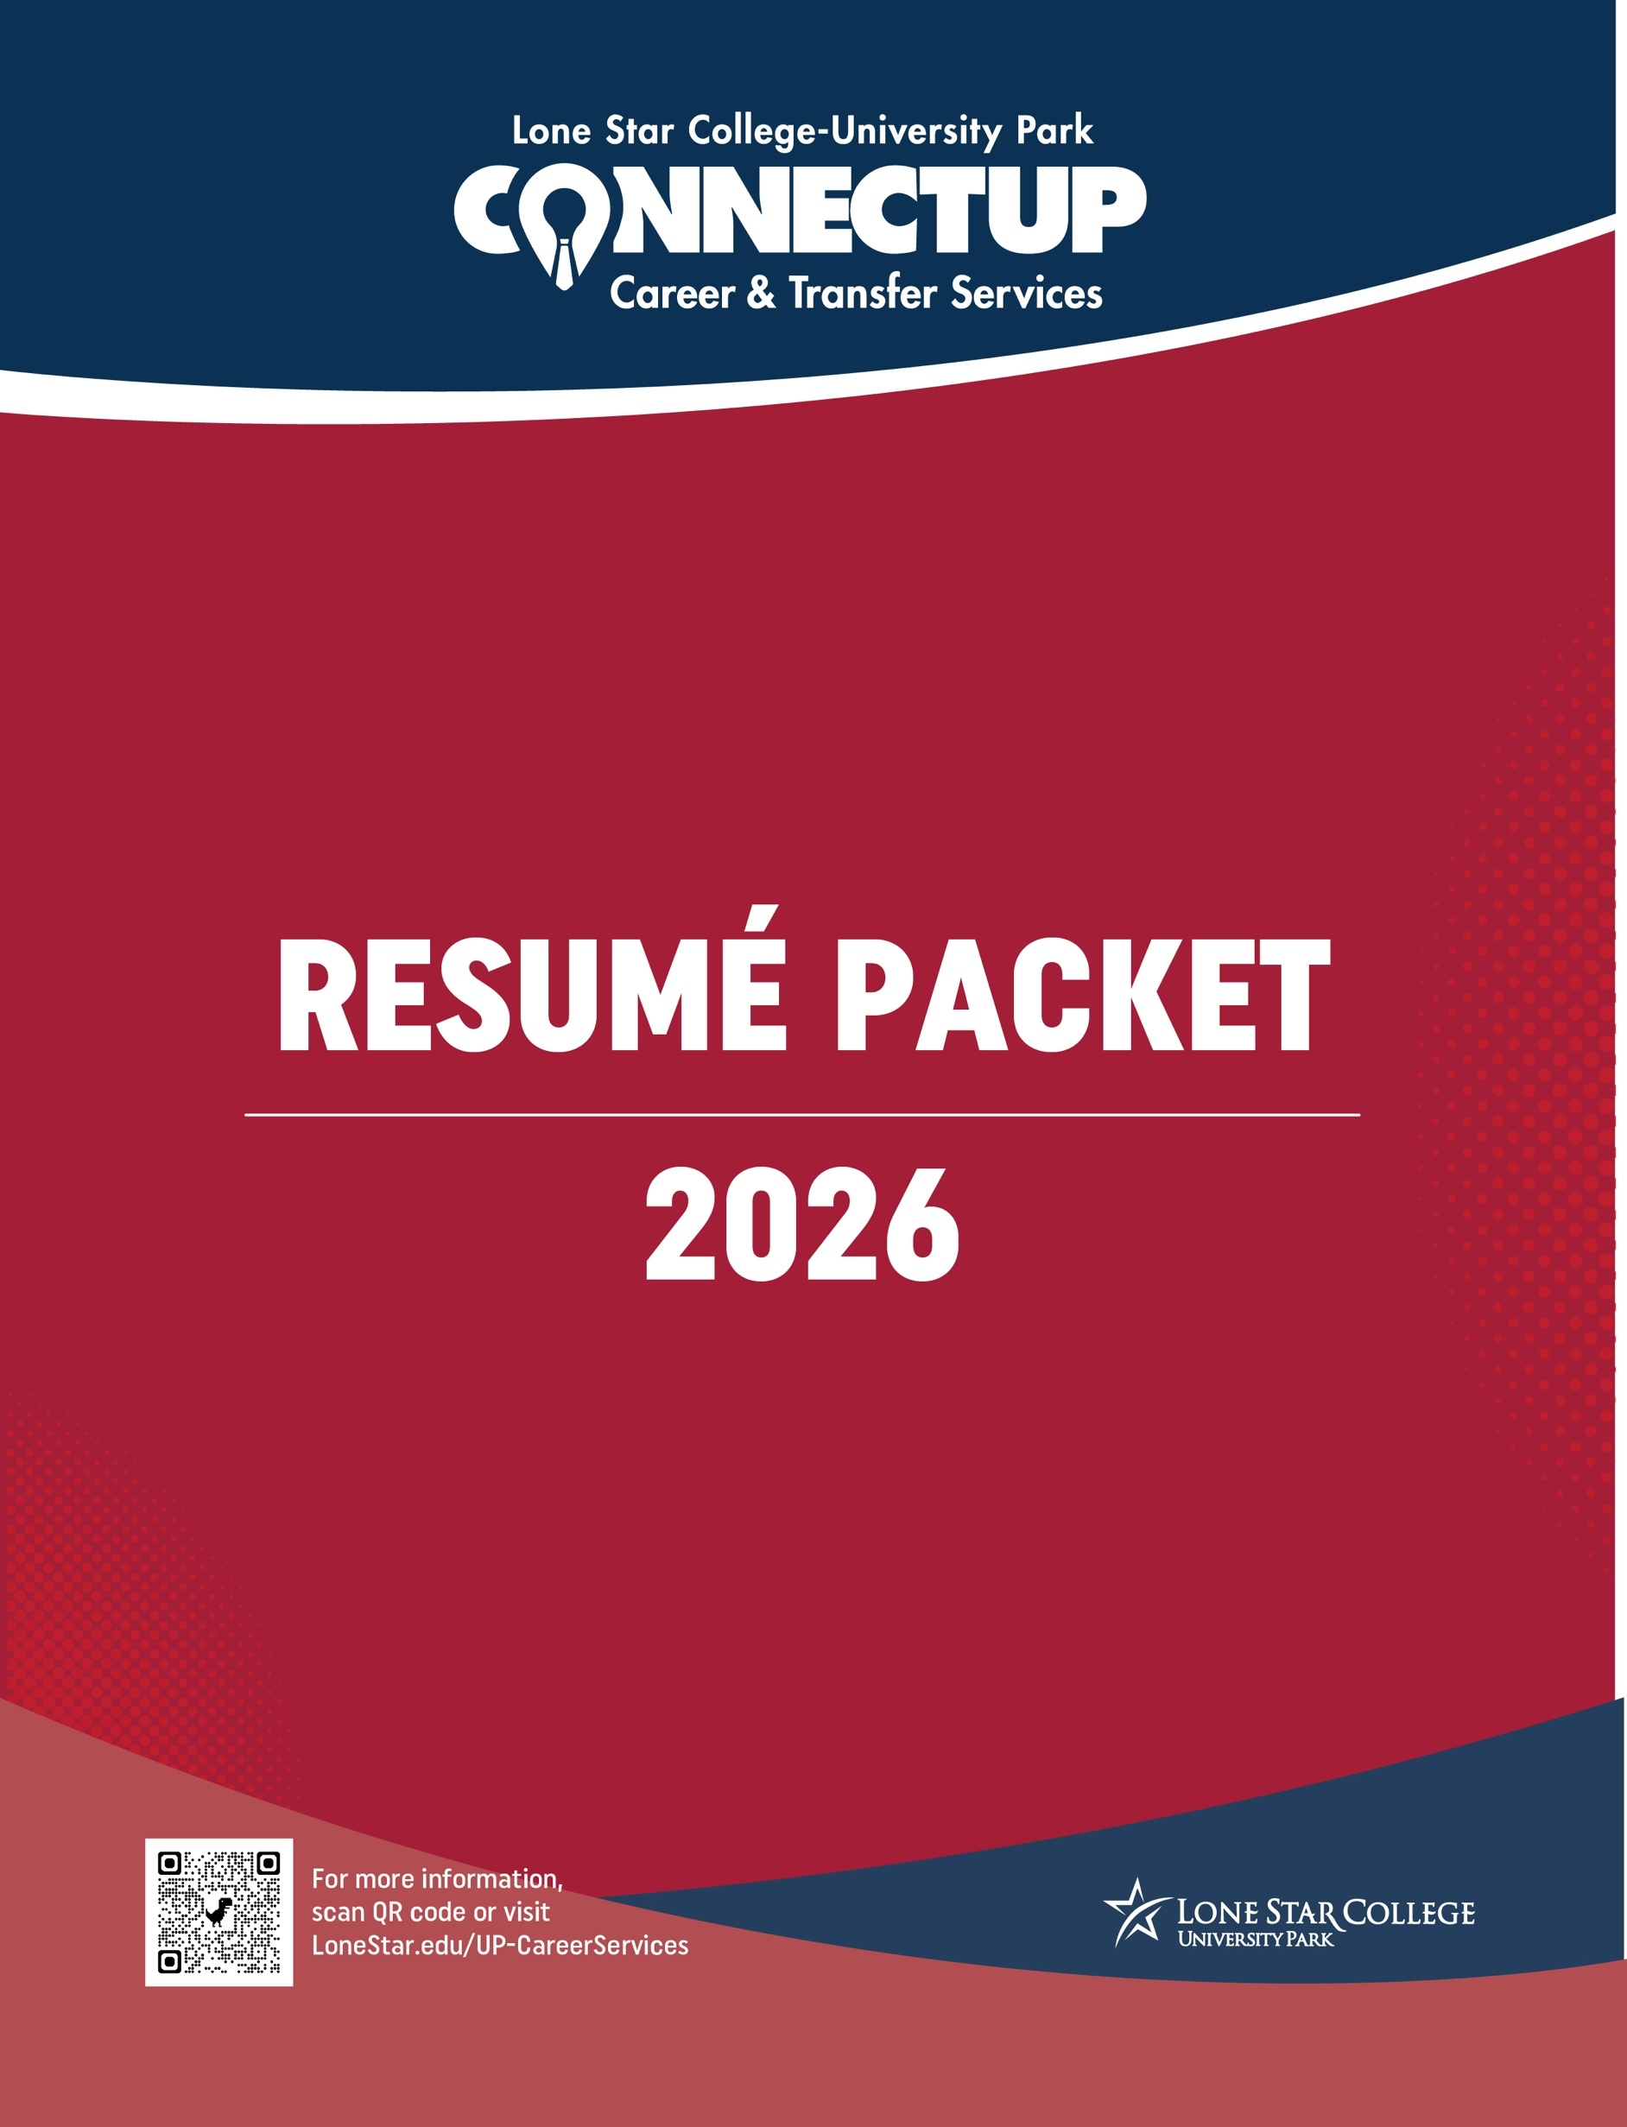
This guide is designed to take you step-by-step through building a competitive, modern application packet.
TABLE OF CONTENTS
SECTION | TOPIC & DESCRIPTION | PAGE
Introduction | Why Your Resume Matters  Understanding your resume's role in 2026: skills-first hiring, ATS screening, and making a  7-second impression. | 3
Section 1 | AI & ATS Guidance  Strategies for passing Applicant Tracking Systems and rules for using generative AI tools ethically. | 4
Section 2 | The Bullet Point Upgrade Framework  Transforming basic job duties into impact-driven bullet points using the Google X-Y-Z formula. | 5
Section 3 | Branding & Cover Letter  Consistent contact header formatting and a 3-paragraph structural blueprint for cover letters. | 6
Section 4 | Differentiated Resume Templates  Tailored layouts for Early College, Experienced/Transfer-Ready, and Technical Workforce students. | 7 - 9
Section 5 | Reference Page  Professional reference template and categorized action verb clusters for targeted resume writing. | 10
Section 6 | NACE Skills Crosswalk & Pre-Submission Checklist  Mapping everyday experiences to NACE competencies and a self-audit checklist before submitting to ConnectUP. | 11 - 12

Why Your Resume Matters More Than Ever
Your resume is no longer just a passive list of past jobs—it is your personal marketing document and primary bridge to professional opportunity. Whether you are applying for your first internship, transitioning into a workforce industry, or preparing to transfer to a four-year university, a strategic resume opens doors.
In today’s fast-paced job market, employers evaluate hundreds of applications for a single opening. Your resume serves three critical functions:
- Your Professional First Impression: It tells employers who you are, what value you bring, and why you stand out in under seven seconds.
- Your Proof of Competency: It translates your academic coursework, lab experience, campus involvement, and part-time jobs into tangible skills that modern employers demand.
- Your Career Launchpad: It provides the foundation for your LinkedIn profile, cover letters, transfer applications, and interview talking points.

Navigating the Hiring Landscape in 2026
The way companies hire has evolved rapidly. Successfully landing an interview in 2026 requires understanding how technology and modern recruitment practices intersect:
1. AI & Applicant Tracking Systems (ATS)
Over 90% of mid-to-large companies use ATS and AI-driven screeners to evaluate candidate pools before a human ever sees a resume. Modern algorithms scan for direct keyword alignment, clean single-column formatting, and clear job titles. Understanding how to format for ATS is no longer optional—it is required.
2. Skills-First Hiring
Employers are increasingly shifting away from strict degree requirements in favor of skills-first recruiting. Today’s hiring managers look for verifiable technical competencies, industry certifications, and NACE core competencies (such as critical thinking, communication, and digital literacy).
3. Outcome-Focused Bullets
Listing job duties is an outdated practice. In 2026, candidates must demonstrate impact. Employers look for standard outcome formulas that prove how your actions achieved measurable results.
4. Responsible AI Integration
While generative AI tools can assist in drafting and tailoring application materials, employers expect authentic, highly tailored content. Knowing how to leverage AI ethically to enhance your draft—without relying on generic text—is a critical career skill.

Section 1: AI & ATS Guidance
Ethical AI Prompting for Resumes
- The 80/20 Rule: Use AI (like Gemini or ChatGPT) for brainstorming, structure, and initial drafting (20%), but heavily edit and refine the content yourself to ensure accuracy and authentic tone (80%).
- Sample Prompt for Students: "I am applying for a [Job Title] role. Here is the job description: [Paste Text]. Here is my current experience: [Paste Bullets]. Rewrite my bullets to highlight matching keywords using strong action verbs without exaggerating my role."
Modern ATS Rules
- Stick to Clean Single-Column Layouts:
  - Multi-column layouts, graphics, text boxes, and tables can distort data when parsed by ATS software.
- Standard File Naming:
  - Save and submit files using the naming format: Firstname_Lastname_Resume.pdf unless Word format (.docx)

Section 2: The Bullet Point Upgrade Framework
Replace general guidance with the Google X-Y-Z Formula (Accomplished [X], as measured by [Y], by doing [Z]).
- Weak (Task-focused): "Responsible for helping customers and taking payments at the register."
- Improved (Action-focused): "Served customers, managed cash register, and resolved complaints quickly."
- Strong / X-Y-Z Standard (Outcome-focused): "Delivered high-quality customer service to 100+ daily patrons, resolving average of 15 service inquiries per shift while maintaining a 98% register accuracy rate."

Categorized Action Verbs

Categorized Action Verb Clusters
- Data & Analytics: Analyzed, Audited, Calculated, Diagnosed, Evaluated, Forecasted, Interpreted, Measured, Modeled, Systematized
- Leadership & Strategy: Architected, Coached, Delegated, Directed, Facilitated, Headed, Initiated, Mentored, Orchestrated
- Project Management & Operations: Automated, Budgeted, Coordinated, Executed, Implemented, Organized, Planned, Restructured, Scheduled, Streamlined
- Communication & Marketing: Authored, Branded, Campaigned, Drafted, Negotiated, Pitched, Publicized, Represented, Spearheaded, Translated

Section 3: Standardized Branding & Cover Letter
Always use the same header template across Cover Letter, Resume, and Reference Page.

LEO LION
Houston, TX | 281-290-2600 | LLion@lonestar.edu | linkedin.com/in/leolion

[Date]
[Hiring Manager Name or Hiring Committee]
[Company Name]
[Company Street Address]
[City, State Zip]

Dear [Hiring Manager Name or Hiring Committee],
Paragraph 1: The Hook & Value Proposition
State the position you are applying for, how you discovered it, and a brief statement summarizing why your background makes you a strong fit. Mention a genuine connection to the company's mission, recent project, or core values.
Paragraph 2: Highlight Key Achievements & Align Competencies
Connect 2–3 of your core experiences directly to the job requirements. Use concrete examples and metrics rather than simply listing duties. Explain how your previous experience translates to value for their team.
Paragraph 3: Closing & Call to Action
Reiterate your enthusiasm for the role, state where they can review your credentials, and express interest in discussing your application in an interview.

Sincerely,
Leo Lion

Section 4: Differentiated Resume Templates
Template 1: Early College (Projects & Coursework Focus)

LEO LION
Houston, TX | 281-290-2600 | LLion@lonestar.edu | linkedin.com/in/leolion
SUMMARY
Meticulous Lone Star College student pursuing an Associate of Science in Business. Demonstrates strong analytical, project management, and cross-functional communication skills developed through academic coursework and campus leadership.
EDUCATION
Lone Star College-University Park — Houston, TX
Associate of Science in Business Administration | Expected Graduation: May 2027
GPA: 3.8 / 4.0 (Optional, include if 3.5+)

Relevant Coursework: Principles of Financial Accounting, Microeconomics, Business Computer Applications

ACADEMIC PROJECTS
Market Analysis & Business Plan Project — Business Principles Course | Fall 2025
- Conducted market research analyzing competitor pricing and demographic trends for a hypothetical local enterprise.
- Formulated a 10-page financial plan and delivered a 15-minute presentation to a panel of 30 peers and faculty.

EXPERIENCE
Student Assistant — LSC-University Park ConnectUP Center, Houston, TX | Aug 2025 – Present
- Greet 50+ daily visitors, answer front-desk inquiries, and direct students to campus career resources.
- Maintain appointment schedules and organize event materials for campus-wide career fairs.

HONORS & CAMPUS INVOLVEMENT
- Member, Business Student Association | 2025 – Present
- Dean’s List, Lone Star College-University Park | Fall 2025

Template 2: Experienced / Transfer-Ready Student (Work & Leadership Focus)

LEO LION
Houston, TX | 281-290-2600 | LLion@lonestar.edu | linkedin.com/in/leolion

PROFESSIONAL SUMMARY
Results-driven professional with 3+ years of experience in team coordination, customer coordination, and process improvement. Proven history of leading small teams and optimizing daily operations. Transferring to a 4-year university to complete a bachelor’s in management.

EDUCATION
Lone Star College-University Park — Houston, TX
Associate of Arts in General Studies | Month Year
GPA: 3.8 / 4.0 (Optional, include if 3.5+)

WORK EXPERIENCE
Shift Supervisor — ABC Logistics & Retail, Houston, TX | Jan 2024 – Present
- Lead a team of eight floor associates, managing daily shift tasks, inventory tracking, and schedule delegation.
- Streamlined restocking procedures, reducing inventory processing time by 15% over 6 months.
- Trained 10+ new hires on safety protocols, register operation, and customer escalation procedures.
Customer Service Associate — XYZ Retail Solutions, Houston, TX | Jun 2022 – Dec 2023
- Managed daily cash and card transactions averaging $3,000 per shift with zero balance discrepancies.
- Resolved customer disputes efficiently, contributing to a 10% increase in store satisfaction ratings.

SKILLS & CERTIFICATIONS
- Technical Skills: MS Office Suite (Excel, Word, PowerPoint), Google Workspace, POS Systems
- Languages: English (Bilingual/Fluent), Spanish (Conversational)
- Certifications: CPR & First Aid Certified, OSHA 10-Hour Safety

Template 3: Technical /Skill based Workforce Student

LEO LION
Houston, TX | 281-290-2600 | LLion@lonestar.edu | linkedin.com/in/leolion

SUMMARY
Analytical and detail-oriented student pursuing specialized coursework in Artificial Intelligence and Machine Learning. Combines strong programming fundamentals, direct model training experience, and data analysis skills to build predictive algorithms and scalable AI solutions.

EDUCATION & RELEVANT COURSEWORK
Lone Star College-University Park — Houston, TX
Associate of Applied Science - AI & Machine Learning | Expected Graduation: May 2027
- Overall GPA: 3.8 / 4.0
- Key Coursework: Introduction to Artificial Intelligence, Machine Learning Fundamentals, Programming Fundamentals (Python/C++), Calculus II, Data Structures & Algorithms

TECHNICAL SKILLS & CERTIFICATIONS
- Programming Languages: Python (NumPy, Pandas, Scikit-Learn), SQL, C++
- AI & ML Frameworks: PyTorch, TensorFlow, Open-CV, Scikit-Learn
- Data & Developer Tools: Jupyter Notebooks, Git/GitHub, Google Colab, VS Code, REST APIs
- Certifications: AWS Certified Cloud Practitioner (or Google Data Analytics Professional Certificate)

TECHNICAL & AI PROJECTS
Predictive Housing Price Model — Machine Learning Coursework | Spring 2026
- Data Processing & Feature Engineering: Cleaned, preprocessed, and normalized a dataset of 10,000+ real estate records using Pandas and NumPy, overseeing missing values and outlier distributions
- Model Development & Evaluation: Built and optimized multiple linear regression and random forest models using Scikit-Learn, achieving an 89% accuracy rate ($R^{2}$ score) in predicting target market prices

WORK EXPERIENCE
STEM / Computer Lab Assistant — Lone Star College-University Park, Houston, TX | Aug 2025 – Present
- Assist 30+ students daily with troubleshooting code syntax errors, configuring Python virtual environments, and installing development libraries
- Maintain operating status of 40+ computer lab workstations, ensuring software updates and proper network connectivity

HONORS & CAMPUS INVOLVEMENT
- Member, LSC-University Park AI & Coding Club | 2025 – Present
- Dean’s List, Lone Star College-University Park | Fall 2025 – Spring 2026
Section 5: Reference Page

LEO LION
Houston, TX | 281-290-2600 | LLion@lonestar.edu | linkedin.com/in/leolion

PROFESSIONAL REFERENCES

Dr. Jane Doe
Professor of Business Administration
Lone Star College-University Park
Phone: 281-290-0000
Email: Jane.Doe@lonestar.edu
Relation: Academic Professor / Project Advisor

John Smith
Operations Manager
ABC Enterprises
Phone: 713-555-0199
Email: JSmith@abcenterprises.com
Relation: Former Direct Supervisor

Section 6: NACE Skills Crosswalk & Self-Audit Checklist
Student Experience to NACE Career Competencies Crosswalk

Student Experience - NACE Competency: - Resume Action Bullet Example:
- Retail / Food Service - Critical Thinking & Problem Solving:
  - "Resolved 15+ daily customer issues, maintaining high satisfaction ratings during peak operational hours."
- Class Group Project - Teamwork & Leadership:
  - "Coordinated a 4-member project team, establishing milestones and delivering final presentation on schedule."
- Campus Club Member - Communication & Inclusion:
  - "Drafted promotional communications and facilitated weekly meetings to engage 30+ active student members."
- Course Work & Labs - Professionalism & Tech Literacy:
  - "Utilized advanced Excel functions (VLOOKUP, Pivot Tables) to analyze dataset trends for coursework."

ConnectUP Resume Pre-Submission Self-Audit Checklist

Career Advisors are available to review your draft, provide targeted feedback, and help you tailor your resume for specific opportunities. Visit LoneStar.edu/UP-CareerServices or scan the QR code on the cover to book an appointment. You can also submit your resume via email for review. ConnectUP@lonestar.edu

Check off each item before submitting your document to ConnectUP Career Services:

[ ] Formatting & Layout:
Is the resume 1 page (or 2 pages maximum for extensive relevant experience)?
[ ] Contact Info:
Are your phone number, professional email, and LinkedIn URL accurate and at the top?
[ ] Verb Tenses:
Are current positions written in present tense and past positions written in past tense?
[ ] Quantified Achievements:
Did you include numbers, percentages, or frequencies in your bullet points where possible?
[ ] ATS Readability:
Is the document saved as a PDF using standard single-column formatting without tables or graphics?
[ ] Tailoring:
Did you incorporate relevant job keywords from the target job posting into your skills and experience sections?

