Dear Graduation Candidate,

Congratulations on your candidacy for graduation from Lone Star College-Kingwood! We look forward to your participation in the May Commencement Ceremony of Lone Star College-Kingwood on May 13, 2023 @ 10:00 AM, at the M.O. Campbell Educational Center located at 1865 Aldine Bender Road, Houston, TX 77032.

Your participation in this special ceremony is encouraged. Please visit the link below to confirm your participation in the 2023 Commencement Ceremony. RSVP is REQUIRED!

https://form.jotform.com/220655941907158

Orientation Prior to Graduation is Mandatory:

You will be expected to attend one of the following 1 hour orientation sessions:

Monday, April 24th Tuesday, April 25th Wednesday, April 26th
5:30-6:30 PM 12:30-1:30 PM 12:30-1:30PM

All orientation sessions will be held in the Student Conference Center*

Early College High School Graduates will have separate orientation sessions at their high schools.

Graduation Commencement Ceremony Seating:
Upon arriving at the M.O. Campbell Educational Center you will see signs directing you to the check-in rooms to which you need to report. Graduates whose last names begin with A-L will report to Room 104 (West Entrance) and graduates whose last names begin with M-Z will report to Room 158 (East Entrance). You are expected to arrive no later than 8:30 AM to ensure your spot. If you are an EARLY COLLEGE graduate you must arrive at 8:00 AM.

Please arrive dressed in cap and gown. You will receive your assigned seating card and additional instructions at this time from the check-in table in your respected rooms. There will be special assigned seating for graduates please do not arrive late as you will not be seated correctly and will be placed at the end of the procession.

Family and friends will be seated on a first come, first served basis and reserved seating will not be permitted. All in attendance (graduates and guests) are required to wear a mask and will pass through a metal detector. Tickets are not required.

Graduation Fee/Cap & Gown:
There is no graduation fee; however, you must wear a cap and gown, which is available for purchase at the Barnes & Noble Lone Star College-Kingwood Bookstore. If the cost of regalia is preventing you from participating in the commencement ceremony, please contact Ms. Tiera Johnson at Tiera.Johnson@lonestar.edu

Photographer:
A professional photographer will take your photograph as you are recognized on stage. Proofs will be emailed to you after the ceremony, and you may order copies from the photographer if you choose. Family and guests are allowed to take photographs from their seats; however, no one is permitted to block the aisles or enter the auditorium floor to take photographs.

Sincerely,
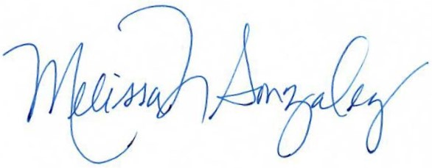
Melissa Gonzalez, Ph.D.
LSC-Kingwood President

