**PART I – Course Information**

**CHECK HERE ONLY IF APPLYING FOR THE COMPONENT AREA OPTION A**

**Course Type**

Existing Course Currently in LSCS Core Curriculum

Existing Course NOT Currently in LSCS Core Curriculum

New Course Proposed for Core Curriculum 2014

**Course Prefix & Number**:

**Course Title**:

**Course Catalog Description** (Copy and paste from [online catalog](http://www.lonestar.edu/lscs-catalog.htm) for existing courses):

**Course Prerequisites**:

**Curriculum Team Contact Person** (for follow-up communication purposes):

**E-Mail Address**:

**Phone:**

**Curriculum Team Facilitator Digital Signature:**

(DO NOT DIGITALLY SIGN UNTIL YOU ARE COMPLETELY FINISHED FILLING IN THE FORM. THIS IS YOUR LAST STEP. Right click the signature line, select **Sign** from the menu that displays, Click **OK**, Choose **Create your own digital ID**, confirm that information is correct, click **OK**, type your name, and click **Sign**. To remove a signature, right click mouse and select **Remove Signature** from the menu.)



**COMPLETED CORE FORM AND SYLLABUS SHOULD BE EMAILED TO** [**curricdev@lonestar.edu**](mailto:curricdev@lonestar.edu)

**PART II – General Education Vision Statement**

*The Lone Star College general education curriculum is designed to empower students with foundational knowledge and transferrable skills guided and informed by a strong sense of values, ethics, and civic engagement. The general education curriculum prepares students for academic excellence and careers through progressively higher-level studies in the areas of critical thinking, communication, empirical and quantitative skills, teamwork, personal responsibility, and social responsibility.*

*Embedded in the Lone Star College Core Curriculum is our firm belief that educated members of society must possess a broad base of experience and general knowledge to balance the narrow focus of degree and vocational requirements.  We strive to ensure that our core curriculum provides many important benefits that exceed those listed above.  Students taking the core curriculum interact with a wide range of cultures, both domestic and international. They develop important individual traits and skills such as empathy and communication that are critical for their future careers and personal development.*

*Students hone interpersonal skills and develop critical workplace and academic skills, such as communication, time management, and leadership that will enhance their ability to collaborate with colleagues, employers, and society.*

*Lone Star College values civic engagement and encourages students to become informed participants in the civic and social responsibilities of our local, state, national, and global communities.  Participation in our core curriculum creates opportunities and encourages our students to evaluate their own value systems through the study of the humanities and sciences while recognizing the diversity of beliefs and values present within our society.*

*In sum, our graduates learn to become autonomous decision makers through the development of a broad base of knowledge, skills, personal wellness, and interpersonal competencies.*

**In one paragraph, describe how the proposed course will support the LSCS General Education Vision Statement:**

**PART III – THECB Foundational Component Areas**

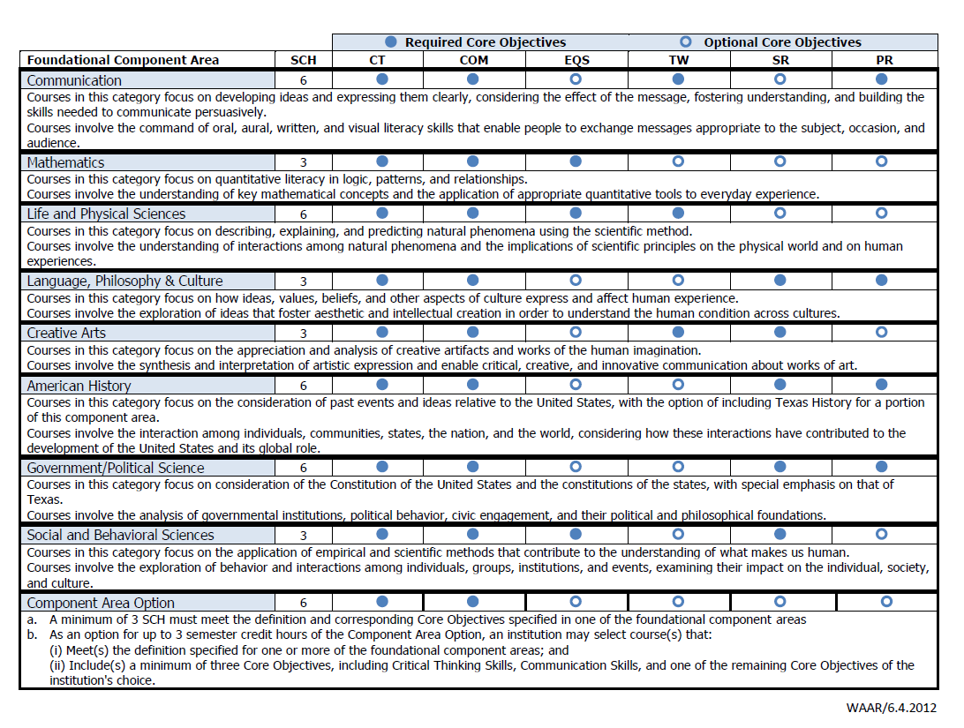

**1. Describe how the course will focus on describing, explaining, and predicting natural phenomena using the scientific method.**

**2. Describe how the course will involve the understanding of interactions among natural phenomena and the implications of scientific principles on the physical world and on human experiences.**

**PART IV – Aligning Course Outcomes (Student Learning Outcomes) to Component Area Statements**

Insert the student learning outcome(s) (e.g., Students completing the course will be able to…) that support the core component area statements shown on the previous page.

**Student Learning Outcome (SLO) 1:**

**How does this SLO align with the component area statements?**

**Student Learning Outcome (SLO) 2:**

**How does this SLO align with the component area statements?**

**Student Learning Outcome (SLO) 3:**

**How does this SLO align with the component area statements?**

**Student Learning Outcome (SLO) 4:**

**How does this SLO align with the component area statements?**

**Student Learning Outcome (SLO) 5:**

**How does this SLO align with the component area statements?**

**PART V – THECB Core Objectives**

Address each of the THECB core objectives required within the component area. Explain how the skill is addressed by the course’s student learning outcomes, agreed upon instructional strategies, or both. Assessment must include at least one direct measure. Direct measures are defined as students' demonstrations of learning. Indirect measures are defined as students' perceptions of their learning or other measures not derived directly from student work.

**Critical Thinking Skills: to include creative thinking, innovation, inquiry, and analysis, evaluation and synthesis of information**

**How will the skill be addressed by this course? Please specify a course’s student learning outcome and/or agreed upon instructional strategy that addresses this required core objective.**

**How does the curriculum team propose to measure students’ achievement of this required competency in this specific course?**

**Communication Skills: to include effective development, interpretation and expression of ideas through written, oral and visual communication**

**How will the skill be addressed by this course? Please specify a course’s student learning outcome and/or agreed upon instructional strategy that addresses this required core objective.**

**How does the curriculum team propose to measure students’ achievement of this required competency in this specific course?**

**Empirical and Quantitative Skills: to include the manipulation and analysis of numerical data or observable facts resulting in informed conclusions**

**How will the skill be addressed by this course? Please specify a course’s student learning outcome and/or agreed upon instructional strategy that addresses this required core objective.**

**How does the curriculum team propose to measure students’ achievement of this required competency in this specific course?**

**Teamwork: to include the ability to consider different points of view and to work effectively with others to support a shared purpose or goal**

**How will the skill be addressed by this course? Please specify a course’s student learning outcome and/or agreed upon instructional strategy that addresses this required core objective.**

**How does the curriculum team propose to measure students’ achievement of this required competency in this specific course?**