Registering for your WC Online Account

Go to lonestar.mywconline.net

This is the page you will see:

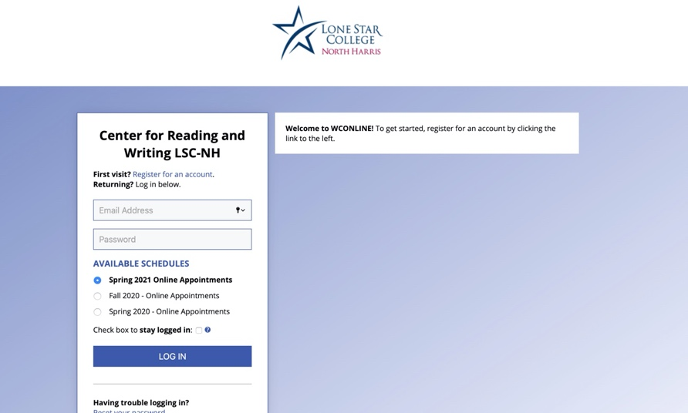

If this is your first time logging in, you will need to register for an account.

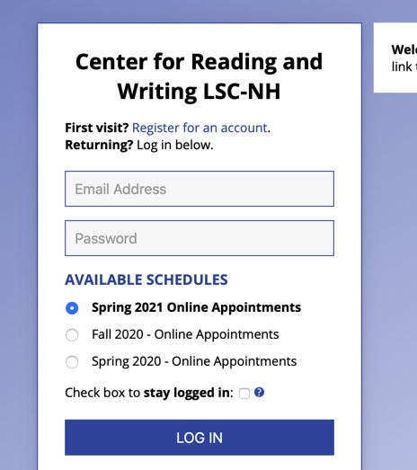

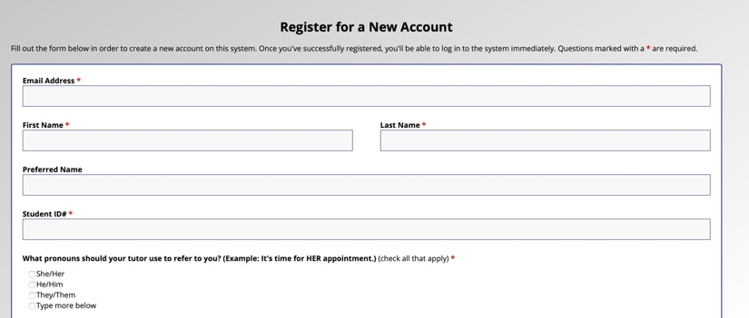

Complete the basic information in the registration form.

You will need to enter your password twice. The password must include at least 10 characters.

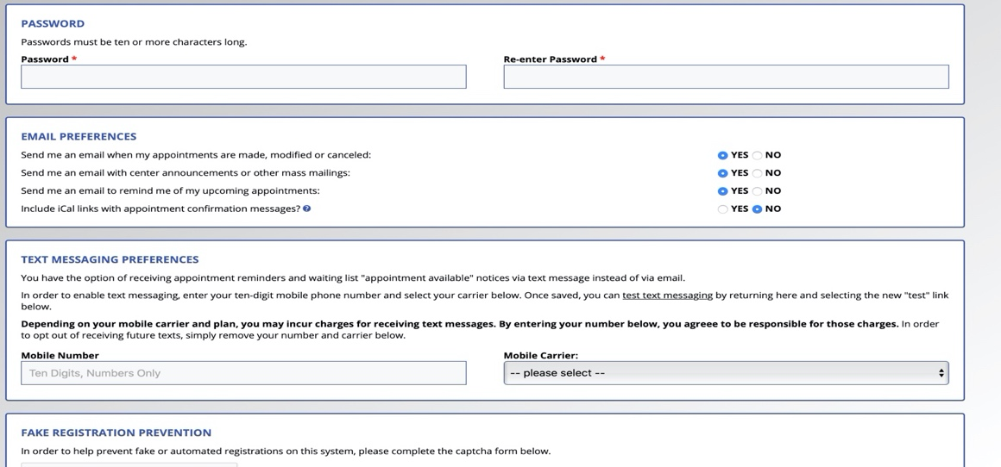

Your cell number is not necessary unless you want to receive text notifications in addition to e-mail notices. In that case, you will need to enter your phone number and your mobile carrier (service provider).

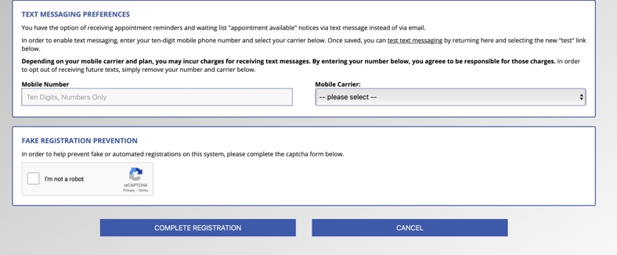

Do not forget to click the “I am not a robot” at the very end!

