Reserving your Writing Center Appointment

To reserve your Writing Center Appointment, you should have completed the Registration Process.

Return to the lonestar.mywconline.net page:

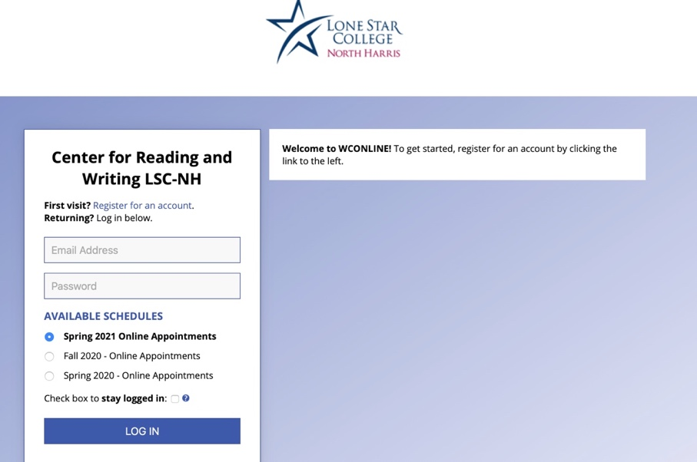

Enter your e-mail and password to login.
Once you are logged in, you will see the schedule of appointment times.

Sessions that are in gray mean that time has already passed for the day.
Sessions that are in blue mean they are already booked.

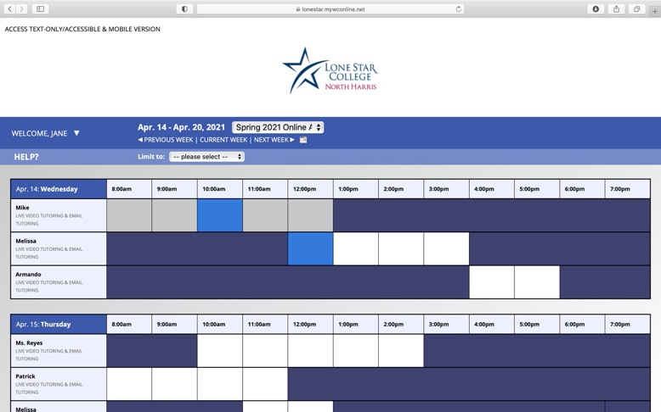

Click on a time session that works for you. You will then see the form to reserve that session.
The session time and tutor will automatically appear at the top.

Please be careful to select the correct type of tutor session you want. You make select an e-mail feedback appointment or a live video session.

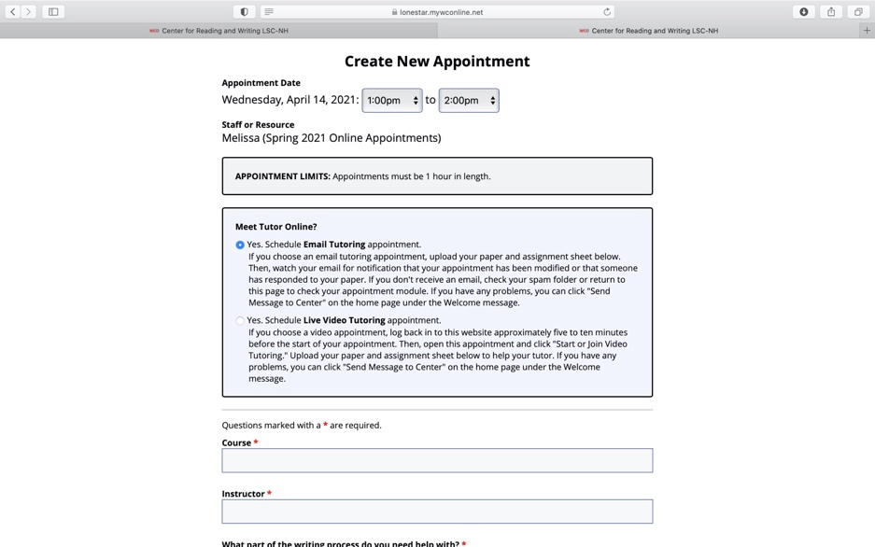

Enter the rest of the general information requested.

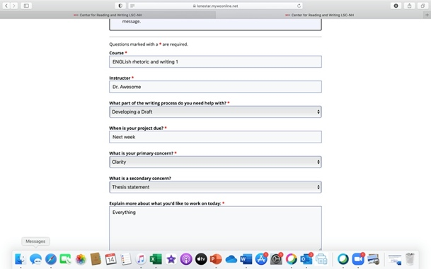

You will upload your assignment sheet and your paper at the end. Be sure to download your documents to your desktop and then upload them to your appointment form.

