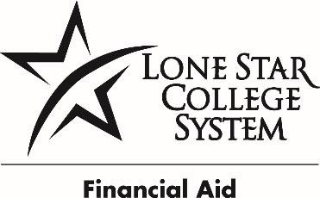LONE STAR COLLEGE SYSTEM COLLEGE WORK STUDY JOB DESCRIPTION

POSITION NUMBER: SO00011
JOB TITLE: Student Worker II, | College Work Study Position
DEPARTMENT: Financial Aid Reporting and Reconciliation (FARR) | PAY: 8.74 per/hr.
CAMPUS: LSC-University Park System Office | HOURS: 19.5 per/wk.

POSITION SUMMARY
This position will assist the FARR team with data entry, processing documents and information, and prepare files for State and Federal review. Duties will include: maintain accurate excel data for loan reports, assist with reviewing sensitive documents for Pell Grant and Return of Title IV, assist with recording and maintaining work study files for accurate reporting, and assist with processing and recording electronic documents for audit review. Will work with highly sensitive and confidential information. Will work with and assist diverse groups.

PRIMARY RESPONSIBILITES
- Filing
- Copying
- Faxing
- Scanning and/or shredding
- Record maintenance, preparation and review of forms, data entry
- Prepare reports
- Collect and record data
- Maintain knowledge of multiple programs
- Interpret regulations and policies
- Maintain and/or process records

REQUIRED QUALIFICATIONS
- High School Diploma or Equivalent
- 0-1 Year experience

KNOWLEDGE SKILLS AND ABILITES
- Customer service
- Interpersonal skills
- Organizational skills
- Analytical and problem solving skills
- Working knowledge of general office procedures and practices
- Proficiency with one or more office software (Word, Excel, PowerPoint, Access)
- Ability to multi-task

USE OF EQUIPMENT AND MACHINERY
- Use small office equipment including copy machines or multi-line phone system
- Use computer for word processing

